**MathVerse: Integration of Roblox Math Game for Engagement**

**and Effectiveness to Grade 4 Learners of Tierra**

**Grande House of Learning, Incorporated**

____________________

A Research Paper

Presented to the Senior High School Department

Cebu Institute of Technology – University

Cebu City, Philippines

____________________

In Partial Fulfillment

of the Requirements for the Subjects

Research 3: Inquiries, Investigations, and Immersion and

Research 4: Capstone Project

____________________

by

Aguas, Jian J.

Castillo, Kadmiel T.

Cuarez, Kate A.

Dela Cruz, Angelica A.

Guadalquiver, Phillip L.

Labra, Aryanna V.

Lumapas, Lewis V.

Mañoza, John C.

Mañoza, Matthew C.

APRIL 2025

**Abstract**

Mathematics remains a challenging subject to most learners, particularly when taught through traditional methods that often lower to engage or motivate learners. These conventional approaches can lead to low retention, limited understanding, and decreased academic performance. Game-Based Learning, however, presents an alternative by integrating interactive and engaging elements that support motivation, deeper learning, and skill development. This study introduces MathVerse, an educational game developed using Roblox Studio, aimed to enhance the math proficiency and engagement of Grade 4 learners. The game incorporates lessons from the Mathematics 4 MATATAG fourth quarter curriculum. A pretest-posttest method, along with structured teacher interviews, will assess the effectiveness of this game-based approach in improving learning outcomes. This study examined the effectiveness of traditional and game-based learning methods. Pre-test and post-test scores were analyzed using mean scores, the Shapiro-Wilk test for normality, and an independent samples t-test to compare student performance. Thematic analysis was also conducted to explore teacher perspectives. Results showed that both methods helped improve learning, with game-based learning increasing student interest and engagement. However, the difference in performance was not statistically significant. These findings suggest that combining traditional and game-based approaches can support better learning outcomes, especially when addressing different learning styles.

Keywords: Mathematics, traditional learning, game-based learning, engagement, effectiveness

**TABLE OF CONTENTS**

**Page**

**Abstract iii**

**Acknowledgement iv**

**List of Tables vi**

**List of Figures vii**

**Chapter 1 INTRODUCTION 1**

* 1. Background of the Study **1**
  2. Statement of the Problem **7**

Hypothesis

* 1. Significance of the Study **9**
  2. Definition of Terms **11**

**Chapter 2 THEORETICAL FRAMEWORK 13**

2.1 Conceptual Framework **13**

2.2 Philosophical Stance **16**

2.3 Literature Review **18**

**Chapter 3 METHODOLOGY 32**

3.1 Research Design **32**

3.2 Research Environment **34**

3.3 Research Respondents **35**

3.4 Research Instrument **36**

3.5 Data Gathering Procedure **38**

3.6 Data Analysis **41**

3.7 Ethical Considerations **43**

**Chapter 4 RESULTS AND DISCUSSION 46**

**Chapter 5 SUMMARY, CONCLUSION, AND RECOMMENDATIONS 62**

5.1 Summary **64**

5.2 Conclusion **65**

5.3 Recommendations **66**

**BIBLIOGRAPHY**

**Appendix A**

**Appendix B**

**Appendix C**

**Appendix D**

**Appendix E**

**Appendix F**

**Appendix G**

**List of Tables**

**Page**

Table 4.1 in Chapter 4 **49**

Table 4.2 in Chapter 4 **50**

Table 4.3 in Chapter 4 **51**

Table 4.4 in Chapter 4 **52**

Table 4.5 in Chapter 4 **53**

Table 4.6 in Chapter 4 **54**

**List of Figures**

**Page**

Figure 1 in Chapter 2 **13**

**CHAPTER 1**

**INTRODUCTION**

1.1 Background of the Study

Most learners show their point of weakness has always been Mathematics.

Especially when more Traditional approaches are used, it can be hard for learners to take in information given by their teachers. Some often come out of their classesconfused and having only retained surface concepts of the lessons taught. As observed by [1] , getting the learners' attention enough for them to focus on the lessons were difficult, remarking that learners need activities in order to get their attention.

When more Traditional approaches are utilized, it can be hard for students to take in information given by their teachers. These methods have learners sit in a classroom and listen to lectures, afterwards answering workbooks and quizzes. While it works for some students, others unfortunately struggle with it as they may find it monotonous when such methods are used. The repetitive nature doesn’t allow opportunities for those students to really hone needed skills for later in life. Many of these learners struggle with traditional learning methods, finding it hard to stay focused and motivated. According to the [2] during 2022, 16% of students achieved Level 2 proficiency in the Mathematics subject, significantly less than the average for The Organization for Economic Cooperation and Development (OECD) countries.

Traditional methods raised concern levels regarding the effectiveness and engagement of learners due to limited interactivity, lack of personalized learning experiences, and minimal opportunities for hands-on application. These results decline engagement levels, leading to lowered academic performance and reduced motivation. Learners are challenged with managing interest, adapting learning paces and applying theoretical knowledge in real-world concepts.

Integrated Learning (or cross-curricular learning) is an educational approach that connects learning in classrooms to real-world applications, applying knowledge and skills in diverse settings. This method emphasizes the relationship of concepts and skills from various experiences and sources. Moreover, students benefit from integrated learning through promoting critical thinking and problem-solving skills and encouraging reflection in improving their learning process.

Integrated learning often incorporates alternative approaches to help learner effectiveness and engagement, going beyond traditional methods. Game-based Learning (GBL) incorporates elements such as leaderboards, points, and challenges, transforming learning experience into a more interactive, game-like environment. Personalized learning adapts educational platforms to each learner’s progress, offering customized recommendations and supporting diverse learning through individualized pacing, proficiency-based progression, and targeted small-group instruction. Meanwhile, Project-Based Learning (PBL) engages students through hands-on projects rooted in real-world scenarios, encouraging exploration and deeper understanding of various academic concepts.

Moreover, Game-based Learning (GBL) is the best alternative for effectiveness and engagement to learners, as it provides a beneficial educational approach through technology. This method incorporates games or game-like elements in the learning process, involving interactive experiences and structured gameplays to teach concepts and encourage problem-solving skills.

Game-Based Learning utilizes games as tools to facilitate learning for pupils, applying active and engaged learning in learning platforms. This approach implements interactive learning experience to pupils, ensuring enhanced education from educational games. Additionally, helping to improve cognitive, social and emotional engagement in learners and allow better results alongside traditional teaching styles.

Roblox is a gaming platform that allows users to develop and play games created by other users. It provides various genres throughout millions of games, from adventure and role-playing to simulations and racing. The platform becomes popular among audiences, encouraging online communities where users can interact and collaborate in games. Roblox is an ideal medium that offers interactive experience with a three-dimensional environment. Lua is a lightweight scripting, which serves as an aligned level programming language for the researchers. Mathematics and Roblox correlate as Roblox’s capability to apply mathematical concepts in an interactive environment. Moreover, the platform provides both visual and creative ways to show math skills in coding and problem-solving. The researchers have named the Roblox math game "MathVerse." This title appeals to younger and elementary audiences, creating an engaging connection between fun and learning mathematics.

The researchers aim to create a Roblox Math Game for Grade 4 learners to measure both effectiveness and engagement. This employs a mixed methods approach, incorporating quantitative (pretest-posttest approach) and qualitative (interviews) components. Additionally, the research-made questionnaire and interview gathers the data asboth utilize pretest-posttest approach and structured interview. This study conducts the setting at Tierra Grande House of Learning Incorporated, where Grade 4 learners participate in the experiment. The local setting provides spaces and respondents needed for the intervention.

The research study applied Mathematics 4 research-made lesson plan from Fourth Quarter, as the detailed guide of  the Roblox Math Game. Symmetry, Patterns, Units of measures and conversions, Probability, Fractions, Percentages, and Basic Geometry are the lessons in the lesson plan. This includes the learning objectives, teaching methods and assessment needed in the intervention.

The aim of the researchers is to make learning obtainable through e-learning. With the goal to make learning fun and be able to apply concepts that helps them better comprehend previous lessons. Having interactive activities that enhance the learners’ planning, communication and team skills can be especially significant in the approach. This gives the possibility for the learners to learn deeply about their lessons in mathematics, even though the learners who get easily bored may become more engaged through hands-on activities and interactive tools. Additionally, integrating e-learning with activities that foster critical skills, learners can build a stronger foundation in mathematics.

Despite the benefits the Roblox game offers, it also carries downsides with it. With the researchers current skills in programming, the Roblox game will have limited options of its templates. Prior to conducting the study, the researchers observed that game quizzes often have a countdown as a feature. While it helps the learners to become more competitive, it also comes with the downside of relying more on the speed of answering quickly rather than actually comprehending the content. Furthermore, game-based learning allows for more graceful failure as said by [3] , having lowered consequences and prompting the learners in more risk-taking and exploration. The participants in this study are limited to Grade 4 learners aside from Grade 1 to Grade 3 due to the restrictions from MATATAG Curriculum. These restrictions were made by the Department of Education (DEPED) as needed to be assessed in future school years.

This study adheres to the Sustainable Development Goals (SDG) [4] to find peace and success for individuals and their planet by 2030. The 17 Sustainable Goals (SDGs) aim to change the world, making action to end poverty and inequality, ensure that all individuals enjoy health, justice, and prosperity, and protect the planet. This study coordinates with Sustainable Development Goal 4 (SDG 4), ensures inclusive quality education, and encourages lifelong learning opportunities for all individuals. This study aims to enhance academic performance and increase engagement by applying game-based learning to learners.

1.2 Statement of the Problem

The objective of this study is to compare the effectiveness of game-based learning and traditional learning methods to determine which approach yields better outcomes. Additionally, it aims to understand the challenges faced by learners in Mathematics. By analyzing the effectiveness, engagement, and its correlation with learning success, this research seeks to answer the following questions:

1. What are the problems or challenges faced by learners in learning Mathematics?

2. What is the average pre-test score of learners based on:

2.1 Traditional Learning

2.2 Game-based Learning

3. What is the average post-test score of learners based on:

3.1 Traditional Learning

3.2 Game-based Learning

4. Is there a significant difference in the average post-test score of Traditional Learning and Game-based Learning?

1. What is the perception of Elementary teachers towards integrating Mathematics in Roblox?

Hypothesis:

**H0:** There is no significant difference in post-test scores between Traditional Learning (TL) and Game-Based Learning (GBL).

**H1:** The post-test scores in Game-Based Learning (GBL) are significantly higher than in Traditional Learning (TL).

1.3 Significance of the Study

The goal of this study is to make a Roblox game that will be used by learners to make learning enjoyable, engaging, and interactive, enabling them to review and apply concepts from previous lessons effectively. With the help of this research, the following will greatly benefit from its results:

**Learners.** This study can help elementary learners by creating a gamified way of learning mathematics for them, making their learning fun, enjoyable and educational at the same time.

**Teachers.**  With this study, teachers are given a tool that can aid them in meeting the diverse learning needs for their learners that can be easily integrated in their curriculum, especially for mathematics.

**Parents.** Parents ensures confidence in their child’s education through integrated learning methods, benefiting both learning process and problem-solving skills.

**Game Developers.** This study serves as a foundation to game developers in creating educational games for learners, applying in Roblox and other game engines.

**Curriculum Developers.** This study offers valuable insights for curriculum developers by presenting an innovative approach to teaching mathematics through gamification. It provides a model that can be adapted to create engaging, learner-centered materials that align with educational standards while addressing diverse student needs.

**Schools.** Schools can benefit from this study by adopting game-based learning platforms as part of their instructional tools. It encourages a more interactive and inclusive learning environment, supports technology integration, and helps foster a positive attitude toward mathematics among students.

**Future Researchers.** This study provides a basis and reference for future academics interested in making or developing a game-based learning platform. With this, researchers in the future may be assisted in understanding some of the challenges, strategies, and outcomes with such systems.

1.4 Definition of Terms

**Academic Performance** is a measure of how well students perform in school, usually quantified through tests, quizzes, or other evaluations, particularly in subjects such as mathematics.

**Critical Thinking** is the power to think logically and carefully analyze information in order to make rational decisions. It makes students grasp concepts better, particularly when they participate in interactive learning.

**Digital Technology** involves electronic equipment and web-based interfaces that facilitate learning by increasing accessibility and engagement with educational materials.

**Game-Based Learning (GBL)** refers to an approach to teaching based on using aspects of games—such as rewards, points, and challenges—to enhance learning, making it engaging and interactive.

**Gamified Learning** uses game thinking to educate and engage learners through interactive lessons designed to enhance motivation and comprehension.

**Integrative Learning** is a learning approach that combines multiple disciplines, perspectives, and real-world applications to create a more holistic understanding of concepts.

**Learning Styles** refer to the various methods students learn and process information and how these may affect their reaction to varied teaching strategies.

**Math Curriculum** is the planned sequence of lessons, subjects, and learning objectives intended to instruct in mathematics, particularly at the elementary level.

**Online Game-Based Platform** is a website or application that offers educational material in game form, allowing students to become proficient at particular subjects.

**Problem-Solving Skills** are the skills to recognize problems, think carefully, and arrive at good solutions, usually achieved through practical or interactive learning activities.

**Rewards** are incentives, such as points or badges, awarded to learners for achieving learning milestones, so that they can remain motivated and engaged.

**Roblox** is a digital platform that allows users to create, share, and play interactive experiences using game development tools.

**Traditional Teaching Methods** are the conventional modes of teaching, such as lectures and textbook-based lessons, that do not always involve interactive or digital components.

**CHAPTER 2**

**THEORECTICAL BACKGROUND**

2.1 Conceptual Framework

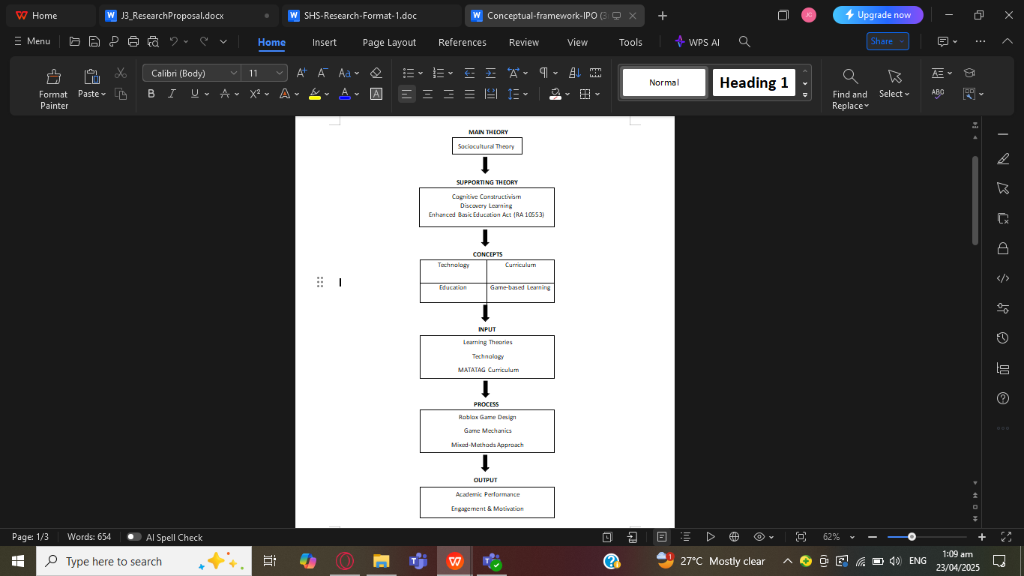

Figure 1. Conceptual Framework

This conceptual framework is anchored in Vygotsky’s Sociocultural Theory, which emphasizes that cognitive development is socially mediated and shaped through meaningful interactions, tools, and language [5]. Supporting this are Piaget’s Cognitive Constructivism, which highlights the learner's active role in constructing knowledge through experience [6], and Bruner’s Discovery Learning, which promotes exploration and problem-solving as essential to learning [7]. The Enhanced Basic Education Act of 2013 (RA 10533) further supports this framework by advocating for technology-integrated, learner-centered approaches in the Philippine education system [8]. The framework connects these theories with key concepts such as Technology, Curriculum, Education and Game-based Learning. These are operationalized through the Input–Process–Output (IPO) model.

The Input includes the integration of interactive learning theories alongside the use of technology to create a game-based platform grounded in the competencies outlined in the MATATAG Curriculum for Grade 4 mathematics [9].

The Process involves the development and implementation of a Roblox-based math game using Lua scripting within Roblox Studio. Game mechanics such as point scoring, leaderboards, and real-time feedback are embedded to promote critical thinking and learner motivation [10]. The research follows a mixed-methods design: quota sampling is used to assign students to experimental and control groups, while data are gathered through pre- and post-tests (quantitative) and teacher interviews (qualitative), analyzed statistically and thematically using Braun and Clarke’s method [11].

The Output reflects the intended outcomes of the study: (1) enhanced academic performance in mathematics specifically in critical thinking, problem-solving, and mastery of Grade 4 math competencies; and (2) increased motivation, participation, and positive attitudes toward math through the integration of digital, game-based environments [10]

2.2 Philosophical Stance

**Epistemology**

This study grounds in the perspective of epistemology that through meaningful engagement and interaction, knowledge is constructed. The integration of game-based learning in mathematics education has an idea that is being emphasized, that learners acquire knowledge not only through absorption of information, but also through active participation on the learning process. This perspective aligns with the theory of constructivism which suggests that when individuals actively engage with their environment and connect some new information to their prior understanding, learning is most effective.

The researchers recognize that for learners to constructing their own understanding, relying on habitual or mechanical memorization and passive reception of information, the traditional teaching methods are often limiting them.

This stance acknowledges also the learning experience’s subjective nature. Every learner brings existing or prior knowledge, learning preferences, and experiences to the classroom that is unique, which is the influence of how they process and perceive new information.

This study views the learner as a participant who is active in the creation of knowledge. The use of game-based learning is hoped to help learners in controlling their own education and also to assist them in engaging more with mathematical concepts. This foundational knowledge makes it possible to design new instructional strategies that fit the changing patterns of learners in the digital era.

**Ontology**

Our research on the gamification of mathematics for elementary students gives emphasis on how learning is not merely just a transfer of knowledge but a dynamic and interactive process. Through gamified environments of learning, the students are encouraged to actively engage in their learning process.

The researchers recognize that while mathematics nature has its objective and universal truths, the process of understanding and internalizing these mathematical concepts is inherently subjective for each person. Every student approach learning with their own unique perspective, which shapes their way of learning mathematical concepts.

With gamification, the design of the game environment becomes the critical element for influencing the student through stimuli, such as challenging questions or visual cues, which help elicit the desired behavior, like solving a problem correctly or better comprehension of mathematics. Repeated exposure of such stimuli solidifies the student’s behavioral response, providing a more automatic and ingrained approach to problem-solving.  
 Our research on the gamification of mathematics for elementary students emphasizes the importance of combining structured guidance with personal exploration. Us researchers understand that through external reinforcement and engaging stimuli, students can develop key skills while also connecting with the material in a way that feels meaningful to them.

2.3 Literature Review

**Gamification**

Gamification is a technique that has become popular for increasing engagement, motivation, and learning in non-game settings [12]. It involves the utilization of game design components within non-game contexts which aim to convert routine tasks as enjoyable and rewarding by exploiting people’s natural competitive inclinations [13]. Gamification is expanding as one of the innovative strategies, especially in business and marketing applications, and is also a transformational approach to business management. The goal of gamification is to create a more dynamic, flexible, and interactive culture [14].

Gamification enhances students' learning outcomes and motivation in education. It integrates both challenges and rewards as gamified elements, which contributed to both social and cognitive skills [9]. Gamification acknowledges adaptability and creativity in implementing various mechanics to these pupils. This subject increases social interaction and action productivity, as the services structure positive patterns and user engagement. These patterns were provided to motivate students with 'gameful' experiences [15]. Gamification improves the efficiency between teachers and students, rather than disregarding the traditional approach. This strategizes rewards, challenges and leaderboards to progress students' motivation [9].

**Learners**

In education, learners are individuals who actively engage in acquiring knowledge and skills through various methods, such as solving problems, reading, and applying concepts [16].  Students are at the heart of learning, and a research view of what is called student-centered is rooted in what we know about the learning and the learners themselves to promote positive educational surroundings [17]. The idea of learners is looked at through different theoretical prisms. They are analyzed to inform effective and inclusive adult education policies of learning. In the context of e-learning, one of the most important challenges is encouraging learner participation [18]. People have been posited to be natural, self-directed learners . The terms student-centred or learner-centred education are open to interpretation and should be approached with flexibility, depending on the context  [19].

By participating in interactive activities, students can practice and apply knowledge in meaningful ways, which contributes to improved learning outcomes [20]. Game-based learning also adapts to each learner’s unique needs by allowing them to progress at their own pace. It gives students the freedom to explore topics, revisit concepts, and receive real-time feedback without the pressure of traditional assessments. This individualized approach fosters confidence and encourages experimentation, making learning less intimidating. Research has shown that Game-based learning enhances motivation, academic performance, and the development of critical thinking and problem-solving skills [16][20]. This personalized and engaging method aligns with how learners absorb and retain information, making education more impactful.

**Mathematics**

Mathematics is a fundamental discipline which includes many concepts, principles, and techniques of solving problems. It is mainly categorized into broad areas of arithmetic, algebra, geometry, calculus, statistics, and probability. These broad areas constitute the core mathematical literacy which is needed to solve most problems in both academic and professional settings. Mathematics is also crucial in STEM (Science, Technology, Engineering, and Mathematics) education, where it acts as a foundational element for analytical thinking, logical reasoning, and computational skills [21]. Mathematics learning must be conceptual in addition to procedural fluency. The former is understood to denote learners' understanding of mathematics concepts, operations, and their relationships, whereas the latter is about mathematical procedure and its execution effectively. More importantly, the training also emphasizes the growth of mathematical reasoning, problem solving, and critical thinking ability [22].

The implications of mathematics are profound in education, industry, and research. Mathematical competency in education is associated with higher cognitive development and career opportunities [23]. Economically, it powers technological innovation, driving artificial intelligence, data science, and finance [24]. Societally, it supports policy-making, healthcare, and climate modeling decisions, where predictive models are dependent on sophisticated mathematical algorithms. The lack of mathematical literacy in society can extend socioeconomic gaps; hence, access to maths education becomes an important equity issue, according to the [25].

**Social Development**

Social development is one of the most critical components of the overall development and it has received international approval with the help of Sustainable Development Goals (SDGs) introduced by [26]. However, existing literature presents inconsistent views and a lack of consensus on what exactly constitutes social development, often focusing on its physical dimensions and frameworks [27]. Social connectedness in older adulthood has been defined as the antithesis of loneliness, reflecting a subjective appraisal of significant, intimate and generative relationships with individuals, groups and society that involves caring about others, feeling cared for, and a sense of belonging to a group or community [28]. The social work profession likewise affirms commitment to social change and development, social cohesion, empowerment, and the liberation of people

Social development provides individuals and communities with the resources and abilities required to enhance their living standards, make beneficial contributions to society, and promote international collaboration [29]. It plays an essential role in improving social well-being by promoting involvement in activities that foster resilience, equality, and mutual understanding]. As a fundamental element of societal advancement, social development emphasizes nurturing empathy, critical thinking, and civic involvement, ultimately steering individuals towards realizing personal and shared objectives. It links various communities, dismantling social obstacles, and fostering cooperation to tackle urgent worldwide issues. Social progress is closely tied to community-based efforts, where people collaborate to tackle common issues, enhance inclusion, and foster sustainable development. For example, initiatives that focus on cultural sharing, collaboration, and addressing challenges enable individuals to form deep connections and gain insights from varied viewpoints. Participating in social initiatives allows people to address actual issues, formulate meaningful solutions, and devise methods to handle intricate social dynamics.

**Technology**

Technology is more than just machines and systems. It is the knowledge and skills necessary for using these machines or systems [30]. This explanation underscores that technology isn't just about the physical tools. Instead it's about the knowledge required to use them. The aforesaid cognition is indispensable for technology transfer processes where the exchange of knowledge and skills is imperative between technology providers and the recipients. Such an approach ensures effective adoption and utilization of technology in a new context.

Technology in recent times has become more accessible because of its many uses. With one of it being a possibility to offer alternative education to learners. Technology can be used by teachers to bring more vibrancy and dynamics into the lessons as it caters to the learners' different ways of learning [31]. Because of the wide array of tools present in technology, learners should be encouraged to make use of them by their teachers especially through the use of platforms meant for Online Learning. Additionally, students are shown to be more motivated to learn when they are guided well on available Online tools that facilitate their learning [32]. Learning through technology comes in different ways with teachers playing an important role in managing such tools in order to garner effective results through the students’ learnings and teaching said students to navigate platforms. However, students who aren’t properly guided and misuse digital devices for non-educational purposes during class hours often tend to have lower scores [33]. Hence why learners need to be taught how to properly manage such tools in order for it to be effective. One such tool is the gamification of learning which has an approach that uses features found in games and fuses them into educational tools. It shows that Technology can be used to enhance and guide a learner’s education through platforms if it is managed by the teachers well. In an educational context, it benefits students especially those who struggle with a subject like Mathematics. By presenting challenging concepts through Online Learning Platforms, learners are more easily motivated which therefore results in a more strengthened learning outcome [34]. The diverse selection of online platforms allows students to approach a personal learning environment, one which allows students to learn at their own pace which therefore develops more profound skills [35]. Furthermore, the forgiving nature of online learning helps students to improve their confidence and persevere through lessons one might otherwise find complex.

**Curriculum**

Curriculum is a sequence of planned experiences where students practice and achieve proficiency in the subject and learn practical skills or a very short definition is simply called ‘plan for learning’ according to the Rhode Island Department of Education [36]. It ensures that students develop essential skills and knowledge in a systematic and coherent manner. Effective curriculum design aligns with educational goals and adapts to the evolving needs of students and society.

Education plays a vital role in shaping a nation's future, requiring continuous improvements to meet the evolving needs of students. In response to challenges in the Philippine education system, the [37] introduced the MATATAG Curriculum, a restructured version of the K to 12 program aimed at enhancing learning experiences. This curriculum focuses on simplifying content, strengthening foundational skills, and incorporating innovative teaching strategies to ensure students receive high-quality education. In Key Stage 2 (Grades 4 to 6), the MATATAG Curriculum emphasizes building strong literacy, numeracy, and critical thinking skills while making learning more engaging and meaningful. By integrating learner-centered approaches, MATATAG seeks to improve student engagement and comprehension while addressing gaps in the previous curriculum.

Curriculum is fundamental to initiating change. It is the key to the world of education, the cogs and wheels for the knowledge to flow effectively for understanding and thus, the building block for the foundation on learning the world around us. Therefore, it is very crucial for a curriculum to be the very ground the pupils have to stand on to effectively pursue knowledge. Integrating game-based learning into curricula has been shown to enhance student engagement and learning outcomes [38]. However, critics argue that excessive reliance on gamified content may overshadow fundamental subject knowledge and traditional pedagogical approaches [39]. This debate highlights the importance of balancing innovative teaching strategies with established educational frameworks.

**Education**

Education is the process of learning and gaining the necessary skills and knowledge for personal development and societal progress. It involves the different methods of teaching-learning that influence a person's intellectual and social development. Education helps students with the knowledge and skills to manage their lifestyle and positively contribute to their country and the world R. [40]. It is important because it contributes to various activities that manage learning and improve every student's holistic development [41]. Education has become a key factor to society since it develops the knowledge of a community. It has been the growth of a person's life to seize the goal of their future. Subjects under education play a vital role in the learning society. According to [42], it serves as an universal language  that overcomes linguistic barriers, serving as a tool in universal collaboration in making ideas and innovations. Solving hidden patterns to know the world better [43].

Education connects to game-based learning platforms by turning lessons into fun, interactive games with challenges, rewards, and hands-on activities. This approach motivates learners to stay focused, practice skills, solve problems, and think creatively. By blending play with learning, these systems help students understand and remember concepts more effectively. Research shows that game-based platforms create engaging environments that improve focus, academic performance, and critical thinking [44]. They also allow learners to progress at their own pace, catering to individual needs and providing immediate feedback [45]. Students have the opportunity to explore different scenarios, make decisions, and reflect on the outcomes without the fear of failure, which makes learning an exciting and personalized experience [46]. This approach not only boosts academic success but also fosters important skills like strategic thinking and problem-solving, making the learning process both enjoyable and meaningful. Research shows that students who engage with game-based learning tend to perform better than those using traditional methods [39]. Educational games promote active, independent learning by immersing students in real-life situations and offering immediate feedback. Additionally, these games are flexible, allowing learners to progress at their own pace and in a way that aligns with their individual learning needs and preferences [45]. In these gaming environments, students can experiment with different choices, see the effects of their decisions, and learn from their mistakes in a safe and engaging way.

**Game-Based Learning**

Game-based learning improves education by making lessons interactive and fun. Evidence shows that learners utilizing gamified learning platforms outperform learners in regular learning environments [39]. But it counters that if not matched with educational goals, gamification can be a distraction as opposed to an efficient learning aid. [44]

One of the recent trends in schools that has proven to be an effective way to engage students and improve learning outcomes is game-based learning. Game-based learning is a great method for fourth graders to build on vital skills and pull up the academic record as a whole. Research highlights that Game-based learning not only fosters increased motivation but also promotes active participation by transforming conventional learning into interactive and stimulating experiences [6]. Students' interest in games is high and the competitive nature of games not only helps them but also makes the concept easy for them to remember. Studies suggest that active engagement through Game-based learning can lead to improved cognitive, social, emotional, and motivational outcomes in students, thereby positively influencing overall academic performance [47]. In addition to engagement, Game-based learning offers immediate feedback mechanisms that are advantageous for learners. This feedback loop will help the students to assess errors as they arise and to rectify them, which will help them to understand concepts in the game better. Game-based learning comes with some fantastic advantages, but there are also a few challenges that might arise when you try to implement it. Factors such as the level of technology accessibility, the facility of the teachers, and the form of the learning experience can significantly affect the efficacy of Game-based learning. Quite a few teachers might not have acquired the necessary qualities to include video games into their teachings hence they are likely to be held back from exploiting their computers in the classroom. Furthermore, when students are exposed to competitive aspects of Game-based learning, it can also lead to disparities in motivation, where lower-performing students may feel discouraged and disengaged. To be successful in implementing Game-based learning, it is required to have technological tools of high quality and the right kind of training of teachers to ensure they possess skills needed to integrate Game-based learning activities into their lesson plans. This will be the assistance that they need to make Game-based learning a part of their regular teaching strategies.

Game-Based Learning is one of the most important teaching methods today, being one of the prevalent ways to teach in elementary schools, especially for the small children. The method encourages students to attend and motivate themselves in their studies, especially in reading and math, as studies reveal . Moreover, studies reveal that Game-based learning can create a supportive and interactive environment, encouraging collaboration and fostering critical thinking skills amongst learners [6]. Additionally, findings highlight the importance of aligning game mechanics with educational objectives to ensure that the learning experience is both effective and enjoyable [48]. The above approach significantly strengthens the capacity and the knowledge level of the students, enhancing the self-efficacy of students in their learning abilities. Based on these findings, it is evident that the game-based learning experiences for fourth graders should be designed very carefully. In order to realize the full potential of Game-Based Learning, it is important that educators create a learning environment that is inclusive and conducive to it. And to create a strong relationship with young learners, the games have to meet educational objectives and be appropriate for their age. As educational methods keep changing, a lot of studies about Game-based learning are required. Implementing strategies regarding its usage in elementary education in combination with more interaction via relevant learning experiences will make better academic performance. Monitoring the ongoing activities of Game-based learning will give us the necessary data to evaluate their effectiveness, thus making it easier for us to what changes need to be made to both the design and implementation of games.The development of teacher capacity for interactive Game-based learning design within the classroom setting is essential for the sustainability of this approach for the long term.Therefore, future research must examine not only the developmental outcomes of Game-based learning but also the creation of efficient training programs for educators to generate these results.

**Academic Performance**

Academic performance refers to how successfully a student meets their educational objectives, typically evaluated through grades, test scores, and classroom participation. It shows how well a student understands the material, applies knowledge, and develops essential skills like critical thinking and problem-solving. Game-Based Learning boosts academic performance by transforming lessons into interactive and engaging experiences that promote active involvement and a deeper grasp of the content. By incorporating challenges, rewards, and immediate feedback, Game-based learning encourages students to remain focused, absorb information, and apply their learning more effectively, leading to improved academic outcomes [19].

This implies that Game-based learning plays a crucial role in boosting academic performance, as supported by several studies. [49] found that gamified learning led to better grades and higher success rates compared to traditional learning methods. Similarly, [19] highlighted how gamification enhances student engagement and motivation, which directly influences their academic achievements. These findings show that Game-based learning doesn't just make learning more enjoyable; it also results in measurable improvements in academic performance by fostering a more engaging and personalized learning environment.

**Integrative Learning**

Integrative learning is an educational approach that combines multiple disciplines, allowing students to make connections between different subjects and real-world applications. It emphasizes critical thinking, problem-solving, and the ability to apply knowledge in various contexts. This method fosters interdisciplinary understanding, preparing students for complex problem-solving beyond traditional academic boundaries [44].

Integrative learning supports deeper comprehension by helping students see the relevance of their education in real-life scenarios. Research suggests that this approach enhances engagement and long-term retention by making learning experiences more meaningful. However, critics argue that without proper structure, integrative learning can become overwhelming and difficult to implement effectively [50].

**Roblox**

Roblox is an online gaming platform that allows users to create and engage in immersive virtual experiences. It fosters creativity, collaboration, and problem-solving by enabling players to design their own games and interact with others [46]. By integrating game mechanics into learning, Roblox provides students with a hands-on approach to problem-solving and computational thinking.

Roblox has been used in educational settings to promote engagement and digital skills. Studies show that using platforms like Roblox can increase student motivation and practical understanding of STEM concepts [39]. However, concerns exist regarding its potential for distraction, as unstructured game-based environments may lead students to focus more on entertainment rather than educational goals [51]. Not only that, there is also the possibility of learners being subjected to content and interactions that are non-educational, therefore necessitating careful observation and structured implementation from the teachers in order to maximize the benefits and avoid the risks it could bring.

**CHAPTER 3**

**METHODOLOGY**

3.1 Research Design

The researchers in this study employed a mixed design that integrates both quantitative and qualitative approaches in order to be able to evaluate the Roblox Math Game’s effectiveness for one section of Grade 4 learners. The posttest evaluates the effectiveness of Roblox Math Game by comparing the results between pretest and posttest.

The component of quantitative consists of a pretest that is administered in order to establish a baseline, following is the intervention phase wherein the experimental group needed to engage with the Math Game in Roblox, while the control group continued with the traditional learning methods. The researchers conducted a posttest so that the researchers were able to compare the performance of both groups, that assesses the effectiveness of the intervention. Quantitative data from the pretest and posttest is analyzed in order to determine the results’ statistical significance.

Interviews are included in the qualitative component, because it serves as the basis of experiences and insights of the platform. This provided a context that is deeper to the numerical findings and enabled for a more comprehensive analysis of learning outcomes and student engagement. Their responses are analyzed with the use of thematic analysis in order to identify key insights. The purpose of this research is to evaluate if there is a significant difference between traditional learning and game-based learning. Quantitative Data is analyzed with descriptive and inferential statistics, while qualitative data is evaluated through thematic analysis.

3.2 Research Environment

The Tierra Grande House of Learning Incorporated (TGHL) is located in Talisay City, is the component city of province Cebu. The school has two small campuses pre-school and elementary, which can be found along Camella Homes, Lawaan in Talisay City. Researchers conducted this research at TGHL since the researchers were developing a Roblox math game-based learning program for Grade 4 learners, and gathered views through research-made interviews to Elementary Department teachers. Due to the learners and teachers with prescribed schedules, TGHL is the most appropriate location for our research. Furthermore, with cooperation from the school administration, the researchers have the opportunity to test the game and to interview the teachers in 2 available classrooms. As a result of spacious size and capacity to accommodate 14 learners and 10 teachers, the classrooms are the ideal places where the researchers conducted the game testing and interview. Throughout the classrooms provided by the school administration, the learners and teachers would feel comfortable and safe.

3.3 Research Respondents

The researchers cooperated with Grade 4 learners and Elementary teachers who are enrolled in Tierra Grande, located on Camella Homes Lawaan, Talisay City, in accordance and cooperation with the school administration.

The researchers’ selection of Grade 4 learners is based on the learners’ developmental readiness for interactive learning, suitable for the focus of the study on the effectiveness of game-based learning in contrast to traditional teaching methods in mathematics. Furthermore, half of the learners utilized the math game-based learning platform prepared by the researchers, while the other half underwent the traditional teaching approach. A pre-test and post-test were given in order for the researchers to determine their learning progress. The researchers employed quota sampling to examine Grade 4 learners in Mathematics, ensured to include students with different math level proficiency. Additionally, quota sampling helped the researchers as they divided the learners equally according to their math level proficiency, to avoid bias.

The researchers interviewed elementary math teachers, utilized purposive sampling to examine the challenges of learners in learning Mathematics and their perception of the Roblox Game towards Mathematics. This approach helped the researchers analyze their view of Roblox Math Game if the platform will be effective and engaging in learning Mathematics. Additionally, the researchers identified the challenges in learning the core subject, particularly in traditional methods.

3.4 Research Instrument

For this study, the researchers utilized a Research-based Questionnaire as well

as a Structured Interview.

The instrument included a pre-test, post-test, and an interview:

Pre-Test: To assess students' baseline knowledge before the intervention.

Post-Test: To evaluate any improvement in skills after the intervention.

Interview: To assess the research’s suitability and its alignment with educational goals, from the math teachers’ perspective.

The test included items corresponding to the Grade 4 mathematics curriculum and was structured in accordance with the Table of Specifications (TOS) format to ensure coverage of important skills in basic operations, problem solving, and number sense. Subsequently, the questions included in the interviews for math teachers were research-based and part of a structured interview, designed to ensure consistency and reliability in data collection, focusing on their familiarity with educational gaming platforms, and their perception of these tools which helped identify the challenges and strengths in implementing game-based learning into the Grade 4 math curriculum.

The experimental group used the Math Roblox Game while the control group continued traditional learning, following that, both the experimental and control groups took the same test to ensure a fair comparison with the test items following the lesson in the Grade 4 Math Curriculum to ensure the items were clear, accurate and reliable.

The test items aligned from Grade 4 teacher corresponding to the lesson plan, which are key components of the Grade 4 Math 4th Quarter curriculum:

Problem Solving: Applying mathematical concepts to real-world situations

Number Sense: Understanding and working with numbers, including place value andfractions

Symmetry and Patterns: Recognizing and analyzing symmetry and patterns in numbers and shapes

Units of Measure and Conversions: Understanding and converting between different units of measure

Fractions and Probability: Enabling students to simplify fractions, compare fractions, and calculate the chance of simple events.

Percentages and Basic Geometry: Calculating percentages and solving problems related to basic geometric shapes, including finding areas and perimeters of common figures.

3.5 Research Procedures

The research was conducted in three phases: preparation, experimentation, and data gathering. The preparation phase involved planning, game and interview development, and gathering the required permissions needed. During experimentation, Grade 4 learners were divided into control and experimental groups to observe the learning outcomes, and teachers were interviewed to view the perceptions toward game-based learning. The data gathering phase focused on collecting information to assess the effectiveness and engagement of game-based learning.

**Preparation**

**Game Development.** The researchers utilized Roblox Studio to develop the

interactive game-based learning tool for mathematics, using and creating necessary assets for coding the game appropriate to the students. Additionally, the researchers created a structured interview to gather responses from the elementary teachers.

**Acquiring Permission.** The researchers gathered the required permits and consent forms needed from the students and their parents, and elementary teachers.

**Right Alignment.** Before proceeding with the experiment and interview, the researchers discussed with the Grade 4 teacher to align the math topics they would be using and find the right schedule to conduct the experiment. Moreover, the researchers cooperated with the school administration to schedule the time for elementary teachers.

**Experimentation**

**Introduction and Instructions.** After gathering the appropriate permits, requirements, and affirming that the students and elementary teachers did in fact consent to the experiment, the researchers began by introducing the game and what the research entails.

**Grouping.** The researchers started grouping the students into two groups; control and experiment. The control group are taught by the teacher in studying mathematics in one classroom, while the experiment group played the game as the intervention in a separate classroom. The math proficiency of each of the students was taken into account during groupings, equally dividing them without bias.

**Interview.** The researchers interviewed the elementary math teachers about

the challenges of learners in Mathematics and their perception of the Roblox Game and game-based learning.

**Duration of Experiment.** The experiment lasted for half a day, during which the students were given a pretest, intervention, and posttest. Additionally, the teachers were interviewed on a separate day testing the Roblox Math Game.

**Data Gathering**

**Collection.** After the experimentation, the researchers began collecting the scores of each of the students from the two groups and sorted the responses of the teachers from the interview.

**Start of Analysis.** The researchers compared the outcomes of the pretest and post-testto assess the Roblox math Game’s efficiency to determine whether the game was beneficial for Grade 4 students. The comparison indicated the effects of the game on the students’ learning. Moreover, the researchers analyzed the patterns (themes) regarding the challenges and their perception from their responses.

3.6 Data Analysis

The researchers utilized thematic, descriptive and inferential analysis to analyze their data effectively. Thematic analysis can identify and present recurring patterns or themes in qualitative data from the interview with the math elementary teachers. Descriptive analysis helps summarize and organize the post-test results, providing a clear and efficient overview of the learners' performance under each condition. Inferential analysis on the other hand, were applied to compare the outcomes of traditional learning and game-based learning methods.

In determining the challenges of learners in learning Mathematics, the researchers utilized thematic analysis to analyze the problems faced by learners in Mathematics specifically in traditional methods. A Braun and Clarke approach will be used to identify, analyzing, and reporting themes (patterns) within the qualitative data. It is the process of systematically producing codes which will be later on grouped into themes.

Descriptive analysis is used to understand the learners' initial knowledge by examining their pretest scores. This will help determine their starting level before the learning activity begins. The researchers will use measures of central tendency, such as the average score, to find common trends and identify gaps in understanding. The pretest results will serve as a reference point to assess the effectiveness of the teaching method and guide any necessary improvements.

Descriptive analysis is also used to examine the post-test results and measure changes in learning outcomes of learners between game-based learning and traditional methods. By comparing pretest and post-test scores, the study will assess improvements in mathematical skills and engagement. This comparison will help determine whether integrating mathematics into Roblox is an effective way to enhance students' learning experiences.

In finding which learning process is more effective either traditional or game-based learning, the researchers employed an inferential analysis. Specifically, they will use the unpaired t-test as the statistical tool to compare the post-test results between the two groups. This method will allow the researchers to assess whether the observed differences in performance are statistically significant, providing reliable evidence to identify which learning approach yields better outcomes. This tool will thus play a crucial role in validating the findings and drawing meaningful conclusions about the relative effectiveness of the two instructional methods.

In order to understand elementary teacher's perception towards our Roblox Game, the researchers employed a thematic analysis which will be the Braun and Clarke approach. Through this method, this aims to identify key themes, challenges, and opportunities associated with using Roblox as a mathematical learning tool. By analyzing teachers' insights and experiences, the study seeks to provide a deeper understanding of their attitudes, potential feedback, and the effectiveness of such integration in enhancing students’ mathematical engagement and comprehension.

3.7 Ethical Considerations

Confidentiality

Sensitive and identifiable data will be kept confidential with the 4th grade learners’ safety and security in mind when participating in the study so as not to be linked easily. This aligns with the ethical research principles and compliance of the Data Privacy act of 2012. By adhering to this, the researchers guarantee their diligence in protecting the privacy of the respondents and that it is only to be used for the purposes of the study.

Informed Consent

In terms of the ethics surrounding the game, the researchers will be adhering to legal regulations with academic integrity. Alongside that, particular attention will be given towards the respondents overall well-being, safety and privacy. In order for the research to uphold Informed Consent, the respondents will be provided complete information regarding the purpose, procedures, and benefits of the study before agreeing to be part of the study. The stated information will be given concisely and in a transparent manner ensuring they fully understand their rights and the nature of their involvement.

Voluntary Participation

The 4th grade learners are free to choose whether to participate or not in the study. With the importance of Voluntary Participation, it is entirely their action to be part of the research without any coercion involved. Furthermore, the respondents are within their right to withdraw their participation at any point during the research. Should they do so, there will be no repercussions and the decision will be respected. This consideration ensures that the respondents will feel safe and supported throughout the research process.

Parents’ Consent

Since the respondents’ involve minors, the researchers recognize the importance of maintaining transparency not only with the participants but also with their parents and guardians. It is imperative that they will be informed to address any concerns they might have with the pupils’ safety from participating in this study. The same ethical principles will be exercised towards the guardians along with the benefits and procedures that will be present in the study. Parents may choose to allow their child to participate in it or not and either choice will be respected by the researchers.

Permit

The group will be submitting a permission to study letter that will contain the important information about the group’s study in order to obtain a permit. The letter will be specifying the needed respondents, the procedure, and the principles that the study will adhere to. This includes asking for the parents’ consent as stated in the last consideration and the researchers attentiveness towards the 4th grade learners’ safety. Once the group’s study is approved and obtains the permit, the researchers will be sure to take responsibility in conducting it in a way that aligns with ethical expectations.

Game Content

Upon designing the Roblox game, it is important that the researchers manage to highlight its appropriateness for the respondents. Given that the target audience consists of 4th-grade learners, several aspects must be taken into account upon making the game. Aspects such as the game content and its playability must be at the responder’s level. On top of that, the game design should follow its main objective of improving the respondents’ mathematical skills. The respondents must be able to solve the minigames provided in the roblox game whilst also providing a sufficient amount of challenge to encourage perseverance.

Themes

The theme of the Roblox game should be related to mathematics, aligning to concepts and problems that reflect the 4th grade curriculum. Moreover, it will also feature situations that the respondents may come across in real life. This ensures that the game not only provides the educational material but also reinforces it in a relatable and enjoyable way. The themes should also be age-appropriate for 4th grade pupils as a whole, keeping their attention as they learn the skills necessary. With the proper utilization of the game’s themes, it can connect the gap between education and entertainment.

**Chapter 4**

**RESULTS AND DISCUSSIONS**

This chapter presents the results of the pre-test and post-test questionnaires, as well as the interviews conducted as part of the data collection process. The data gathered will be analyzed, presented, and interpreted to address the objectives and sub-problems of this research study. The analysis focuses on the research-based instruments: the pre-test and post-test questionnaires administered to Grade 4 learners, and the interviews conducted with elementary teachers. The findings derived from both the questionnaires and the interviews will be used to answer the research questions. Accordingly, the results will be analyzed using both quantitative and qualitative approaches.

In research question number 1, it aims to determine the challenges of learners in learning Mathematics. A Braun and Clark thematic analysis was used by the researchers to identify, analyzing, and reporting themes or patterns within the interview with the Elementary Teachers. Themes of challenges in learning Mathematics is shown from the results below.

|  |  |  |
| --- | --- | --- |
| Question: What are the problems you observed in learning Mathematics? | | |
| Theme: Solving difficulties | | |
| Core Idea: Addressing learning difficulties requires targeted strategies that identify student needs, provide appropriate support, and promote confidence in problem-solving. | | |
| P1  To be honest, in learning Mathematics **I’ve encountered a lot of struggles such as on how to solve complex solutions**. Honestly, I don’t like Math. But through the years, I realized Math is important, because when I become a teacher, when I teach young learners, they need to start on basic Math lessons. So if I myself don’t know how to solve the basic Math topics, then students won’t be able to understand the lesson quickly. | P2  When I was a student, I had the same difficulties as my students now, which is **the word problem and problem solvings**. | P3  In general, I think for me , I am a person who is not gifted at solving math problems. My common problem is when **solving problem-solving questions and their steps** or procedures on how to answer the problems. |

The struggle of an individual with sophisticated problem-solving, mathematical concepts, fundamental methods, and the comprehension of word problems, and this shows great challenges in their problem-solving skills. It is often a well-known struggle even more so for learners to be unable to understand keywords in problems or not knowing what information is significant in order to solve it. This turns out to be one of the factors explaining overall achievement in mathematics as being relatively low. It also indicates that learners struggle to understand mathematical problems hindering the problem-solving process [52].

|  |  |  |
| --- | --- | --- |
| Question: What are the challenges when you teach your students Mathematics? | | |
| Theme: Learning Styles | | |
| Core Idea: Recognizing and adapting to diverse learning styles can enhance student comprehension and foster a more inclusive educational environment. | | |
| P1  If I were a math teacher, the most challenging part as a teacher to teach students is to know what their strengths are. **It’s a challenge to know their way of learning** because students are gifted, each one of them has different ways of learning. As a teacher, you must know what type of students you have. Because there are different kinds of students, there are students who need to improve their mathematical skills, others are at the middle level, and others are good at it. For me, the best thing we could do for this is that teachers should combine different types of teaching or learning methods. It could be to have more auditory learning or more visual learning. | P2  **Determining their learning ability is a challenging task** for educators. Finding out how they prefer to study is actually pretty challenging. For both yourself and the kids to comprehend the lessons, you must be very patient and committed to your work. | P3  The challenges that I have faced are that they have difficulty in reading and it's difficult for them to understand the word problems because once they dont know how to read then they cannot understand the problem, and also they cannot solve the problem. **As teachers we need to do some extra activities that fit our learners. That is called differentiated instructions**. Once they cannot do certain activities that i have given to them then i have to look for other activities that will fit them. |

The struggle of an individual with sophisticated problem-solving, mathematical concepts, fundamental methods, and the comprehension of word problems, and this shows great challenges in their problem-solving skills. Differentiated instruction is necessary for students with varying learning styles, such as visual learners, since it helps identify their unique learning strengths and respond to their unique needs. Learning styles refer to the belief that individuals vary in the mode of instruction or study that best suits them. Supporters of learning-style testing argue that teaching should be adjusted accordingly. This suggests that teaching is best delivered in the modality that matches the student's preferences. The learning-styles model is widely applied in education, with a booming industry and professional development training for educators [53].

**In evaluating the average scores between both groups,** the following 5-point scale will be used to interpret the results of these scores. Each group’s average score in both pre-test and post-test will be categorized below. This system will provide clear feedback on their level of mastery, areas for improvement, and overall understanding, serving as a baseline for comparison.

**Table 4.1 5-Point Scale**

|  |  |
| --- | --- |
| Scores | Scale Rating |
| 27 – 30 | Excellent |
| 21 – 26 | Good |
| 15 – 20 | Needs Improvement |
| 8 – 14 | Poor |
| 0 – 7 | Very Poor |

In research question number 2, it aims to determine the average of pre-test scores between the Traditional and Game-Based Learning Groups. The central tendency such as the mean average used by the researchers to examine the scores to understand the learners' initial knowledge This will help determine their starting level before the learning activity begins.

**Table 4.2 Pre-Test Scores**

|  |  |  |
| --- | --- | --- |
|  | Average | Description |
| Traditional | 10.88 | Poor |
| Game-Based Learning | 13.43 | Poor |

The pre-test scores indicate low performance across both instructional methods. The Traditional method group had an average score of 10.88, while the Game-Based Learning (GBL) group scored slightly higher at 13.43. Both groups have poor performance levels. These results suggest that students began with a limited understanding of the subject matter. This validates the need for both interventions and ensures a fair starting point for comparison. [54]

In research question number 3, it aims to determine the average of post-test scores between the Traditional and Game-Based Learning Groups. The central tendency is also used by the researchers to measure changes in learning outcomes between learners using game-based learning and those using traditional methods.

**Table 4.3 Post-Test Scores**

|  |  |  |
| --- | --- | --- |
|  | Average | Description |
| Traditional | 13.57 | Poor |
| Game-Based Learning | 17.71 | Needs Improvement |

After the intervention, the Traditional group’s average post-test score increased to 13.57 but still poor performance, while The Game-Based Learning group improved to an average of 17.71 and it needs improvement. This suggests that both teaching strategies had a positive effect on learning outcomes, but the Game-Based Learning method resulted in a more noticeable improvement. However, while performance improved, the average still did not reach a satisfactory level, indicating that additional instructional support may be necessary. [54]

In research question number 4, it aims to determine if there is a significant difference of post-test scores between the Traditional and Game-Based Learning Groups. The unpaired t-test used by the researchers to measure the significant difference of scores between learners using game-based learning and those using traditional methods. This comparison is identified in which method provides a better option in learning Mathematics.

**Table 4.4 Shapiro Wilk-Test for Normality of Post-Test Scores**

|  |  |  |  |  |  |  |
| --- | --- | --- | --- | --- | --- | --- |
| Group | Sample Size | M | SD | W | p-value | Normality  (p > 0.05) |
| Traditional Learning | 7 | 13.57 | 4.20 | 0.8386 | 0.0965 | Yes |
| Game-Based Learning | 7 | 17.71 | 5.22 | 0.9336 | 0.5821 | Yes |

*Note: M = Mean, SD = Standard Deviation, W = Shapiro-Wilk Test*

To assess the normality of the post-test scores in both the Traditional Learning and Game-Based Learning groups, a Shapiro-Wilk test was conducted. The results showed that the Traditional Learning group had a W statistic of 0.8386 with a p-value of 0.0965, while the Game-Based Learning group had a W statistic of 0.9336 with a p-value of 0.5821. Since both p-values are greater than the conventional alpha level of 0.05, we fail to reject the null hypothesis of normality for both groups. This suggests that the distribution of scores in each group does not significantly deviate from a normal distribution, thus meeting the assumption of normality. In terms of [5], the normality of the data supports the idea that both groups exhibit typical cognitive processing in response to the educational interventions. The normal distribution within each group may indicate that the social interactions and tools, whether traditional or game-based, are equally facilitating cognitive development in line with the learners’ abilities, thus allowing the normal learning process to unfold within the expected range of outcomes.

**Table 4.5 F-max Test for Equality of Variances**

|  |  |  |  |  |  |  |
| --- | --- | --- | --- | --- | --- | --- |
| Game-Based (M) | Traditional (M) | Game-Based ($S^{2}$) | Traditional ($S^{2}$) | F-Max | df | p-value |
| 17.71 | 13.57 | 27.24 | 17.62 | 1.55 | (6, 6) | 0.61 |

*Note: M = Mean, $S^{2}$ = Variance, df = degress of freedom*

An F-max test was conducted to determine if the variances between the two groups were equal, which is necessary for conducting parametric tests like the independent samples t-test. The variance for the Game-Based Learning group was slightly higher (27.24) compared to the Traditional Learning group (17.62), resulting in an F value of 1.55. With degrees of freedom (6, 6), the corresponding two-tailed p-value was 0.6101. Since this p-value is much higher than 0.05, the null hypothesis is not rejected. This suggests there is no significant difference between the variances of the two groups, meaning their variances are similar. From the perspective of [5], the lack of a significant difference in variances reflects the idea that both groups, despite differences in the methods of learning, experience similar variability in their learning outcomes. This suggests that, whether learning through traditional methods or game-based approaches, the social and cultural contexts in both groups provide a comparable range of learning experiences, with neither group showing a significant variation in how students’ learning is distributed.

**Table 4.6 Post-Test Scores of TL and GBL**

|  |  |  |  |  |  |
| --- | --- | --- | --- | --- | --- |
| Traditional (M) | Tradtional  (SD) | Game-Based (M) | Game-Based (SD) | Pooled (SDp) | t-test |
| 13.57 | 4.20 | 17.71 | 5.22 | 4.74 | -1.64,  ns |

*Note: M = Mean, SD = Standard Deviation, ns = not significant (p>0.05)*

The comparative analysis of post-test scores shows that the Game-Based Learning (GBL) group achieved a higher mean score (M = 17.71) compared to the Traditional group (M = 13.57). To compute the t-test, the pooled standard deviation (SDp = 4.74) was first calculated by combining the standard deviations of both groups to obtain a more stable estimate of overall variability. Using this pooled standard deviation, the t-test was conducted to determine whether the difference in mean scores was statistically significant. The result showed that the difference was not statistically significant (t = -1.64, p > 0.05). This means that although the Game-Based Learning group performed better on average, the improvement was not strong enough to confirm a meaningful difference between the two methods. Therefore, while Game-Based Learning may offer practical benefits in motivating and engaging students, further research with larger sample sizes may be necessary to statistically validate its effectiveness.

[5] emphasized the importance of social interaction and cultural tools in learning, which in the case of Game-Based Learning, could offer enhanced engagement through its interactive elements. However, the lack of significant difference between the groups may indicate that other factors, such as the quality of interaction, the specific design of the learning tools, or the individual needs of learners, may also play a critical role. This supports the idea that learning outcomes are not solely dependent on the method used but also on the broader social and cultural context in which learning takes place. Therefore, further research may be needed to explore these factors more deeply.

In research question number 5, it aims to understand the teacher’s perception towards the Roblox Game coded by the researchers. The results shown below the insights of teachers Game-Based learning approach can enhance the engagement and effectiveness towards learners.

|  |  |  |
| --- | --- | --- |
| Question: How effective do you find traditional methods of teaching in helping students learn Mathematics compared to game-based approach? | | |
| Theme: Engaging | | |
| Core Idea: Engaging learning experiences capture student interest, sustain attention, and increase motivation, leading to deeper understanding and active participation. | | |
| P1  Personally, both methods, the traditional and game-based approaches, are actually both good, they’re both effective. **Because game-based learning is engaging**, kids are inclined to technology, and most of the kids are into games. And the traditional method is what we are used to and what we have been using ever since before, we should not completely remove it. | P2  Traditional and game based learning have the same goal to achieve. It depends on the teacher and on what approach and strategies that they use in teaching the students mathematics. In games, it is also good because if you are going to apply games in mathematics then **it is more fun to play and learn at the same time to the children**. Iit remains in their minds. And it isn’t entirely boring when learning mathematics. For me, I often use traditional because I'm teaching grades 1-4. And I teach them in a way that I relate my lessons into games. | P3  For me, traditional is the way of teaching where majority of the pupils are already used to. And one advantage of game-based learning is that many students these days are more knowledgeable to the internet because of what this generation has to offer. **It is also better to put learning into a game so that the student can enjoy and have fun at the same time**. For me, what would be more effective is balance. Many students are used to traditional but if the student is exposed to game-based learning maybe it can give progress to the students way of learning. |

Some teachers find putting regular activities into engaging ones challenging. They remarked that they rarely use game-based educational games. However, when the teachers that the researchers interviewed were done trying to play the Roblox game, they realized that indeed games can actually make the activities or lessons much more engaging. Additionally, other teachers said that students will be more interested in the lessons if they are engaged first. Students need more engagement in terms of the lessons and answering the activities because children nowadays are more engaged in technology. The improvements can especially be observed in dynamic environments that allow for interactivity [55], with learners who previously struggled displaying more curiosity and motivation to participate.

|  |  |  |
| --- | --- | --- |
| Question: Have you used Roblox or other online educational games in learning Mathematics? If so, how often and in what ways? | | |
| Theme: Unfamiliar | | |
| Core Idea: Teachers may perceive game-based platforms like Roblox as unfamiliar or unconventional tools for learning, which can lead to hesitation or skepticism regarding their educational value and classroom applicability. | | |
| P1  **I haven’t tried Roblox yet**, but my fellow teacher who is a mathematics teacher she tried Quizlet because the link or the QR code is in the book. But they occasionally use it not often. | P2  I **haven’t yet experienced those** but I let my students watch youtube videos about the processes in mathematics lessons like addition, where it teaches them how to add numbers. | P3  So far, **I haven't tried any educational games**. I only tried quizlet and other apps. |

Unfamiliarity with game-based learning, educational games, and Roblox, which may make it challenging to try these games due to their lack of experience. Differentiated instruction is necessary for students with varying learning styles, such as visual learners, since it helps identify their unique learning strengths and respond to their unique needs. Current studies revealed that teachers did not prefer the application of digital learning games because they were not really sure that games are very effective to enhance their work. Teachers' direct experience, and above all, their own limited game-play experience, work-load, self-efficacy with ICT. [56]

|  |  |  |
| --- | --- | --- |
| Question: What are your initial impressions of the Roblox Math Game as an educational tool? | | |
| Theme: Technologically inclined | | |
| Core Idea: Technologically inclined learners benefit from digital tools and platforms that align with their preferences, fostering innovation and independent exploration in education. | | |
| P1  I haven’t tried playing Roblox yet, but my daughter plays Roblox. So my initial impression is that it’s an advantage, **because kids are fond of playing online games**. I think it’s very useful. What I noticed before when my daughter was not playing Roblox yet, she wasn't able to fully learn on how to read. But when my daughter played Roblox, she later on started reading the chats from the chat box, so I can really say that Roblox can really be an educational tool, because the more interactive it is the more the children will feel the excitement. | P2  Maybe it will depend on the age that will play, since for me I am not so techy so it might look hard for me. But if pupils will play that, I know they can do it easily since **they are more exposed to technologies** rather than traditional things. | P3  Since it was my first time playing that, I struggled a lot. But maybe for people, **especially students who are more hands-on with cell phones and your hands are used to its controls**, it would be easier for you to make the character jump and move. And since I really don’t have experience with games and technology, I was really confused with the controls of it. |

Nowadays, games having integrated into learning processes proved that for enhancing student engagement and comprehension, it is an effective strategy. Game-based learning (GBL) offers an interactive approach, a dynamic as well, particularly beneficial in subjects like technology and mathematics, where it can be challenging to grasp abstract concepts. By elements of play being incorporated, students often find the learning experience more enjoyable and harder to forget, leading to improved interest and retention. The preferences of those modern learners who are increasingly tech-savvy and inclined towards interactive digital environments aligns very well with this method. But a notable challenge, in the other hand, arises from the unfamiliarity some students have with platforms like Roblox and educational games. This lack of prior experience can hinder their ability to engage fully with and benefit from Game-Based Learning activities, with the need for guided introductions and support to maximize the effectiveness of such innovative teaching methods being just highlighted. [57]

|  |  |  |
| --- | --- | --- |
| Question: In your opinion, how does game-based learning impact student engagement compare to traditional learning methods? | | |
| Theme: Balanced Method | | |
| Core Idea: A balanced teaching method integrates traditional and modern approaches to address varied learning needs, enhance comprehension, and support holistic student development. | | |
| P1  Although there are pros and cons, of course, everything has its pros and cons, but because of this method, for the students who have difficult times catching up, it will be somehow easier for them. Participation is high as well. But **it is still important to balance** the traditional method or learning with the game-based learning. I only want a good output for my dear pupils. | P2  In my opinion, it’s more engaging, the kids will be able to understand quickly. And the duration of their learning is not that slow. But still, for me **there still should be a balance** between traditional learning and game-based learning, there should be a mix between the two leanings. | P3  Games these days are advantageous for students compared to traditional since they can immediately get an idea unlike in traditional where they often don’t get it as quick. Based on my observation, my child in grade 2 explores more in Roblox and it gives my child more ideas and still has them learning. Through the many games today, kids can really learn more compared to traditional learning because it's engaging and makes it advantageous. Of course, based on my side, **as long as it's not too prolonged like a whole day where they get addicted to it.** |

Primary school teachers try to balance traditional learning and game-based learning to maximize the usefulness of learning through the incorporation of the advantages of both methods. This balance does not overload students with too much instruction from the teachers and inspires them to discover and learn on their own. The combination of technology-based games with traditional methods ensures prompt feedback, maintaining students' interest, and catering to various learning requirements, making learning holistic and interactive.For students, learning by means of games is quicker and more fun. It's also preferable for students in technology, math classes, online games, and when learning is first presented. This strategy boosts lesson retention and interest. Additionally, technology has the potential to assist in the engagement of learners as it influences multiple aspects in their studies [58].

|  |  |  |
| --- | --- | --- |
| Question: Do you think game-based learning can be effectively integrated into long-term Mathematics instruction? Why or why not? | | |
| Theme: Learning Innovation | | |
| Core Idea: Learning innovation involves the use of creative, research-based strategies and tools to improve the effectiveness, accessibility, and engagement of the educational process. | | |
| P1  For me, **because of the generation today the technology is evolving** and how much more in the future, of course it will be more advanced, the game-based learning will really proceed to long-term Mathematics instruction. But, as I’ve mentioned on number 7 I preferred that there should be a balance between game-based and traditional learning. I preferred to have it mixed. | P2  Yes , because **in our era today the technologies are evolving**, and also the learning methods as well. | P3  I believe that game-based learning is effective because nowadays children can adapt quickly to internet games like the game you showed me awhile ago. There are also times that my students talk about things that i do not understand. After i experienced your game awhile ago, i can say that many students will enjoy it because its fun and exciting and at the same time **its effective to the learners today**. Aside from that, we should minimize on using gadgets but its okay for our students to learn through online games. |

In the present time, multiple emerging methods have come to pave the way for being viable educational tools. Gamification is one of the many methods that could be possible solutions especially towards a subject like mathematics as it can help it achieve results for the learners while also aiding in motivation [59]. Some have stated from the interviews that this type of learning has opportunities especially for learners in this era who are previously stated to be more technologically inclined and hands-on with it [60].

**CHAPTER 5**

**SUMMARY, CONCLUSION, AND RECOMMENDATIONS**

* 1. Summary

The results of the study provided valuable insights into the challenges learners face in mathematics and the effects of using Game-Based Learning (GBL) compared to traditional teaching methods. Interviews with elementary teachers revealed that many students struggle with problem-solving, particularly in understanding word problems and applying correct procedures. Teachers also emphasized the importance of recognizing different learning styles, highlighting the need for varied teaching approaches to support all learners effectively.

Analysis of the pre-test scores showed low performance from both the Traditional and GBL groups, indicating limited prior knowledge of the subject. After the intervention, both groups showed improvement, with the GBL group achieving a higher average score. However, statistical analysis using a t-test and pooled standard deviation showed that the difference in post-test scores was not significant (t = -1.64, p > 0.05). This suggests that while the GBL group performed better, the difference was not strong enough to confirm a statistically significant advantage over the traditional method.

Teacher interviews also explored perceptions of using the Roblox game as a learning tool. Initially, some teachers viewed it as unfamiliar, mainly due to limited exposure to digital learning platforms. However, after experiencing the game, many recognized its potential to engage students, particularly those who are more comfortable with technology. Most teachers agreed that combining traditional methods with innovative approaches like GBL could enhance teaching effectiveness and student engagement.

Overall, the findings suggest that GBL can improve student interest and learning outcomes in mathematics, but its success depends on proper integration, teacher training, and further research to validate its long-term effectiveness in classroom settings.

* 1. Conclusion

Game-Based Learning enhances academic outcomes and offers immediate feedback, encourages exploration, and creates a safe space for learning through trial and error, making it a promising approach. Teachers observed improved attentiveness, excitement, and participation among students using Roblox, especially in Math, where its visual and interactive features helped keep their focus and motivation. Compared to traditional methods, which tend to rely on passive learning and memorization, Game-Based Learning provides a more engaging and effective experience for learners with diverse needs. However, the successful implementation of Game-Based Learning relies on teacher readiness, proper training, clear guidelines, and institutional support, including curriculum-aligned content and reliable infrastructure. Overall, Game-Based Learning supports 21st-century learning by fostering digital literacy, collaboration, and real-world problem-solving, making education more meaningful and relevant.

* 1. Recommendations

Based on the results of the study, the following recommendations are proposed:

1. Teachers should be provided with adequate training to effectively integrate Game-Based Learning tools into their teaching practices and address varying levels of digital familiarity.
2. Curriculum developers should consider incorporating game-based elements that align with learning competencies to enhance student engagement and understanding.
3. Schools should ensure access to the necessary technological infrastructure and support to facilitate the use of digital learning platforms in classrooms.
4. A blended approach that combines traditional teaching methods with Game-Based Learning should be encouraged to cater to diverse learning styles and reinforce key concepts.
5. Further research should be conducted on a larger scale and over longer periods to evaluate the sustained impact of Game-Based Learning on academic performance and learner motivation.
6. The title of this research should be “MathVerse: Development of Roblox Math Game for Engagement and Effectiveness to Elementary Learners of Tierra Grande House of Learning, Incorporated” to solely focus on learners and it provides a larger sample size to experiment.

**BIBLIOGRAPHY**

[1] J. Q. Rondina and D. B. Roble, “Game-based design mathematics activities and students’ learning gains,” Turkish Online Journal of Design Art and Communication, vol. 9, no. 1, pp. 1–7, Jan. 2019. [Online]. Available: https://doi.org/10.7456/10901100/001

[2] Organisation for Economic Co-operation and Development (OECD), “Education GPS - Philippines - Student performance (PISA 2022),” 2022. [Online]. Available: https://gpseducation.oecd.org/CountryProfile?plotter=h5&primaryCountry=PHL&treshold=10&topic=PI

[3] J. L. Plass, B. D. Homer, and C. K. Kinzer, “Foundations of game-based learning,” Educational Psychologist, vol. 50, no. 4, pp. 258–283, 2015. [Online]. Available: https://doi.org/10.1080/00461520.2015.1122533

[4] United Nations, “The 17 Sustainable Development Goals,” 2015. [Online]. Available: https://sdgs.un.org/goals

[5] L. Vygotsky, Mind in Society: The Development of Higher Psychological Processes, Harvard University Press, 1978.

[6] J. Piaget, The Origin of Intelligence in Children, International Universities Press, 1936.

[7] J. Bruner, The Process of Education, Harvard University Press, 1961.

[8] R. A. No. 10533, “Enhanced Basic Education Act of 2013,” Official Gazette of the Republic of the Philippines, 2013.

[9] Basantes-Andrade et al., “Education Journal,” MDPI, vol. 14, no. 6, 2024. https://www.mdpi.com/2227-7102/14/6/639

[10] J. L. Plass, B. D. Homer, and C. K. Kinzer, “Foundations of game-based learning,” Educational Psychologist, vol. 50, no. 4, pp. 258–283, 2015. https://doi.org/10.1080/00461520.2015.1122533

[11] Creswell, J. W., & Plano Clark, V. L., Designing and Conducting Mixed Methods Research, 3rd ed., Sage Publications, 2017.

[12] Nilakshi Anuradhani, Kaushalya Yatigammana, and Gamini Wijayarathna, “Defining gamification: a systematic literature review for developing a process-oriented definition,” vol. 9, no. 1, pp. 66–85, Dec. 2023, doi: https://doi.org/10.4038/jmtr.v9i1.6.

[13] S. Deterding, D. Dixon, R. Khaled, and L. Nacke, “From game design elements to gamefulness,” Proceedings of the 15th International Academic MindTrek Conference on Envisioning Future Media Environments - MindTrek ’11, vol. 11, pp. 9–15, 2011, doi: https://doi.org/10.1145/2181037.2181040.

[14] Ч. Ян, “Gamification as a type of corporate strategy: approaches to definition and main areas of research in management,” Modern Economy Success, no. 2, pp. 93–98, Feb. 2024, doi: https://doi.org/10.58224/2500-3747-2024-2-93-98.

[15] J. Hamari, J. Koivisto, and H. Sarsa, “Does gamification work? – A literature review of empirical studies on gamification,” in Proc. 47th Hawaii Int. Conf. Syst. Sci. (HICSS), 2014, pp. 3025–3034. [Online]. Available: https://doi.org/10.1109/HICSS.2014.377

[16] A. D. Smith, “Game-based learning in STEM education,” STEM Educ. J., vol. 15, no. 2, p. 102, 2023. [Online]. Available: https://stemeducationjournal.springeropen.com/articles/10.1186/s40594-023-00447-2

[17] Y. Owusu-Agyeman, “An analysis of theoretical perspectives that define adult learners for effective and inclusive adult education policies,” International Review of Education, vol. 65, Nov. 2019, doi: https://doi.org/10.1007/s11159-019-09811-3.

[18] S. Hrastinski, “What is online learner participation? A literature review,” Computers & Education, vol. 51, no. 4, pp. 1755–1765, Dec. 2008, doi: https://doi.org/10.1016/j.compedu.2008.05.005.

[19] S. Brookfield, “A Critical Definition of Adult Education,” Adult Education Quarterly, vol. 36, no. 1, pp. 44–49, Mar. 1985, doi: https://doi.org/10.1177/0001848185036001005.

[20] A. R. White, “A systematic review of research about game-based learning in virtual worlds,” ResearchGate. [Online]. Available: https://www.researchgate.net/publication/343523671_A_systematic_review_of_research_about_game-based_learning_in_virtual_worlds

[21] M. A. Kristensen, D. M. Larsen, L. Seidelin, and C. Svabo, “The role of mathematics in STEM activities: Syntheses and a framework from a literature review,” Int. J. Educ. Math. Sci. Technol. (IJEMST), vol. 12, no. 2, pp. 418–431, 2024. [Online]. Available: https://doi.org/10.46328/ijemst.3357

[22] N. Fitzallen, C. Murphy, V. Hatisaru, and N. Maher, Eds., Mathematical confluences and journeys (Proc. 44th Annu. Conf. Math. Educ. Res. Group Australasia), Launceston, Jul. 2022, pp. 554–561.

[23] J. Boaler, Mathematical Mindsets: Unleashing Students' Potential Through Creative Math, Inspiring Messages, and Innovative Teaching. San Francisco, CA: Jossey-Bass, 2016.

[24] H. R. Miller, “Haynes Miller's Home Page,” MIT Mathematics. [Online]. Available: https://math.mit.edu/~hrm/

[25] Organisation for Economic Co-operation and Development (OECD), Equity in Education: Breaking Down Barriers to Social Mobility. OECD Publishing, 2018. [Online]. Available: https://www.oecd.org/education/equity-in-education-9789264073234-en.htm

[26] A. I. A. Mohamed, M. O. Mohammed, and Mohd. N. B. Barom, “A Critical Analysis of Social Development: Features, Definitions, Dimensions and Frameworks,” Asian Social Science, vol. 16, no. 1, p. 14, Dec. 2019, doi: https://doi.org/10.5539/ass.v16n1p14.

[27] A. Ornellas, G. Spolander, and L. K. Engelbrecht, “The global social work definition: Ontology, implications and challenges,” Journal of Social Work, vol. 18, no. 2, pp. 222–240, Jun. 2016, doi: https://doi.org/10.1177/1468017316654606.

[28] H. M. O’Rourke and S. Sidani, “Definition, Determinants, and Outcomes of Social Connectedness for Older Adults: A Scoping Review,” Journal of Gerontological Nursing, vol. 43, no. 07, pp. 43–52, Apr. 2017, doi: https://doi.org/10.3928/00989134-20170223-03.

[29] S. Chatterjee, R. Gupta, and A. Patel, “Building resilience and equality through social development programs,” ResearchGate, 2022. [Online]. Available: https://www.researchgate.net/publication/123456789_Resilience_Through_Social_Development

[30] M. Lamere, B. Omar, M. Saad, Ioannis Ieropoulos, and L. Brodie, “Framework for mapping absorptive capacity as an enabler of effective technology transfer: A case study of the innovative PEEPOWER technology,” International Journal of Technology Management and Sustainable Development, vol. 23, no. 2, pp. 195–219, Jun. 2024, doi: https://doi.org/10.1386/tmsd_00090_1.

[31] Z. G. Shatri, “Advantages and disadvantages of using information technology in the learning process of students,” Tused.org. [Online]. Available: https://tused.org/index.php/tused/article/view/1099/633

[32] R. V. Nuncio et al., “An E-learning outreach program for public schools: Findings and lessons learned based on a pilot program in Makati City and Cabuyao City, Laguna, Philippines,” Eval. Program Plann., vol. 82, p. 101846, Oct. 2020. [Online]. Available: https://doi.org/10.1016/j.evalprogplan.2020.101846

[33] M. D. Patterson, "The effect of digital device usage on student academic performance: A case study in Namibia," International Journal of Education and Development using Information and Communication Technology, vol. 16, no. 1, pp. 44–53, 2020. [Online]. Available: https://files.eric.ed.gov/fulltext/EJ1290261.pdf

[34] S. T. Huber, M. Edlinger, A. Lindstedt, K. Kiili, and M. Ninaus, “Game elements improve affect and motivation in a learning task,” Serious Games Soc., 2024. [Online]. Available: https://journal.seriousgamessociety.org/~serious/index.php/IJSG/article/view/769/558

[35] J.-A. García-Martínez et al., “Digital tools and personal learning environments: An analysis in higher education,” Sustainability, vol. 12, no. 19, p. 8180, Jan. 2020. [Online]. Available: https://doi.org/10.3390/su12198180

[36] Rhode Island Department of Education, Curriculum Definition, 2015. Available: https://ride.ri.gov/instruction-assessment/curriculum/curriculum-definition. [Accessed: 15-Mar-2025]

[37] Department of Education (DepEd), MATATAG Mathematics Curriculum Guide Grades 1-4 and 7, 2024. Available: https://www.deped.gov.ph/wp-content/uploads/MATATAG-Mathematics-CG-Grades1-4-and-7.pdf. [Accessed: 15-Mar-2025].

[38] E. Boyle, . A., Hainey, T., Connolly, T. M., Gray, G., Earp, J., Ott, M., Lim, T., Ninaus, M., Pereira, J., & Riberio, C. (2016). An update to the systematic literature review of empirical evidence of the impacts and outcomes of computer games and serious games. Computers & Education, 94, 178–192. https://pure.hw.ac.uk/ws/portalfiles/portal/9280355/1_s2.0_S0360131515300750_main.pdf

[39] Wang, L.-H., Chen, B., Hwang, G.-J., Guan, J.-Q., & Wang, Y.-Q. (2022). Effects of digital game-based STEM education on students’ learning achievement: a meta-analysis. International Journal of STEM Education, 9, Article 26. https://stemeducationjournal.springeropen.com/articles/10.1186/s40594-022-00344-0

[40] R. Roy and A. Swargiary, “Role of mathematics in the development of society,” ResearchGate, 2020. [Online]. Available: https://www.researchgate.net/publication/343775504_ROLE_OF_MATHEMATICS_IN_THE_DEVELOPMENT_OF_SOCIETY

[41] A. Doharey, S. Sharma, and K. Singh, “Education: Meaning, definition, and types,” ResearchGate, 2021. [Online]. Available: https://www.researchgate.net/publication/372418302_Education_Meaning_definition_Types

[42] D. Crowe, Why is math important?, Prodigy Game, 2021. [Online]. Available: https://www.prodigygame.com/main-en/blog/why-is-math-important/

[43] S. Yadav, Game-based learning in education: A systematic review, IGI Global, 2022. [Online]. Available: https://www.igi-global.com/gateway/chapter/304511

[44] Qian, M., & Clark, K. R. (2016). Game-based learning and 21st century skills: A review of recent research. Computers in Human Behavior, 63, 50–58. https://uploadsssl.webflow.com/5e3d79e2c0abf1c6e78db348/5ec2585da3ddaa01e3a4951f_2016%20Qian%20and%20Clark%20Gamebasedlearningand21stcenturyskillsAreviewofrecentresearch.pdf

[45- N. Videnovik, S. Trajkovik, and A. Vasileva-Stojanovska, "Migration of an Escape Room–Style Educational Game to an Online Environment Using Design Thinking Methodology," JMIR Serious Games, vol. 10, no. 3, p. e32095, 2022. [Online]. Available: https://games.jmir.org/2022/3/e32095/PDF. [Accessed: 15-Mar-2025].

[46] T. Partovi and M. R. Razavi, "The effect of game-based learning on academic achievement motivation of elementary school students," Learning and Motivation, vol. 68, p. 101592, 2019. [Online]. Available: https://doi.org/10.1016/j.lmot.2019.101592. [Accessed: 15-Mar-2025].

[47] M. Nadeem, M. Oroszlanyova, and W. Farag, “Effect of Digital Game-Based Learning on Student Engagement and Motivation,” Computers, vol. 12, no. 9, p. 177, Sep. 2023, doi: https://doi.org/10.3390/computers12090177.

[48] L. White, “Game-based learning: Transforming education through play,” TeachFind J., vol. 10, no. 2, pp. 55–68, 2022. [Online]. Available: https://teachfind.com/interactive-game-based-learning/game-based-learning-transforming-education-through-play

[49] J. H. Lee and S. J. Kim, “A study on the role of mathematics in STEM education,” Educ. Sci., vol. 14, no. 4, p. 367, 2023. [Online]. Available: https://www.mdpi.com/2227-7102/14/4/367

[50] V. F. Braga, G. Fiorentino, G. Bono, P. B. Stetson, and M. Tantalo, “On the use of field RR Lyrae as galactic probes – VI. Mixed mode RR Lyrae variables in Fornax and in nearby dwarf galaxies,” Monthly Notices of the Royal Astronomical Society, vol. 517, no. 4, Oct. 2022, doi: https://doi.org/10.1093/mnras/stac2813.

[51] Khaled Alhasan, Khawla Alhasan, and Sama’a Al Hashimi, “Roblox in Higher Education,” International Journal of Emerging Technologies in Learning (ijet), vol. 18, no. 19, pp. 32–46, Oct. 2023, doi: https://doi.org/10.3991/ijet.v18i19.43133.

[52] Adam et al., 1997 Adam, S., Ellis, L.C. & Beeson, B.F. (1997). Teaching mathematics with emphasis on the diagnostic approach. New York: Harper & Row.https://www.sciencedirect.com/science/article/pii/S1877042814007459

[53] Pashler, H., McDaniel, M., Rohrer, D., & Bjork, R. (2009). Learning Styles: Concepts and Evidence. Psychological Science in the Public Interest, 9(3), 105-119. https://doi.org/10.1111/j.1539-6053.2009.01038.x (Original work published 2008)

[54] Hung, C.-M., Hwang, G.-J., & Huang, I. (2014). Effects of digital game-based learning on students' self-efficacy, motivation, anxiety, and achievements in learning mathematics. Educational Technology & Society, 17(3), 269–279. Retrieved from https://www.researchgate.net/publication/271911310_Effects_of_digital_game-based_learning_on_students%27_self-efficacy_motivation_anxiety_and_achievements_in_learning_mathematics

[55] “View of INTERACTIVE METHODS IN TEACHING MATHEMATICS TO PRIMARY SCHOOL STUDENTS: FOSTERING ENGAGEMENT AND CONCEPTUAL UNDERSTANDING,” Wosjournals.com, 2025. https://www.wosjournals.com/index.php/ptj/article/view/449/711

[56] P. Kaimara, E. Fokides, A. Oikonomou, and I. Deliyannis, “Potential Barriers to the Implementation of Digital Game-Based Learning in the Classroom: Pre-service Teachers’ Views,” Technology, Knowledge and Learning, vol. 26, no. 4, Apr. 2021, https://doi.org/10.1007/s10758-021-09512-7. ‌

[57] C. R. Orbon and S. B. Sapin, “Effectiveness of Game-Based Learning Instructional Materials in Enhancing the Mathematics Performance of Grade 8 Learners,” ResearchGate, May 2023. Effectiveness of Game-Based Learning Instructional Materials in Enhancing the Mathematics Performance of Grade 8 Learners

[58] L. Sun, M. Kangas, Heli Ruokamo, and S. Siklander, “A systematic literature review of teacher scaffolding in game-based learning in primary education,” A systematic literature review of teacher scaffolding in game-based learning in primary education, vol. 40, pp. 100546–100546, Aug. 2023, https://doi.org/10.1016/j.edurev.2023.100546.

[59] C. Abril, E. M. Gimenez-Fernandez, and María-del-Mar Camacho-Miñano, “Using gamification to overcome innovation process challenges: A literature review and future agenda,” Technovation, vol. 133, pp. 103020–103020, May 2024, doi: https://doi.org/10.1016/j.technovation.2024.103020.

[60] C. Moldez, M. A. Crisanto, M. G. R. Cerdeña, D. S. Maranan, and R. Figueroa, “Innovation in Education: Developing and Assessing Gamification in the University of the Philippines Open University Massive Open Online Courses,” ASEAN Journal of Open and Distance Learning, vol. 16, no. 1, pp. 27–42, Sept. 2024. https://arxiv.org/abs/2409.03309

**Appendix A**



**Appendix B**











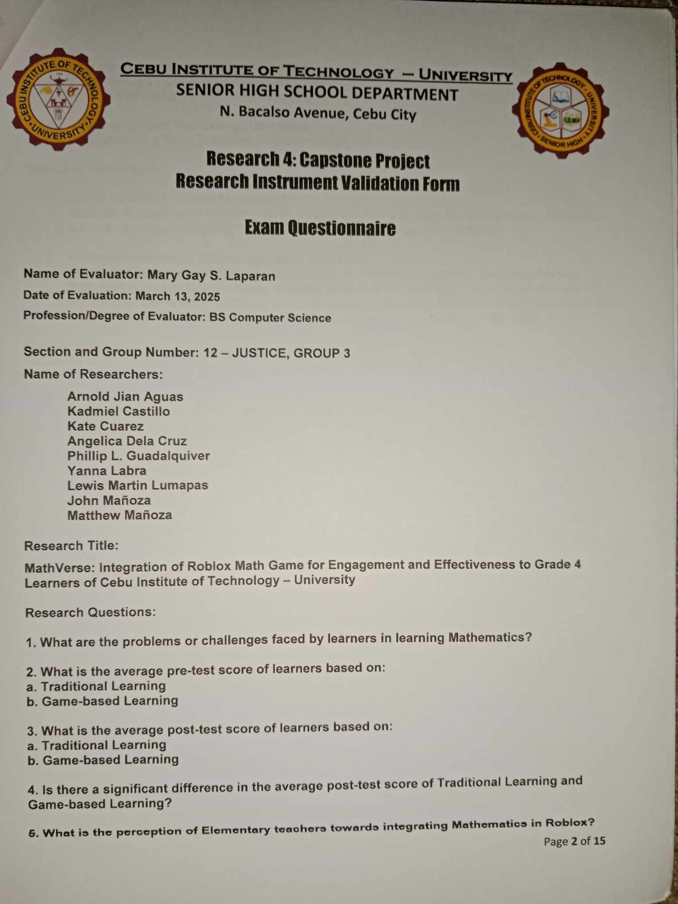

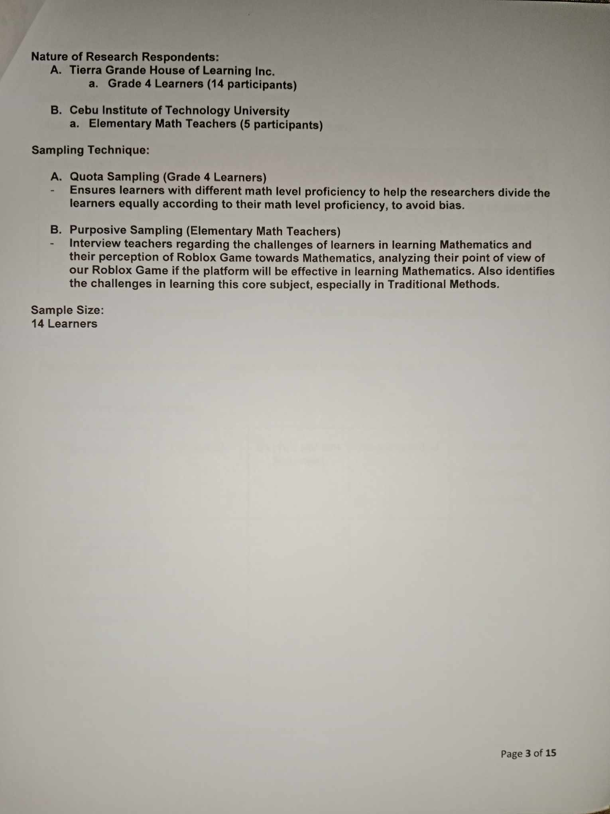

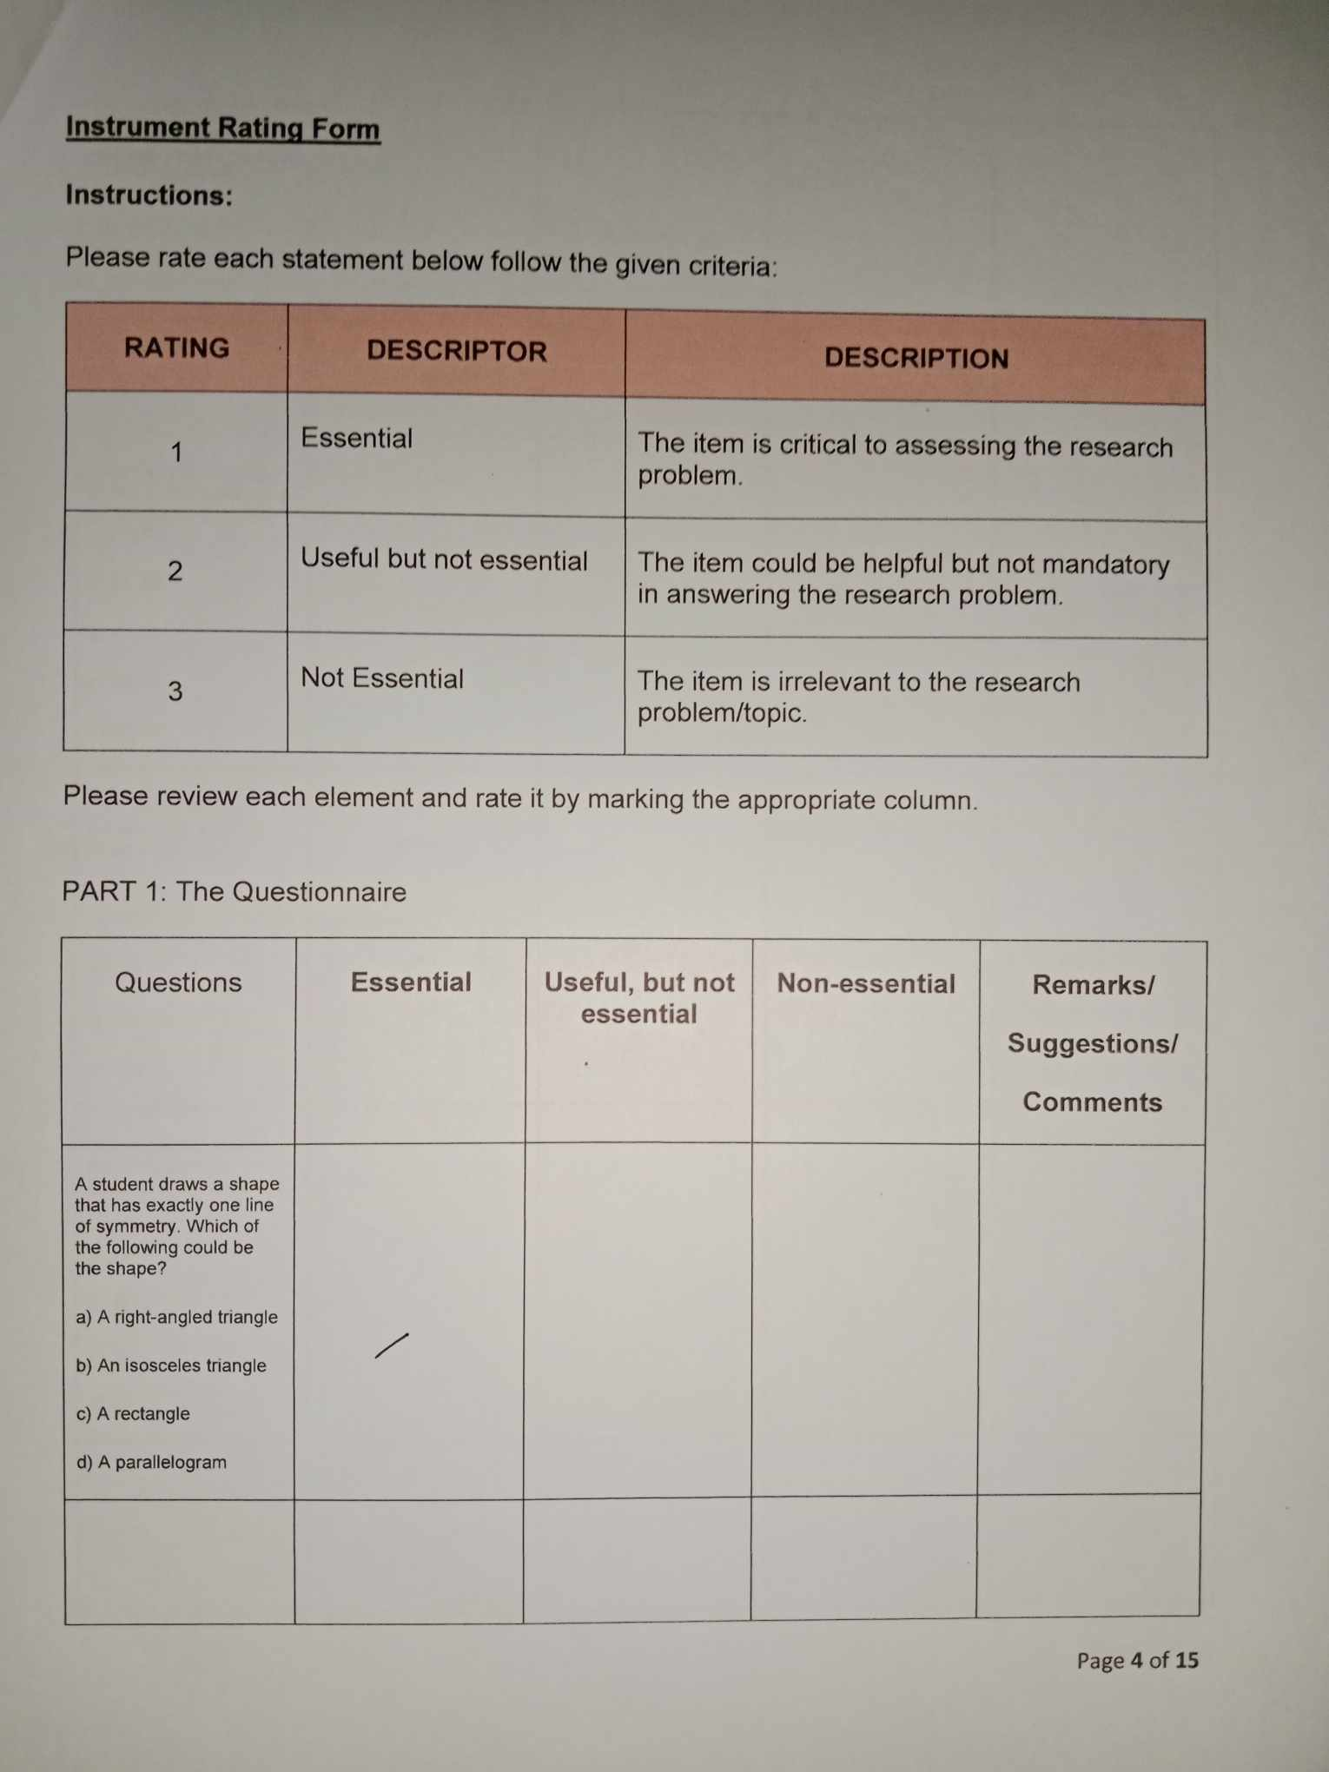

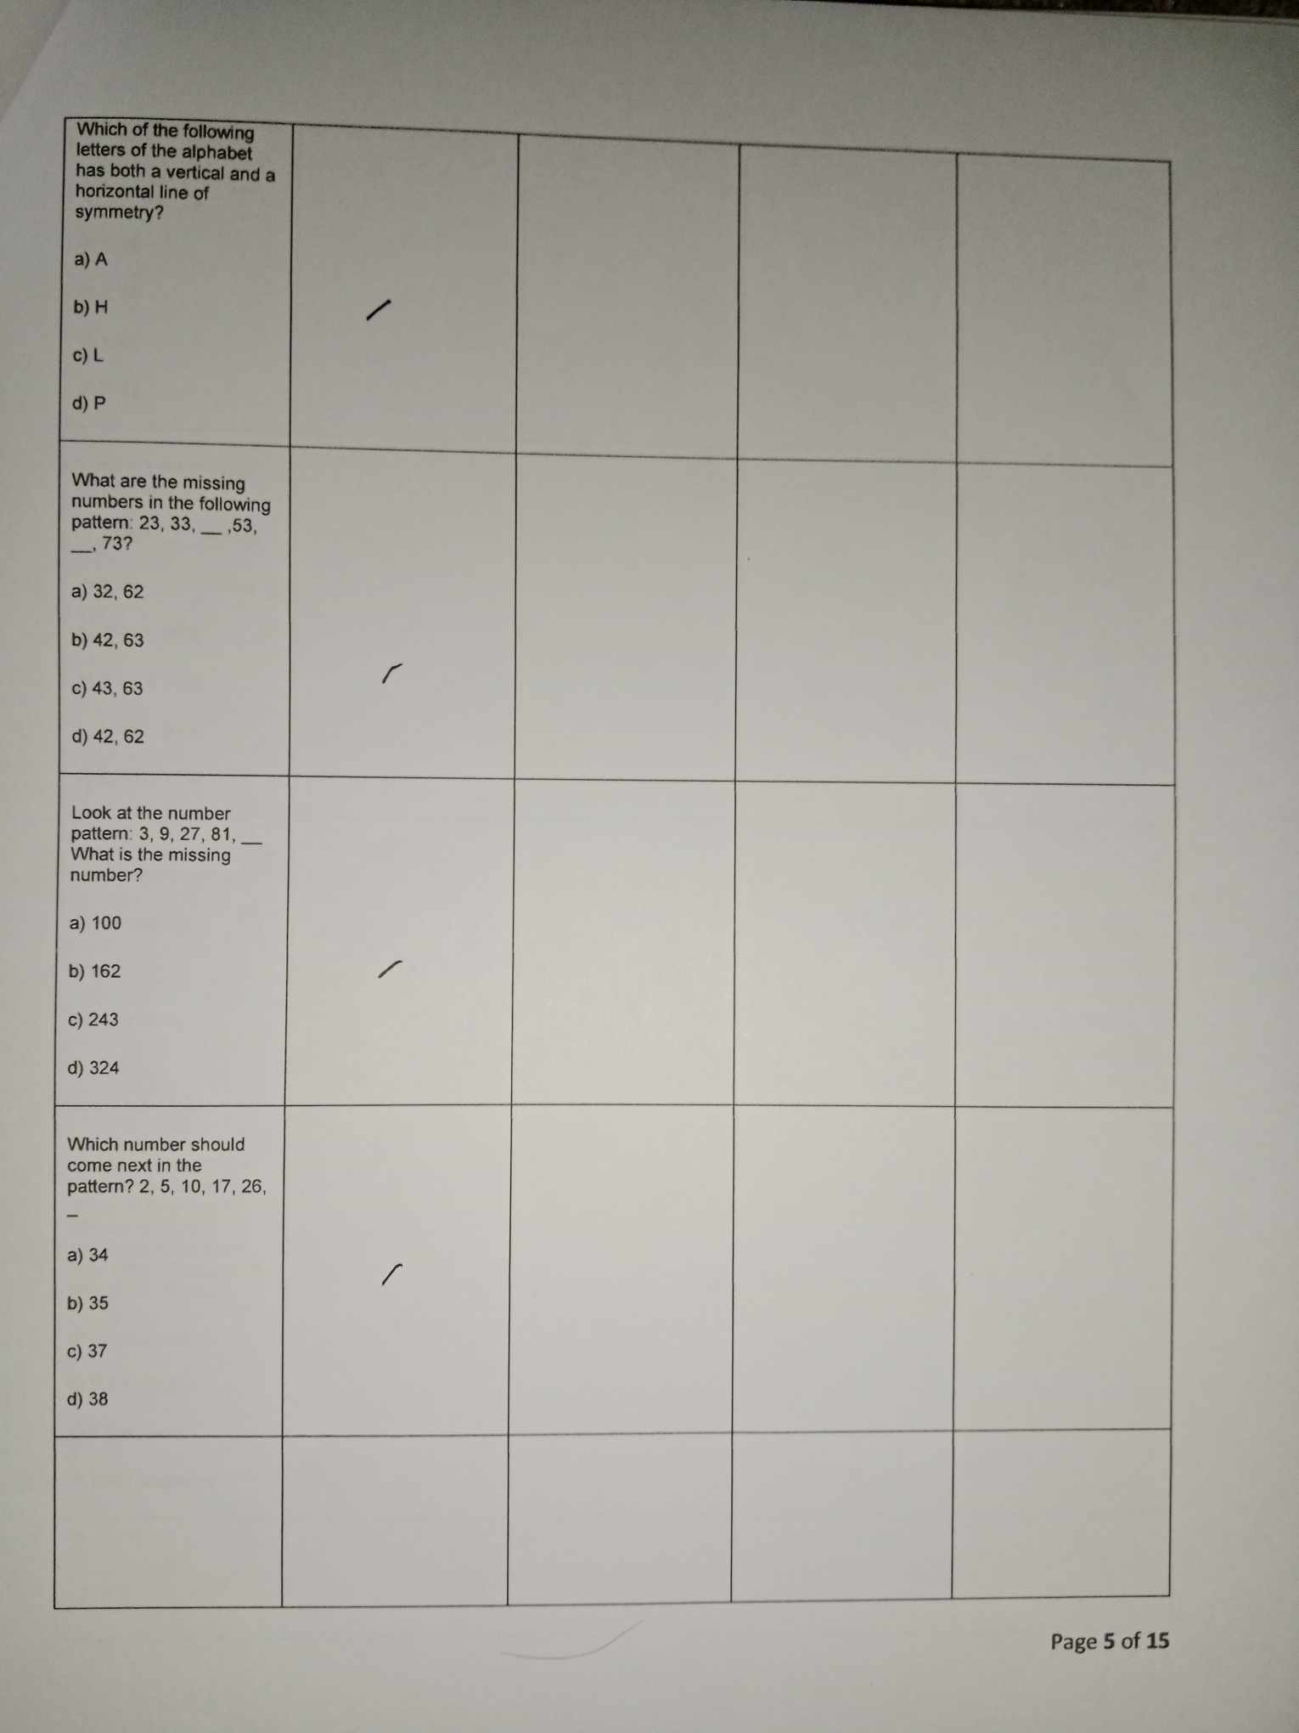

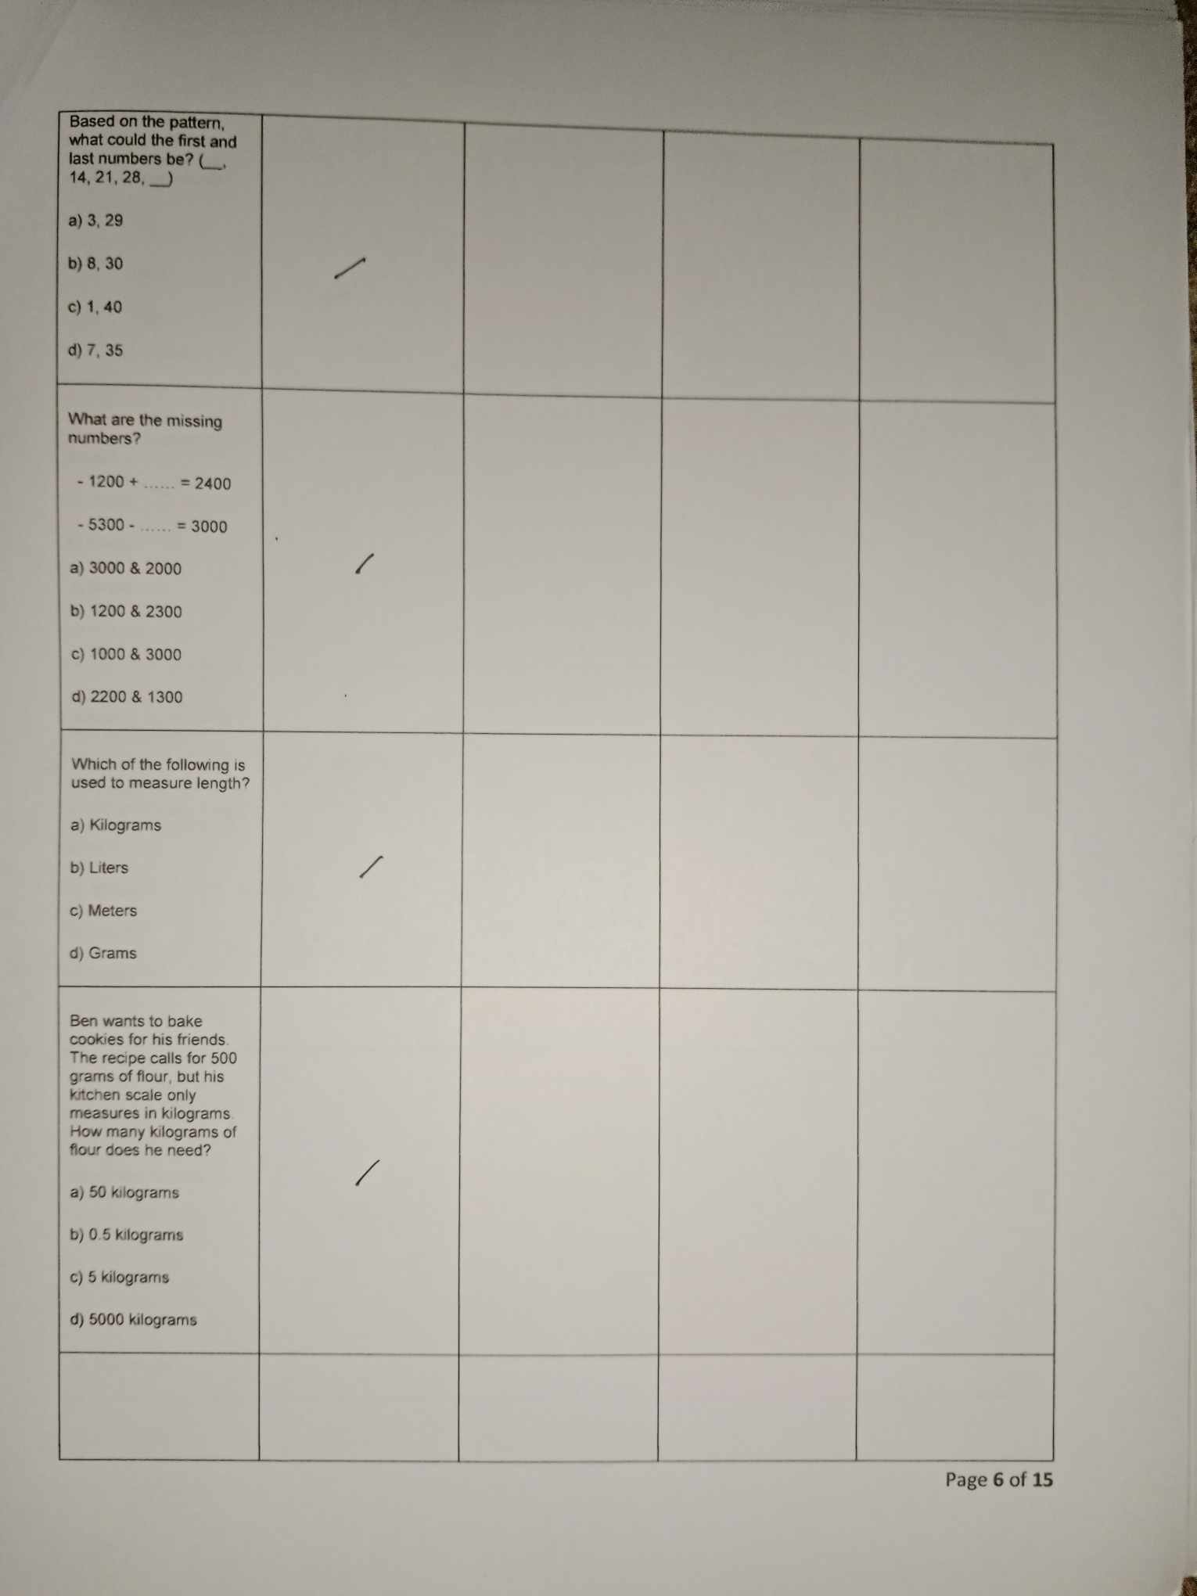

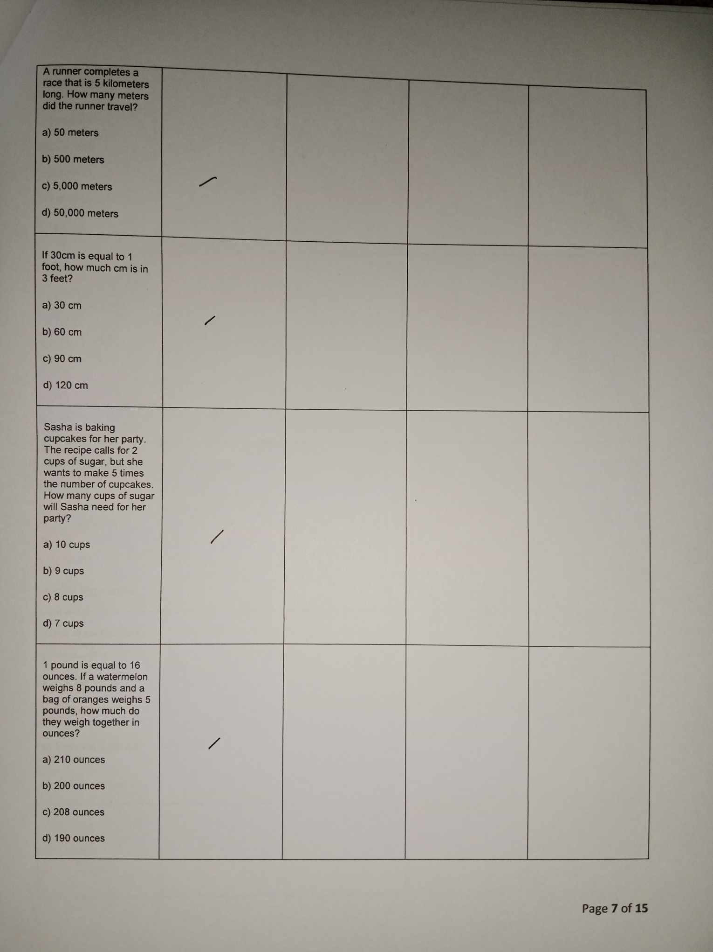

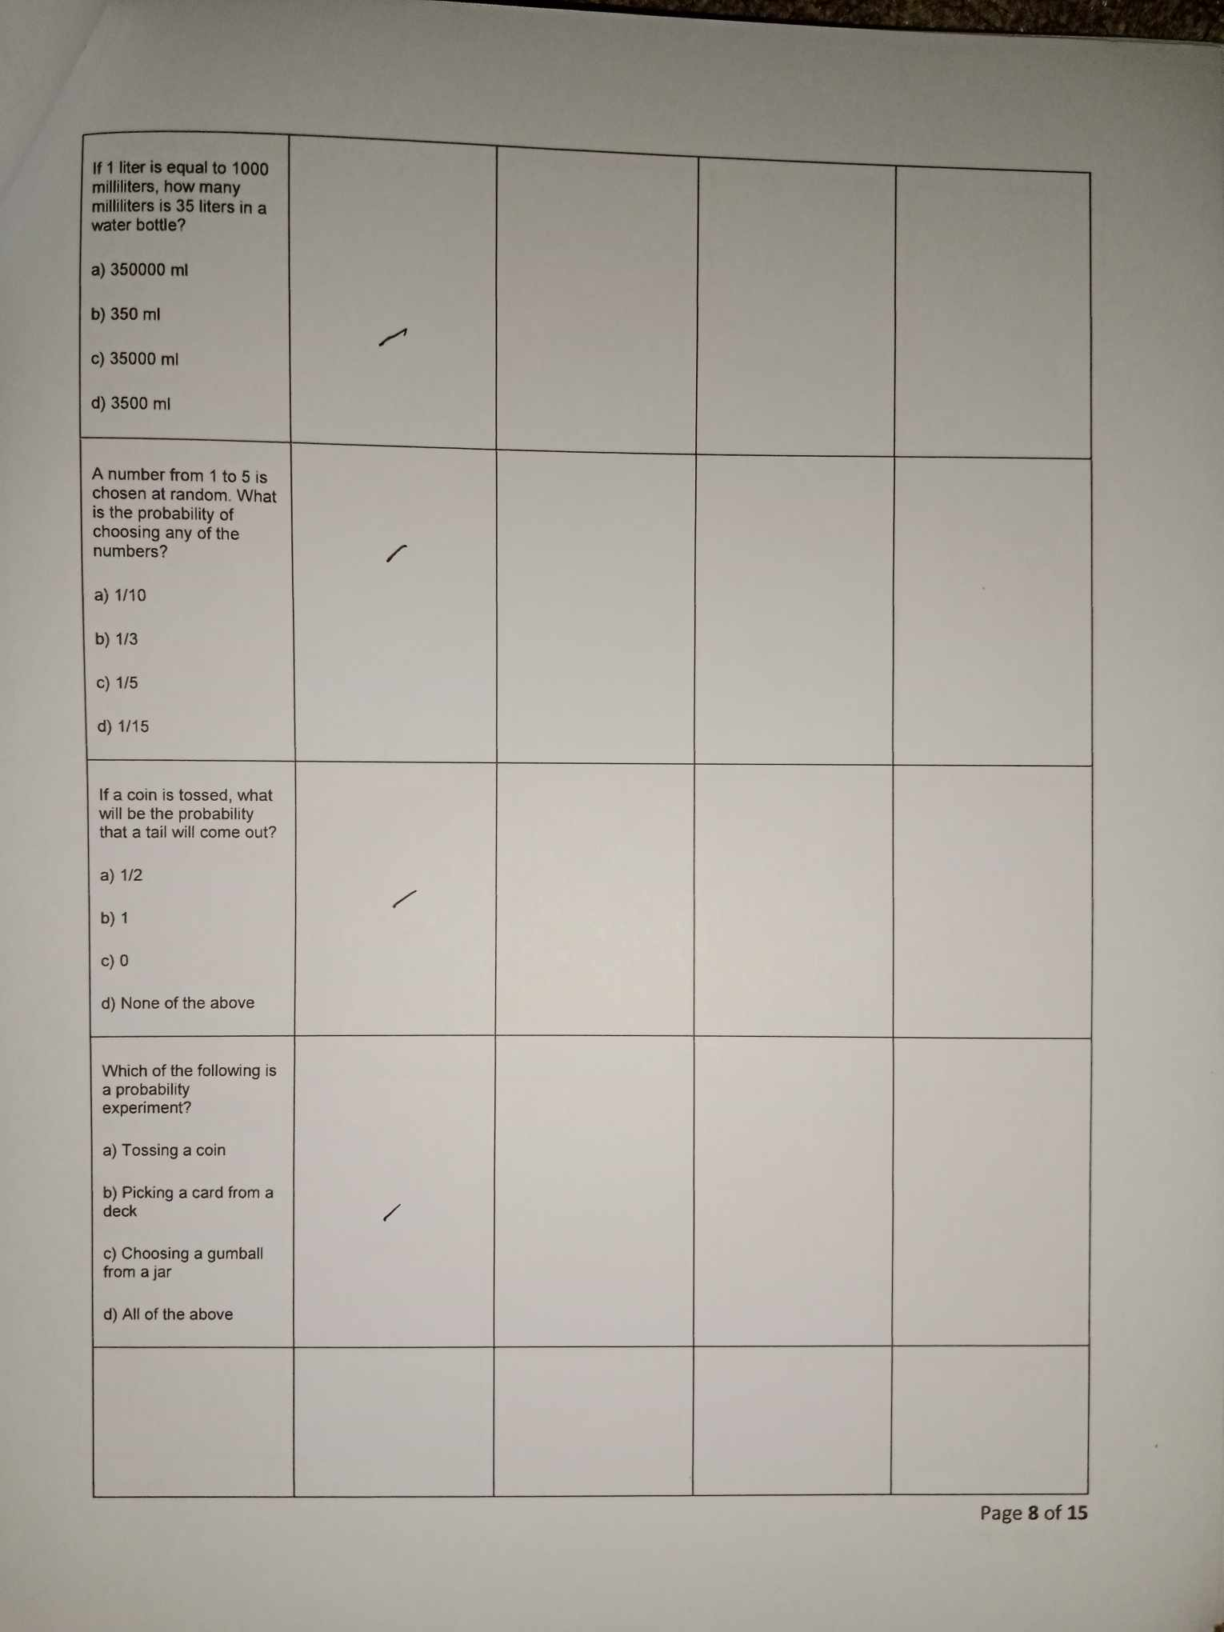

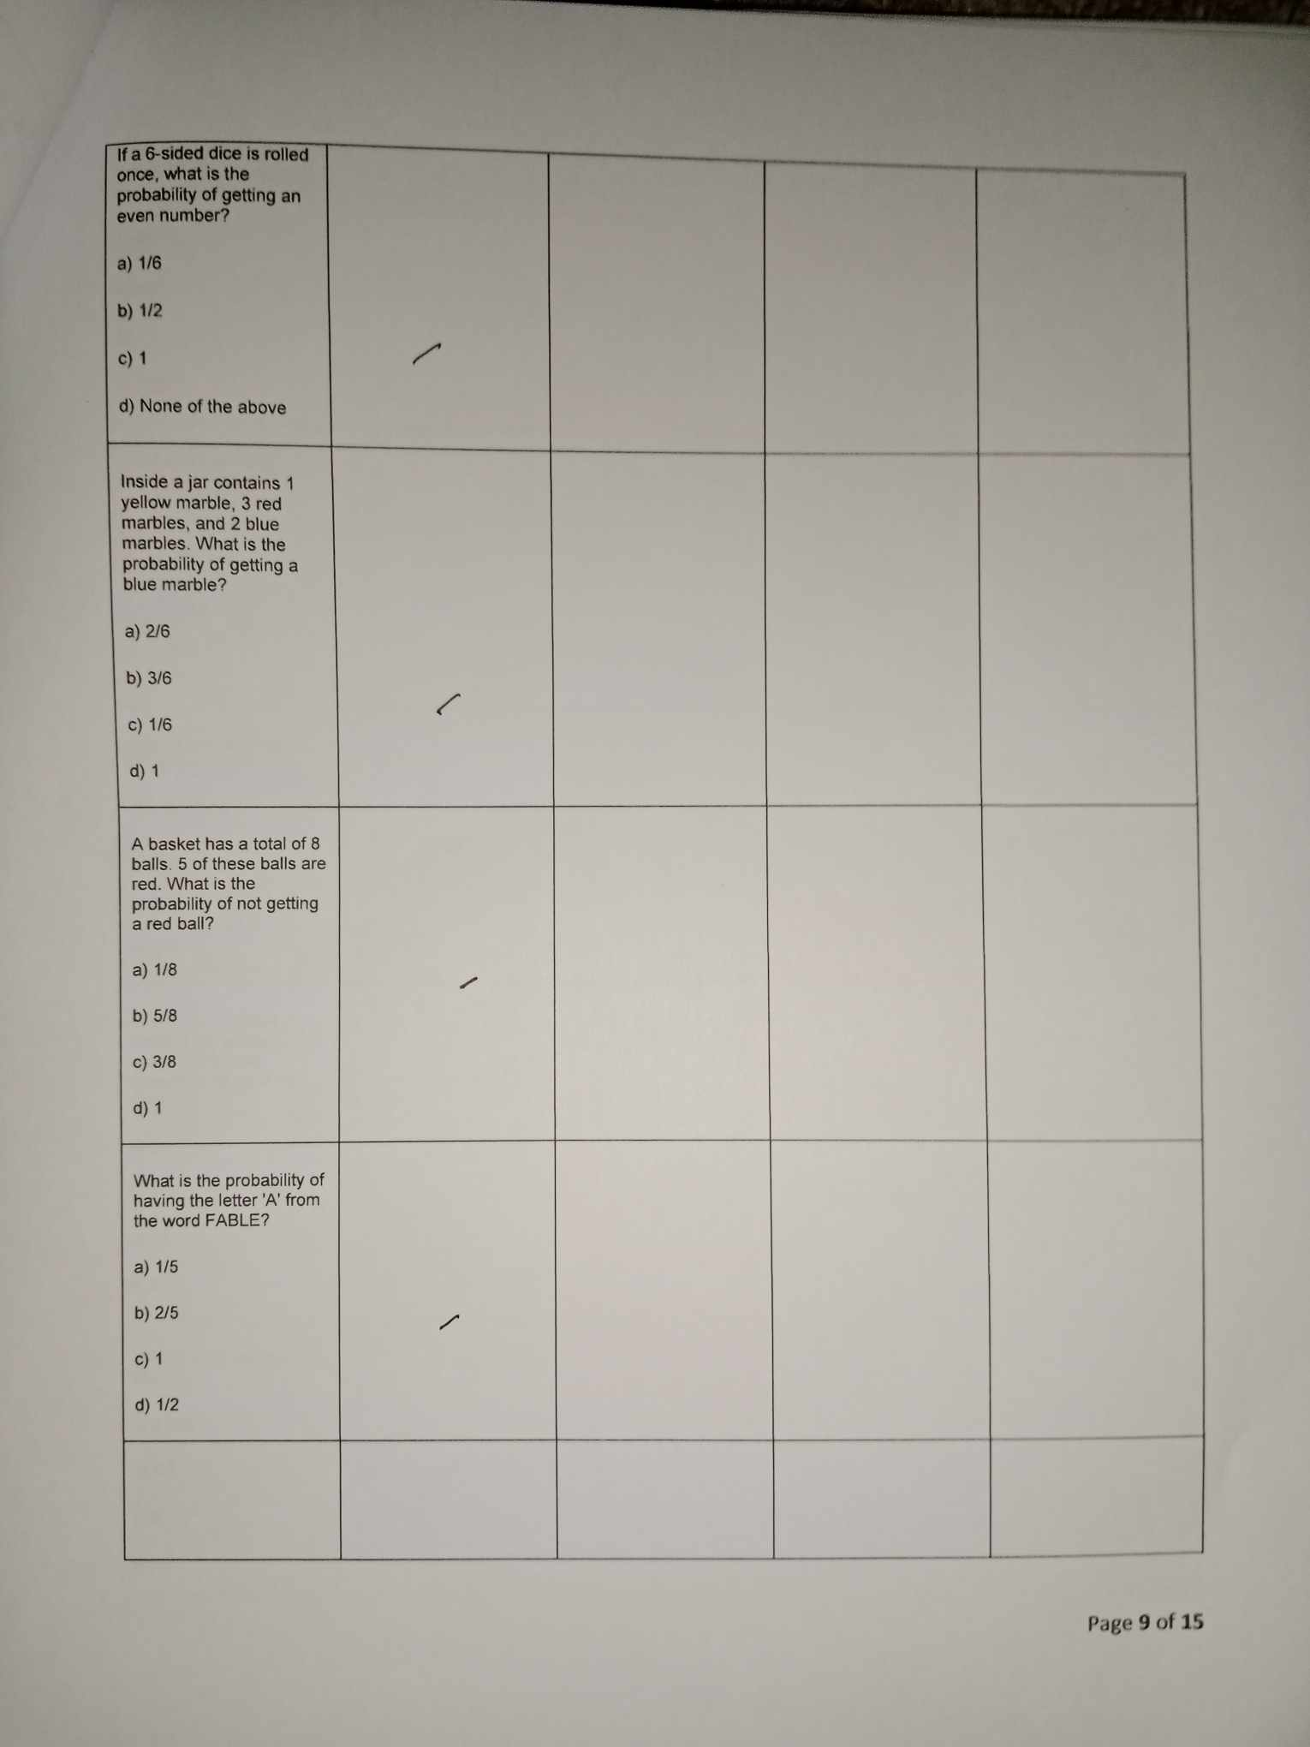

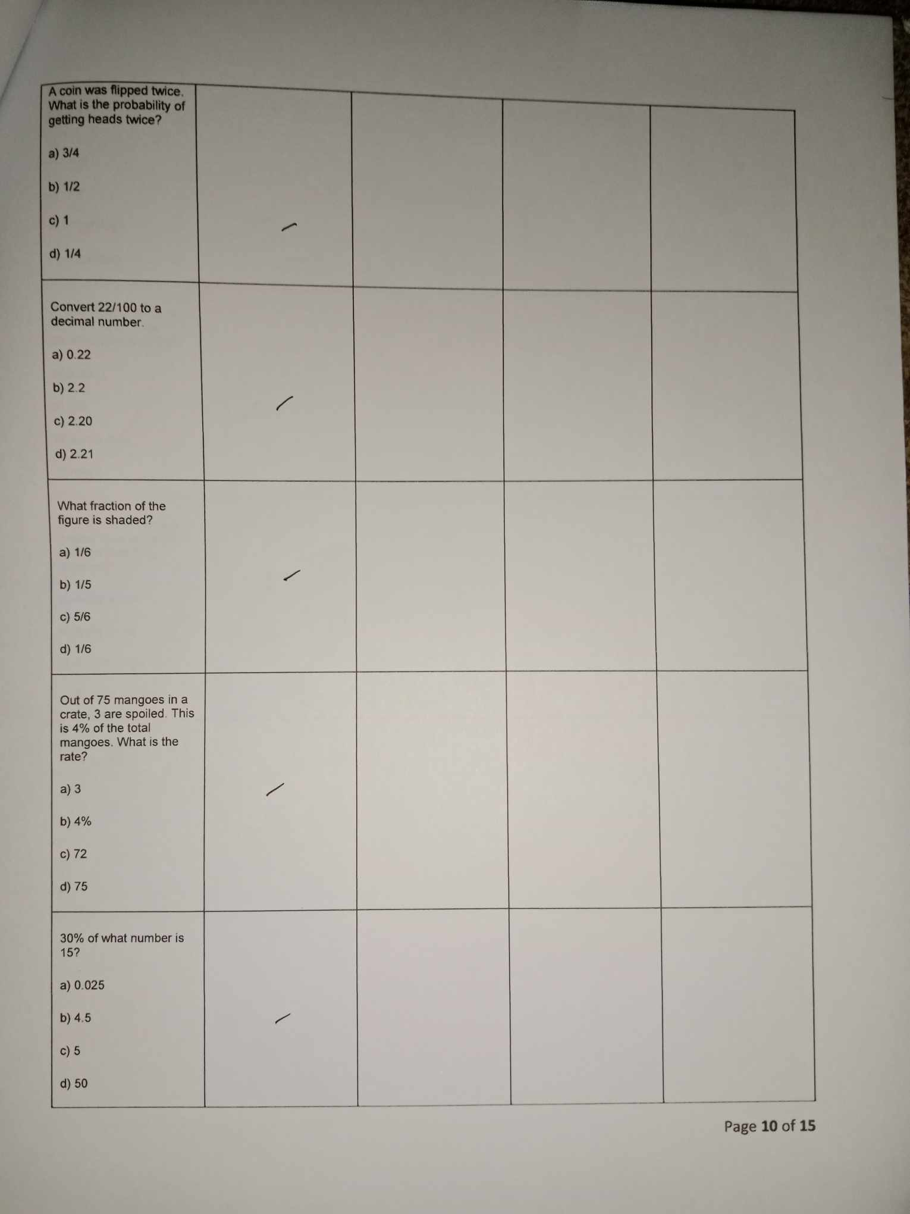

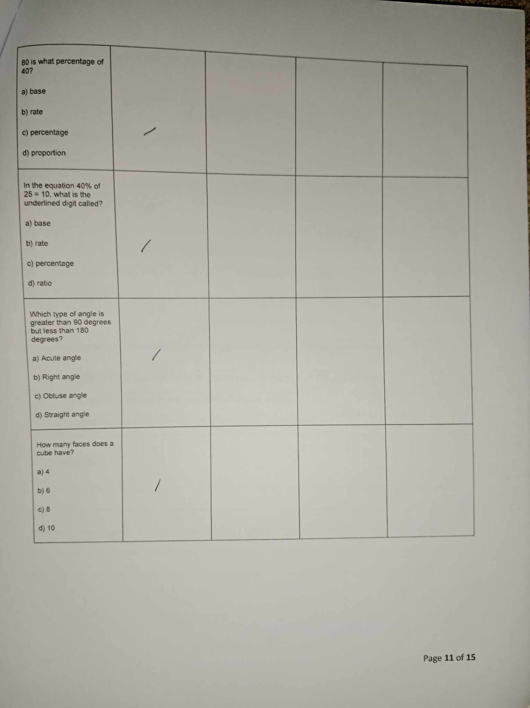

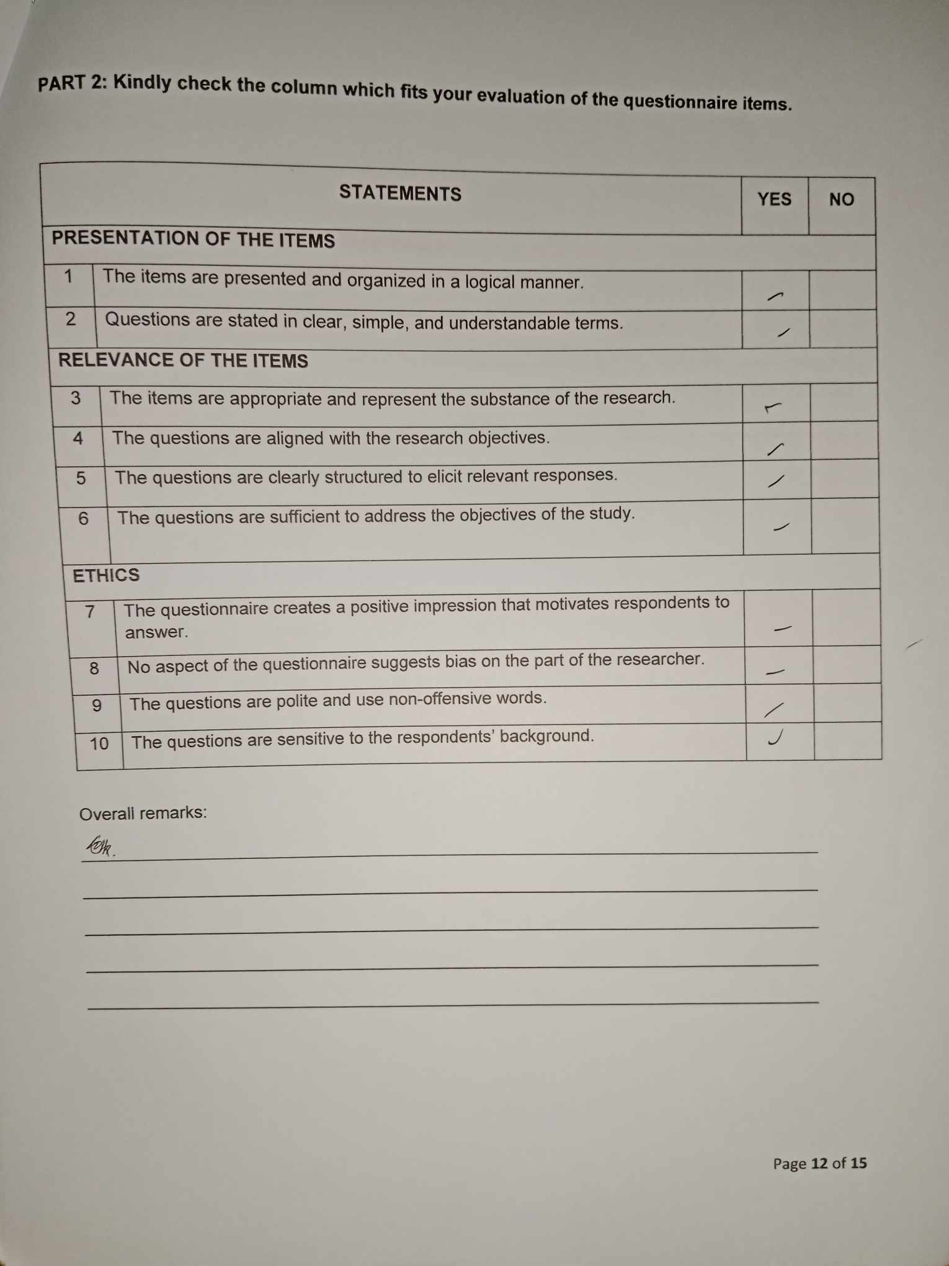



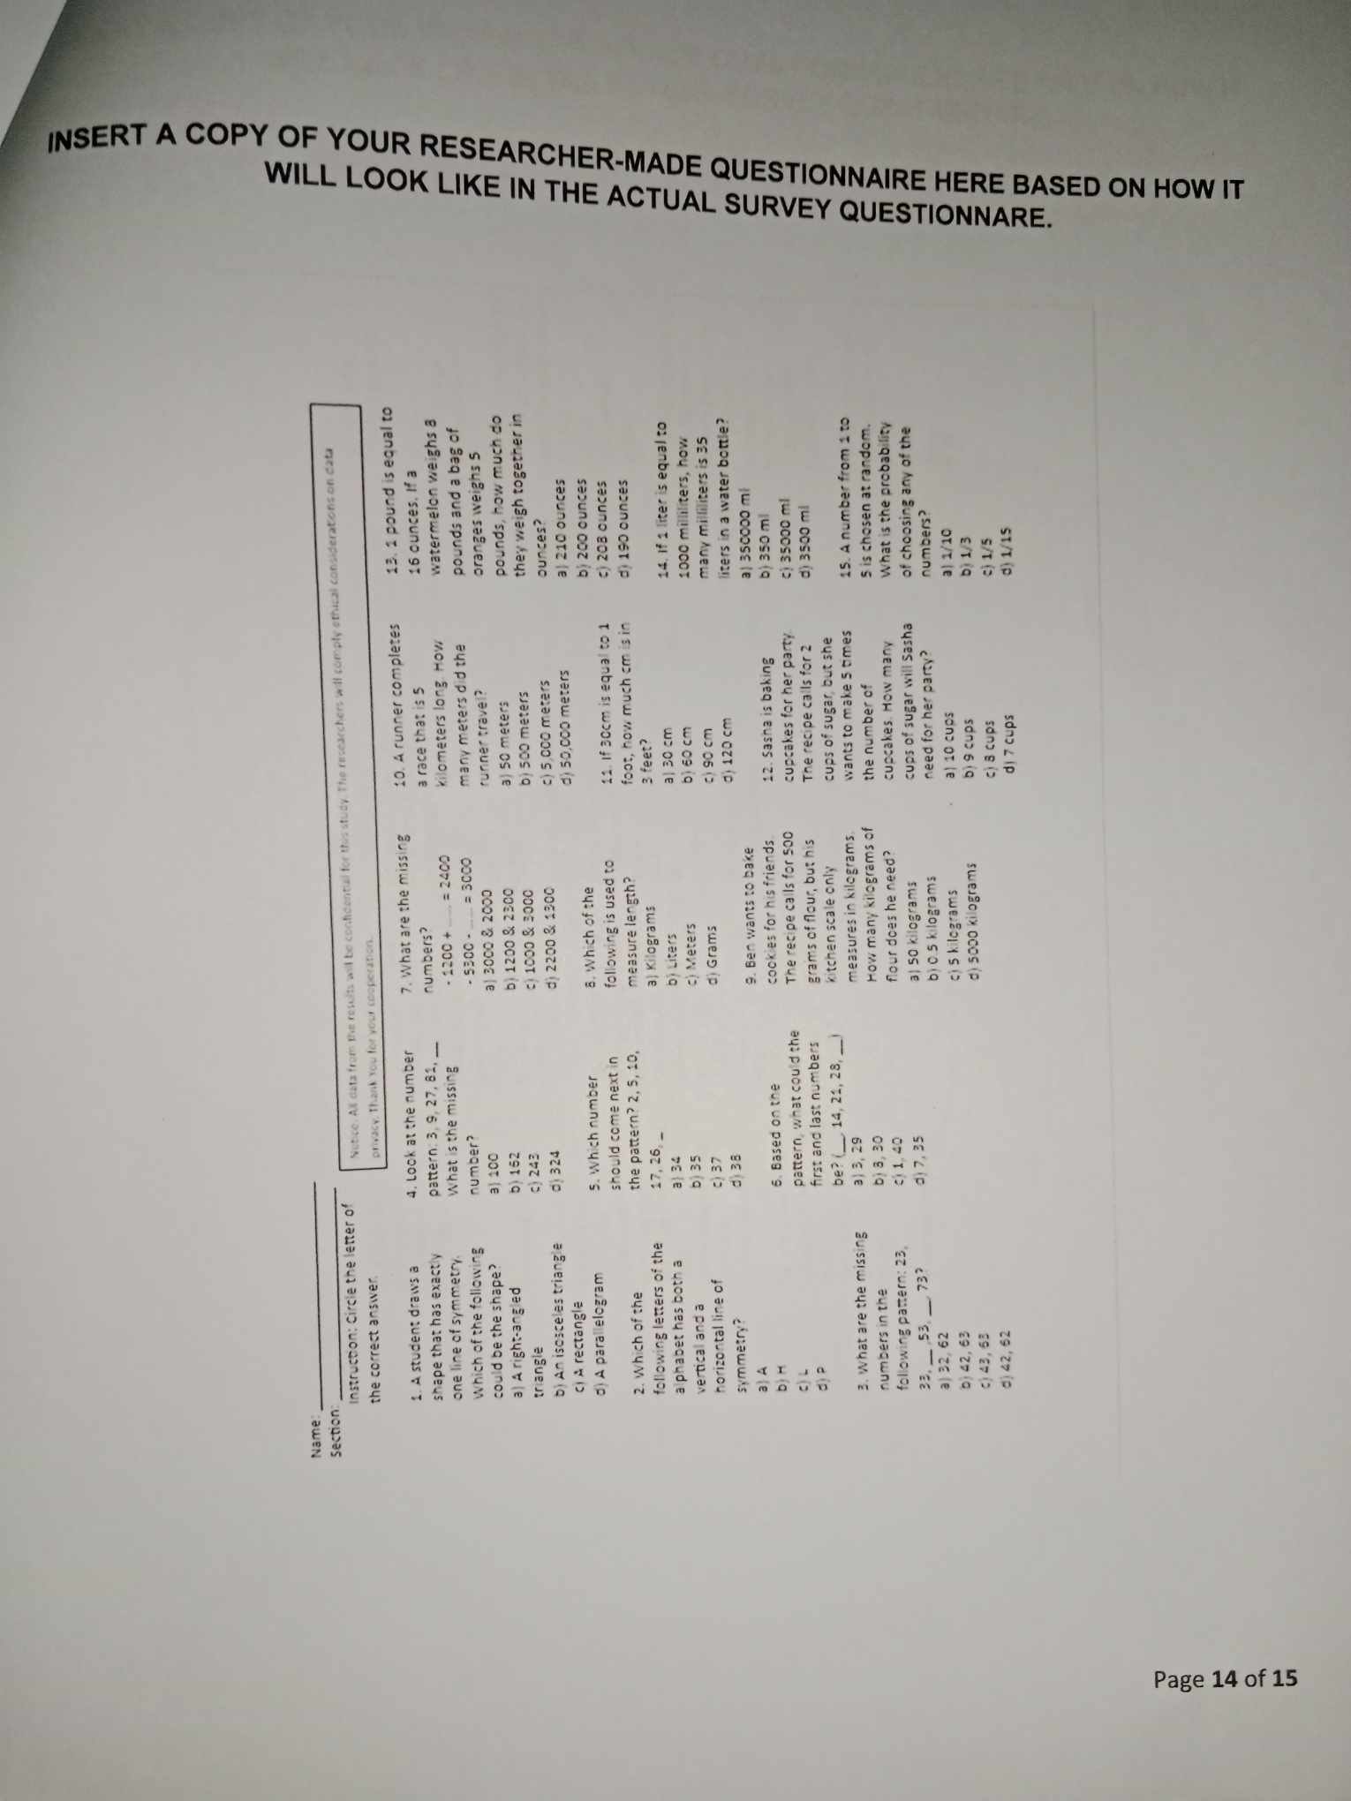



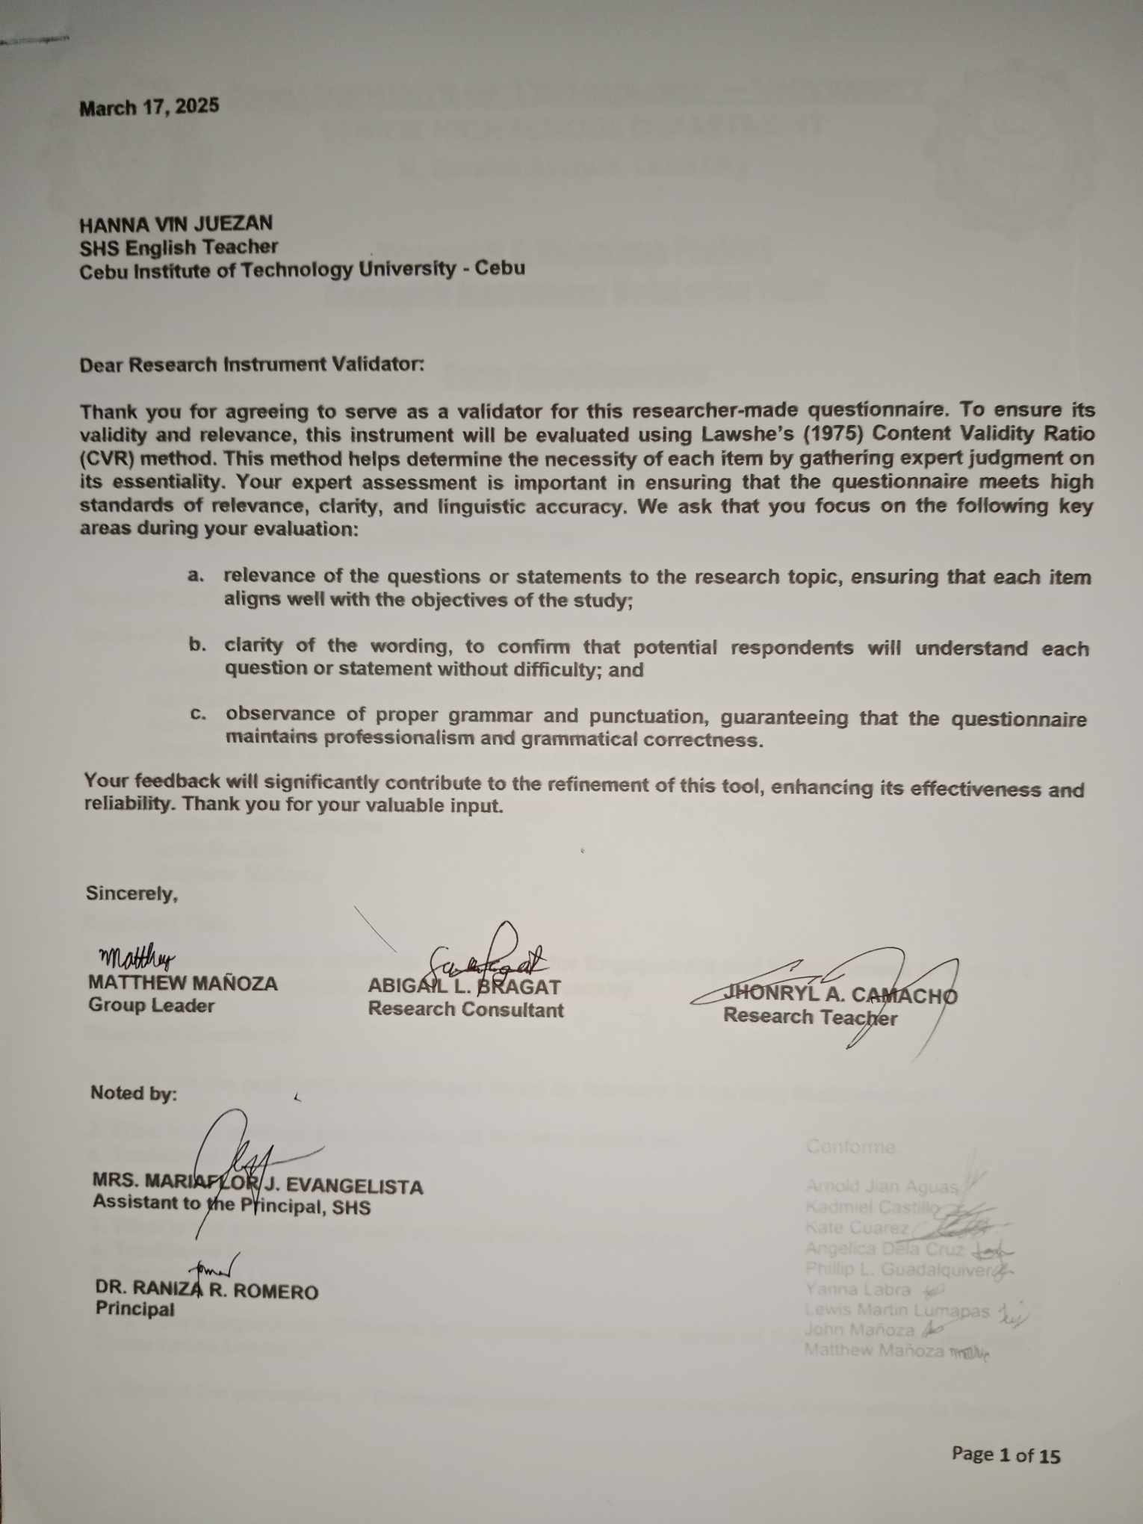

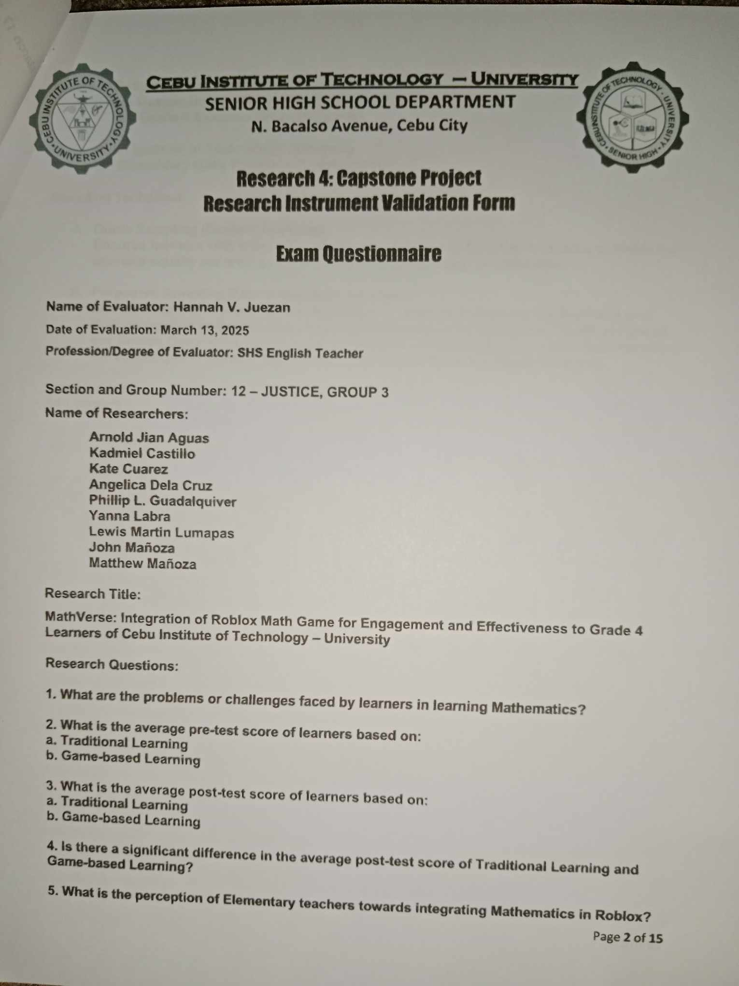



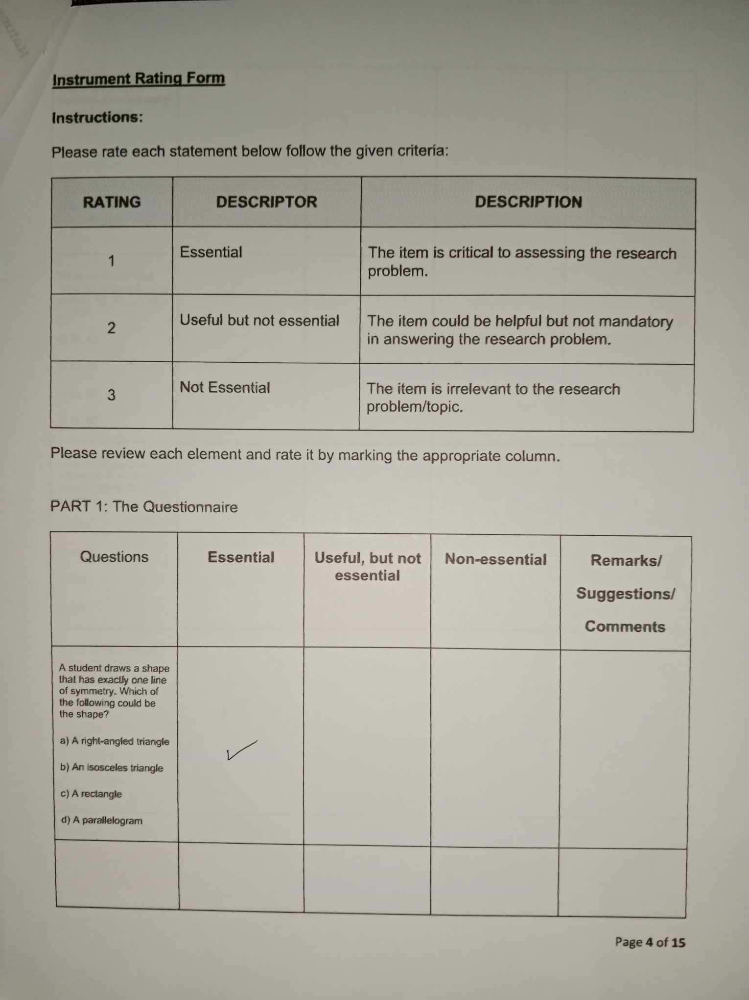

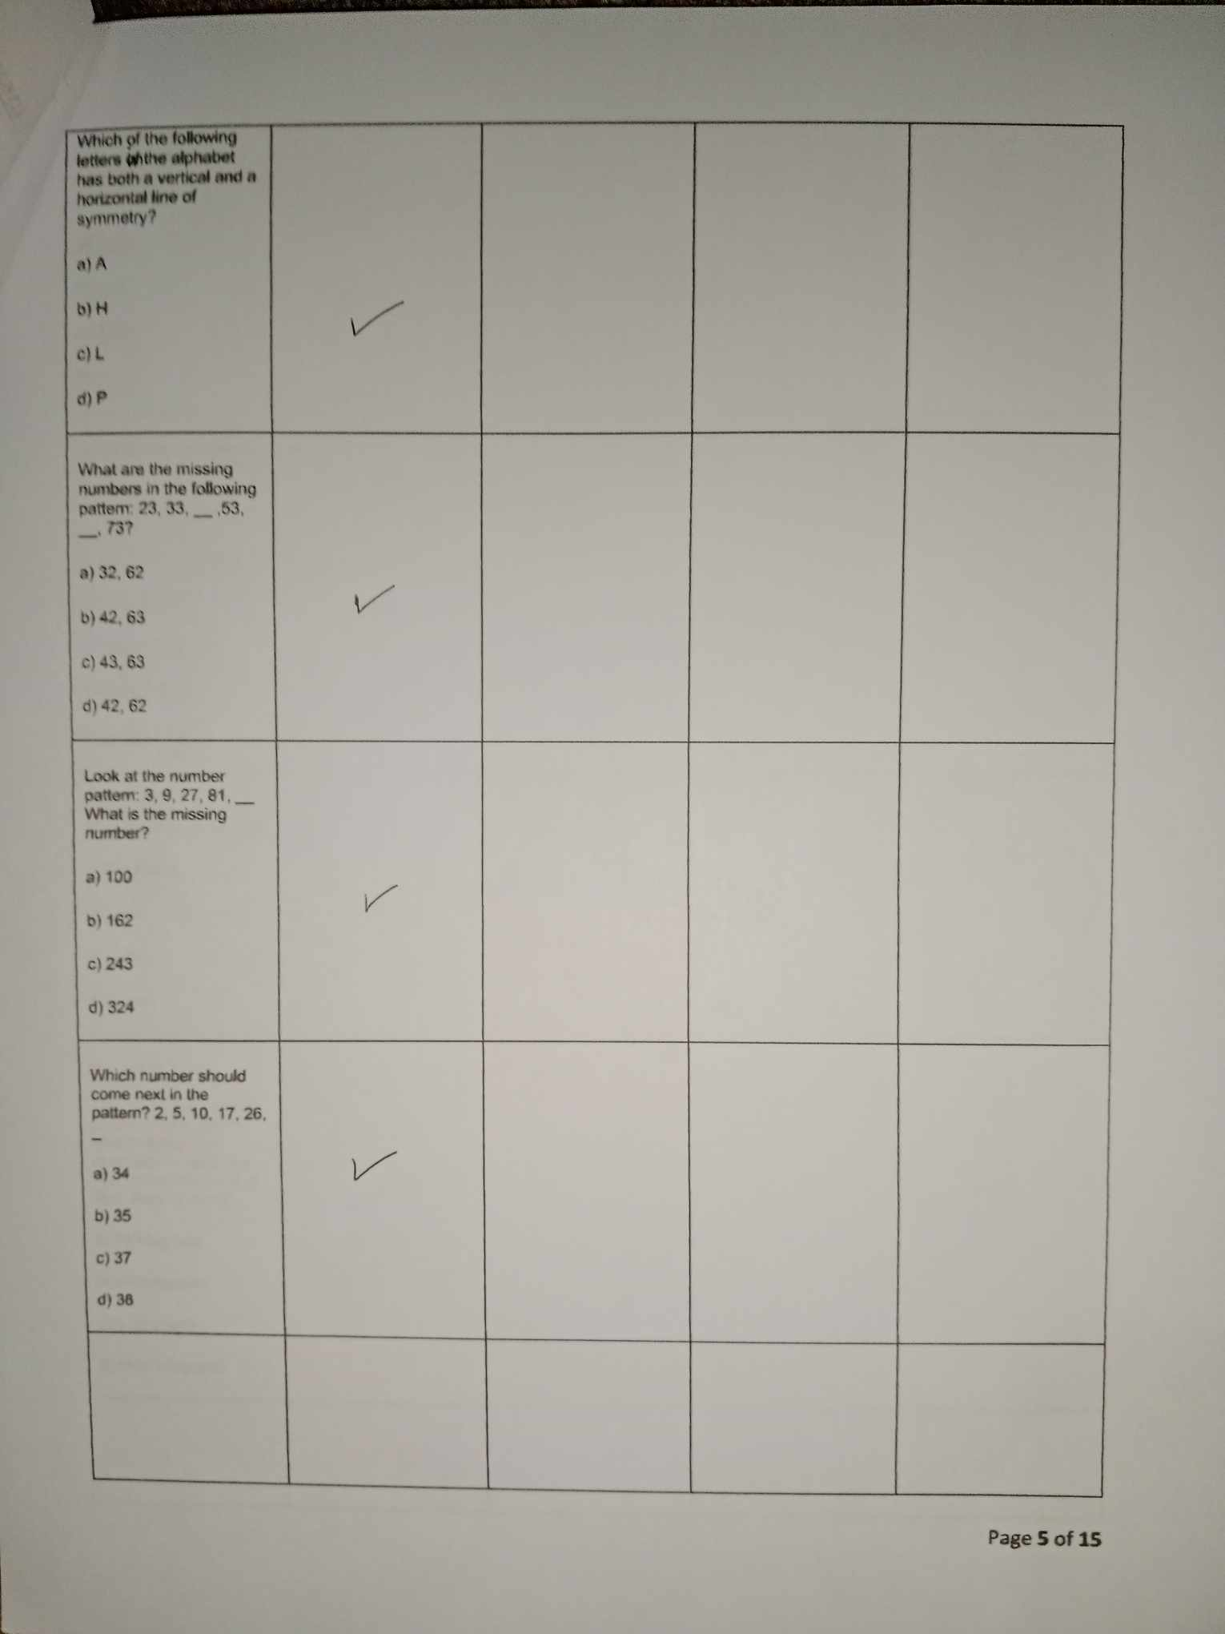

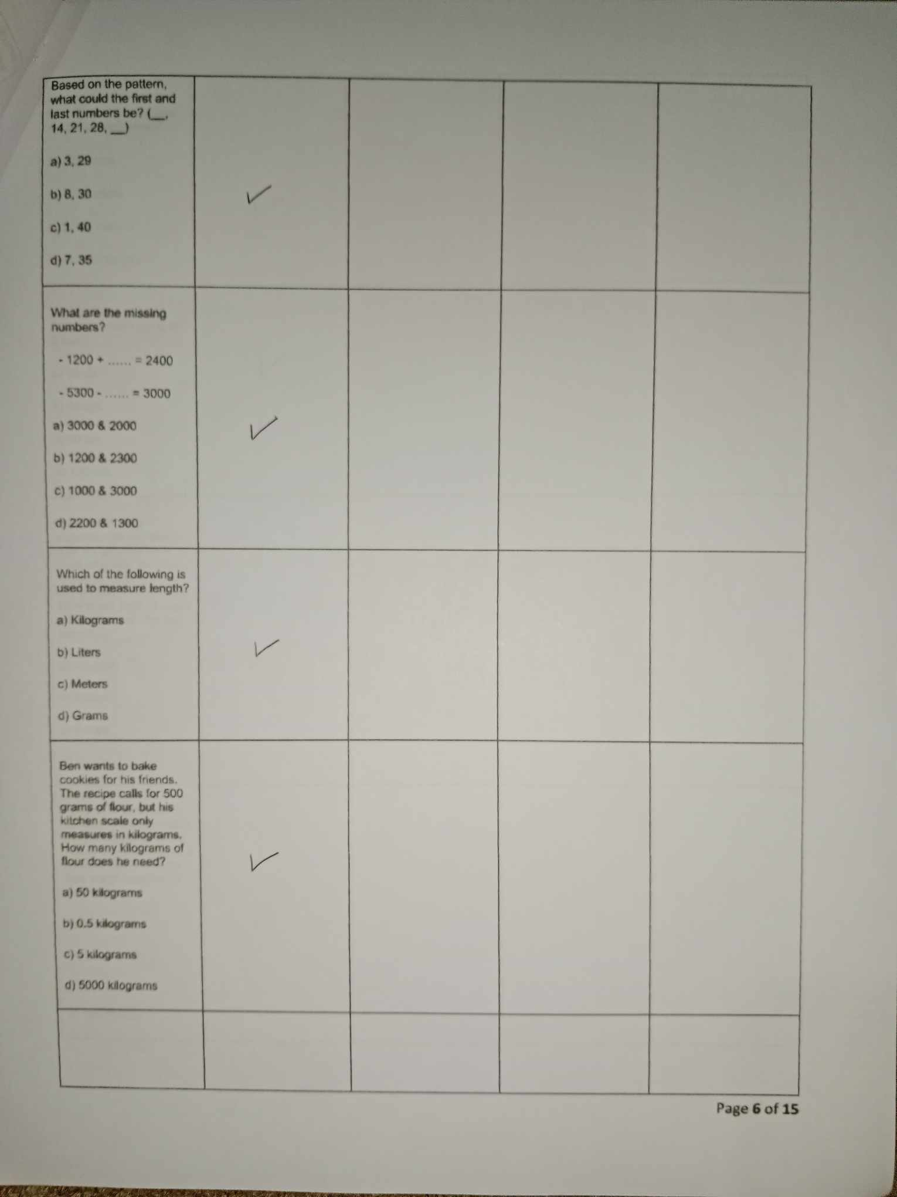

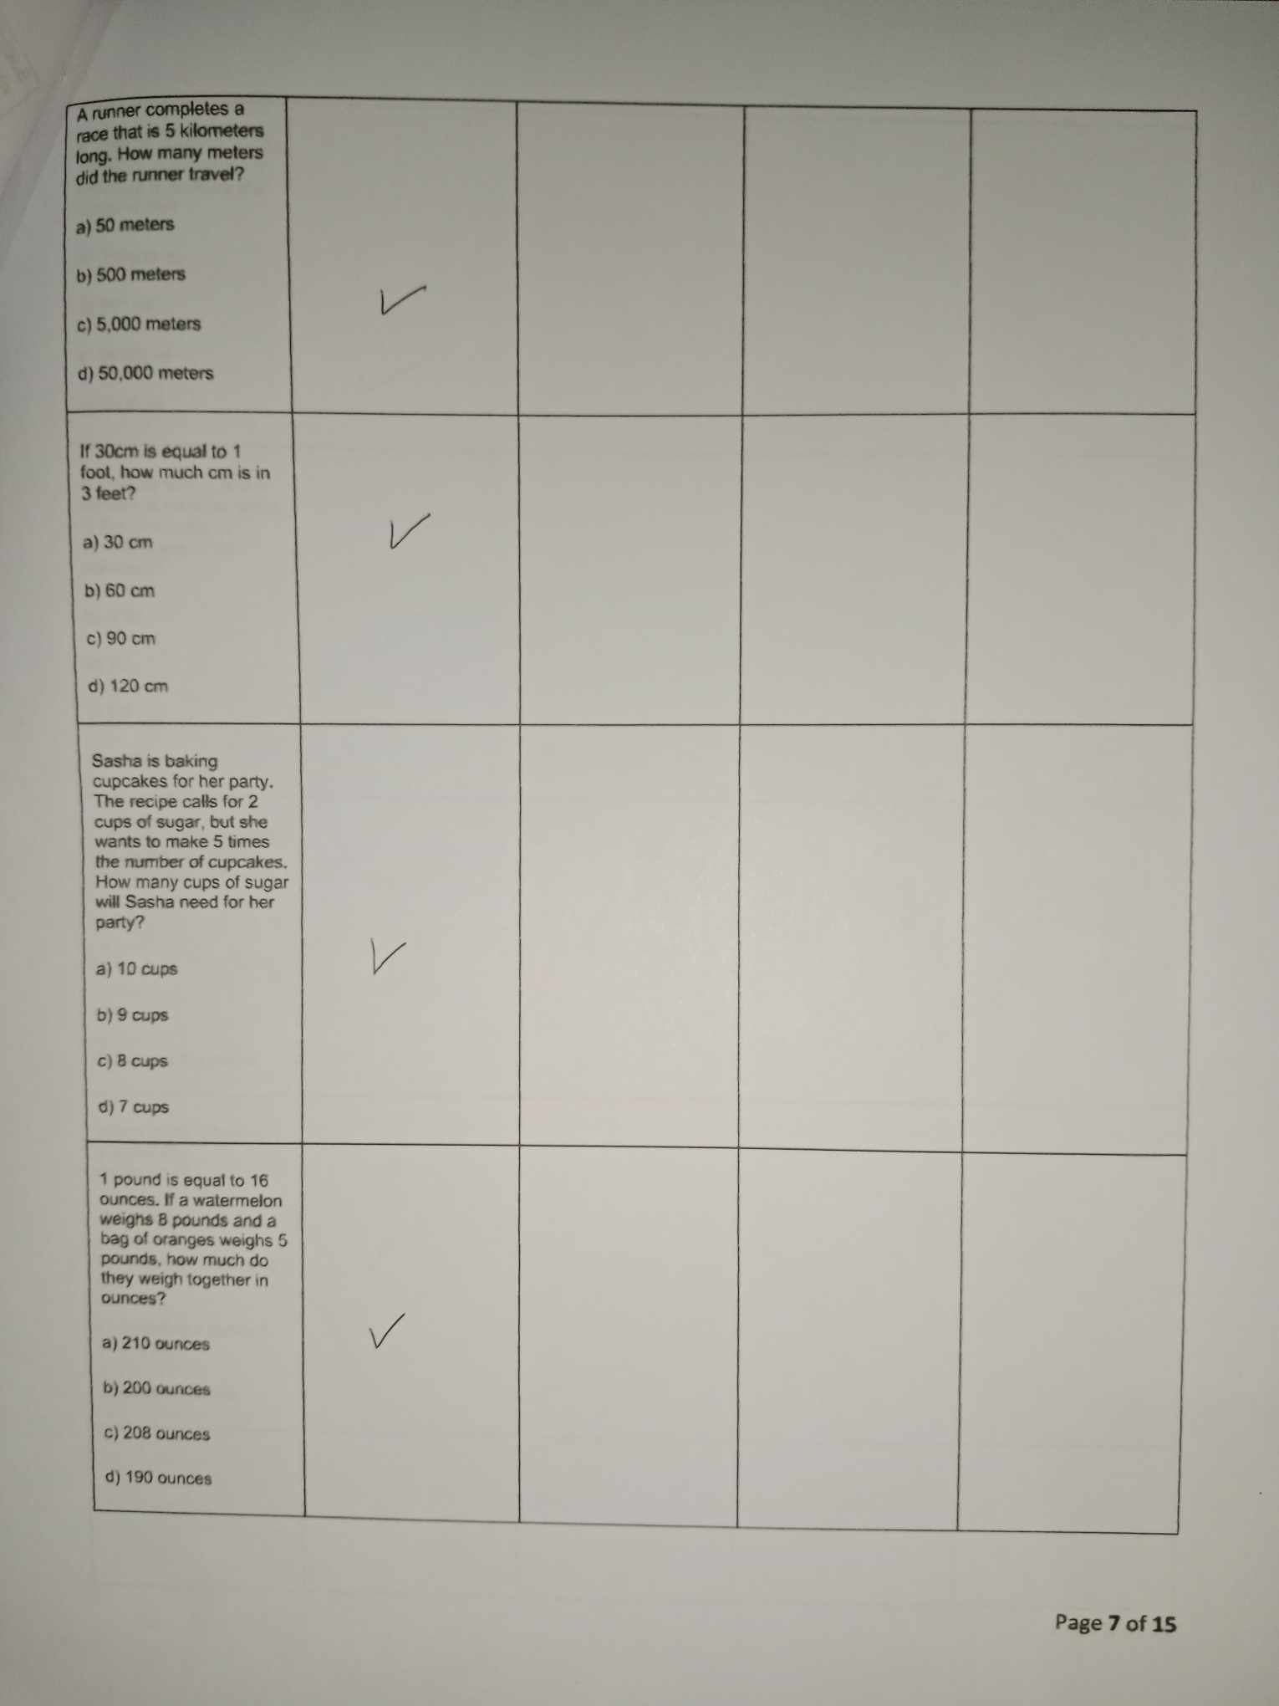

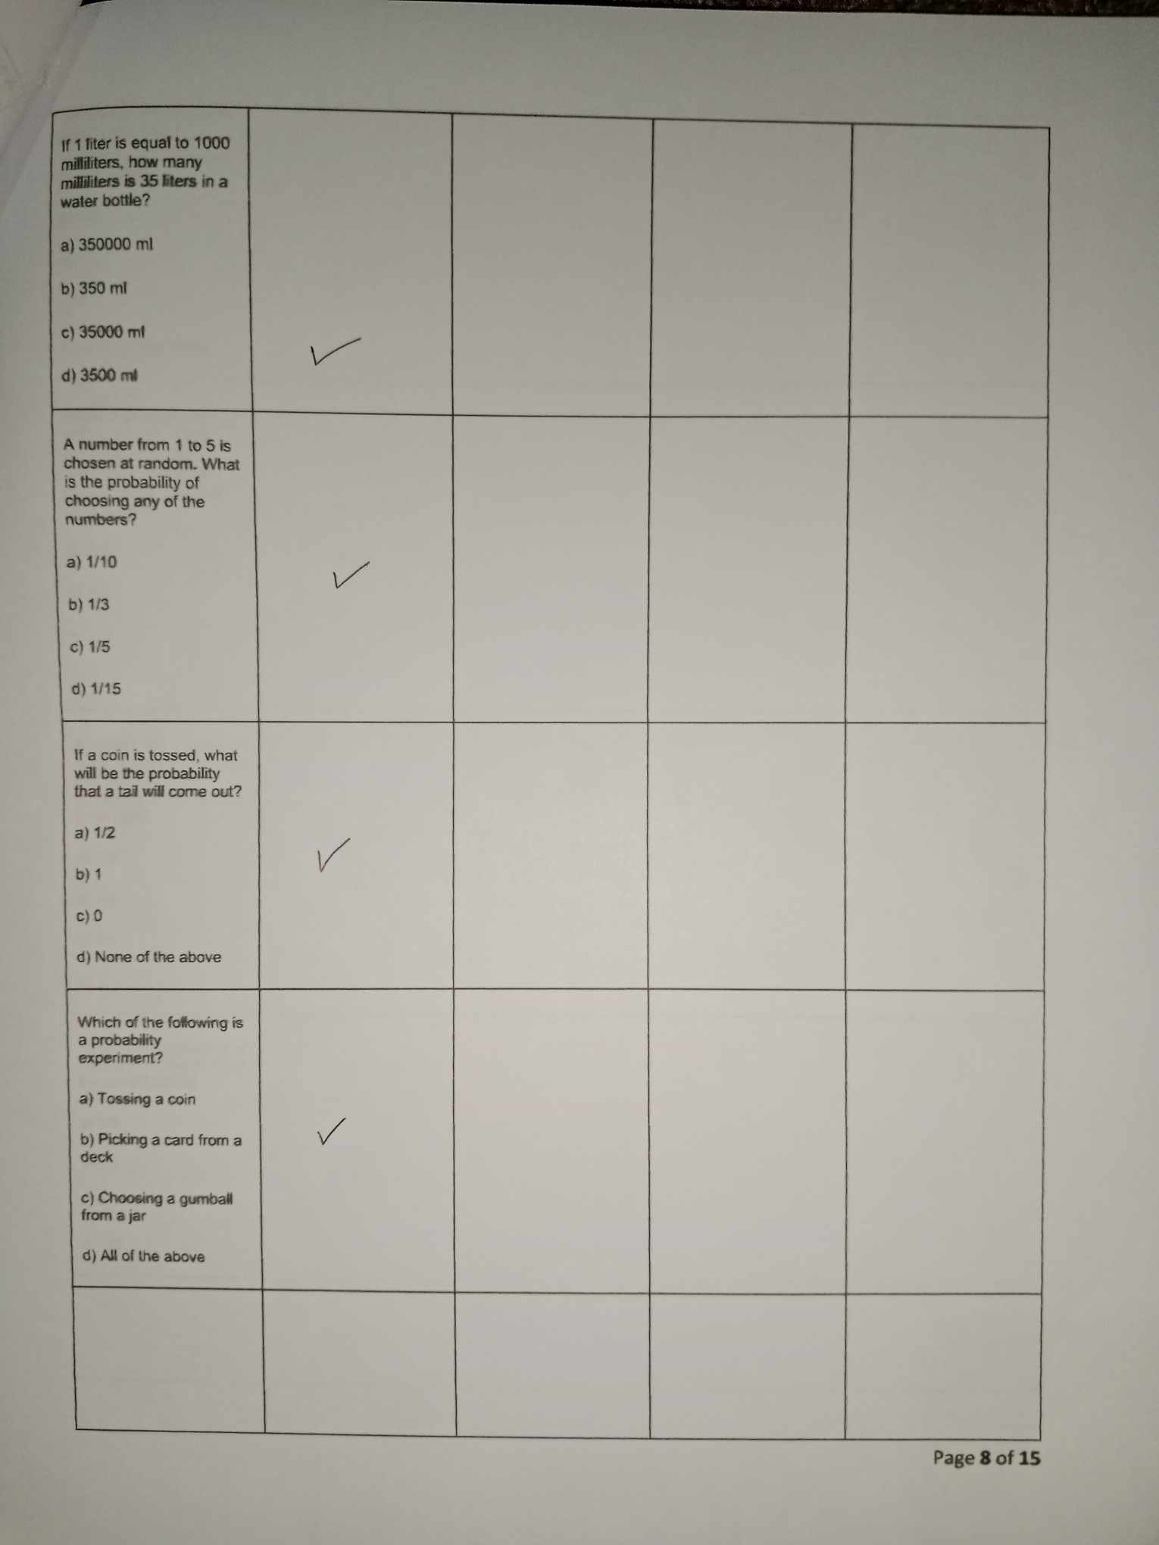

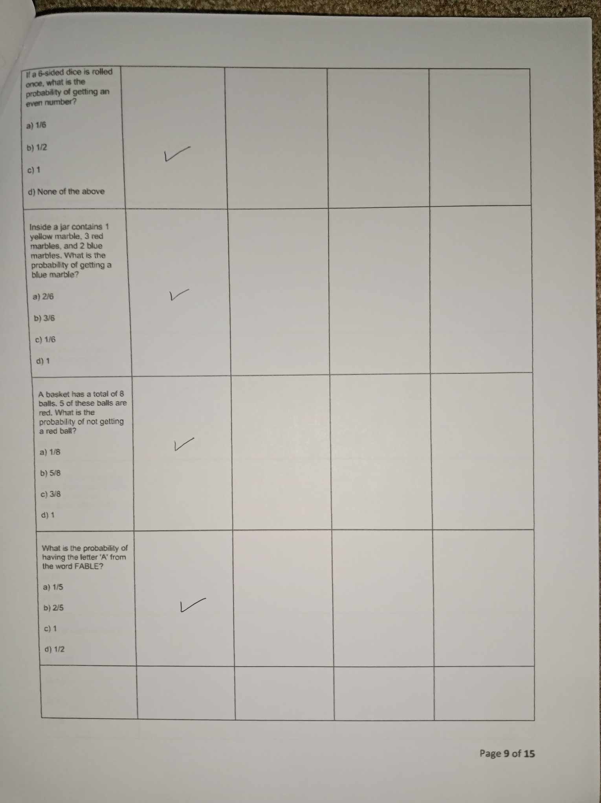

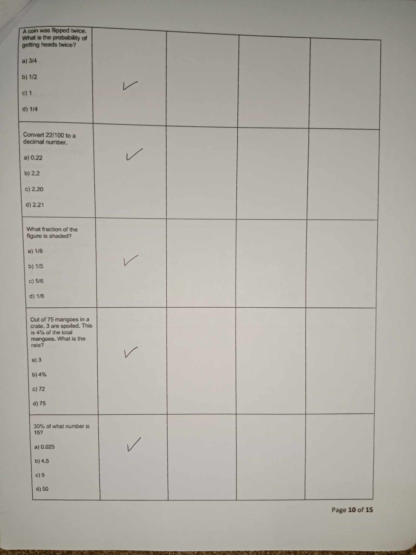

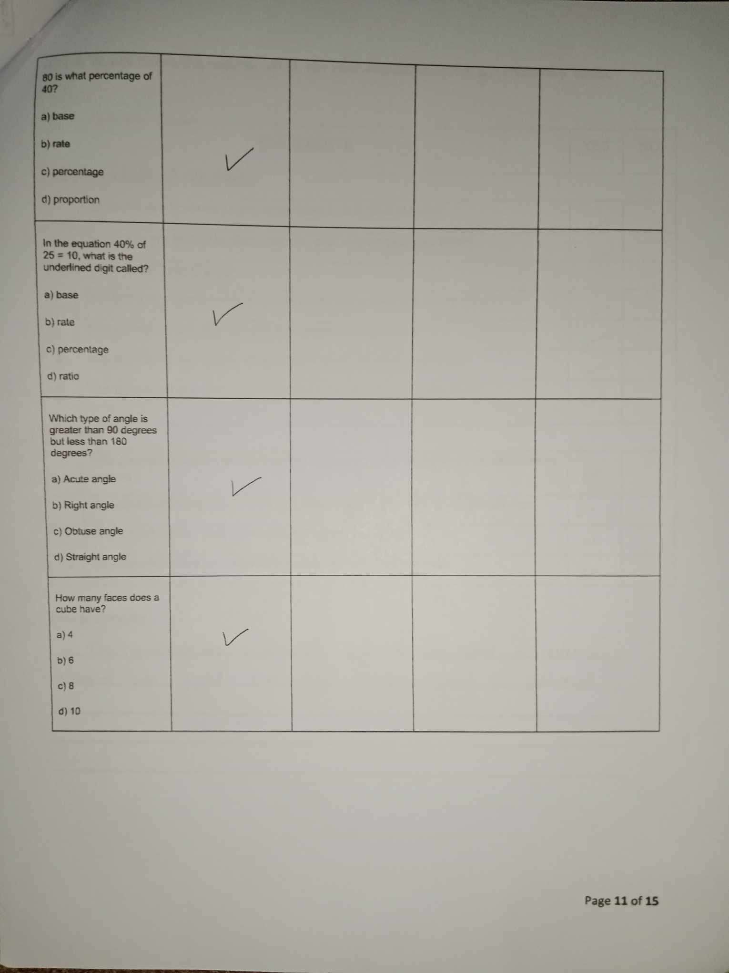

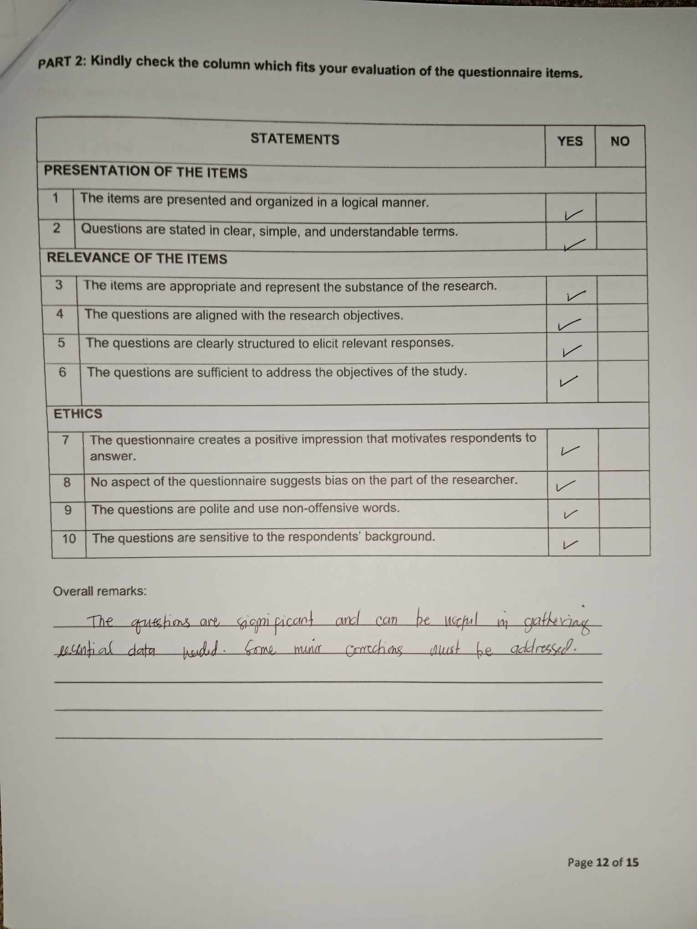









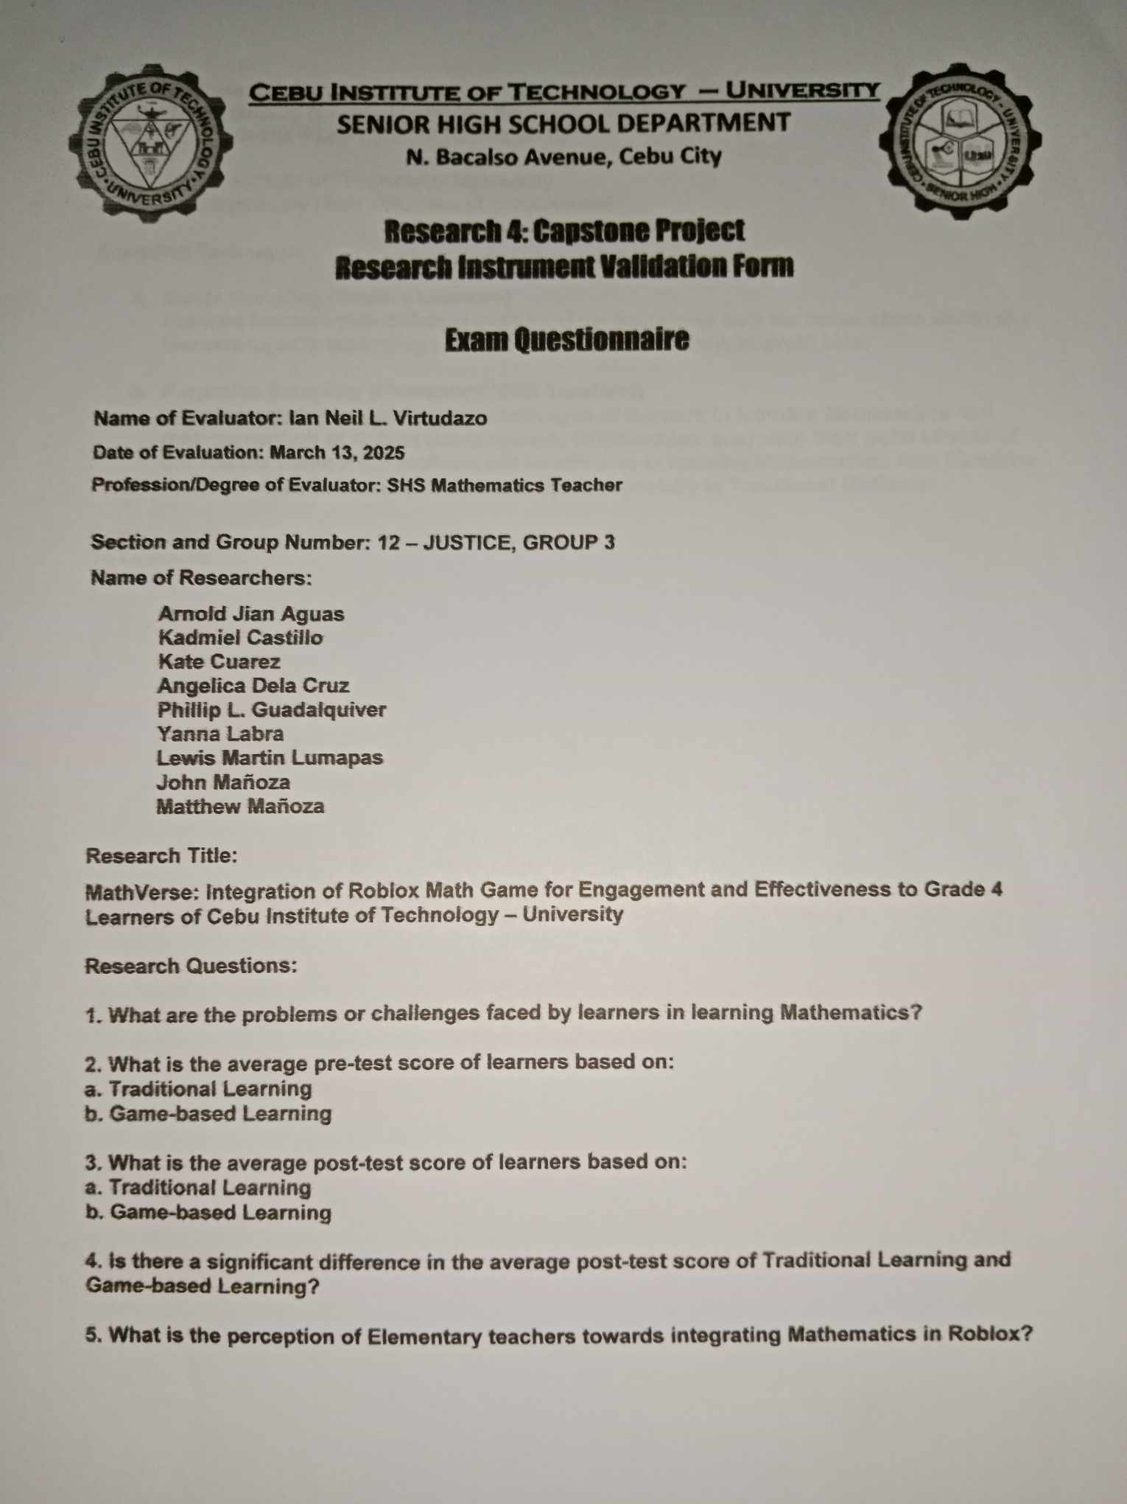

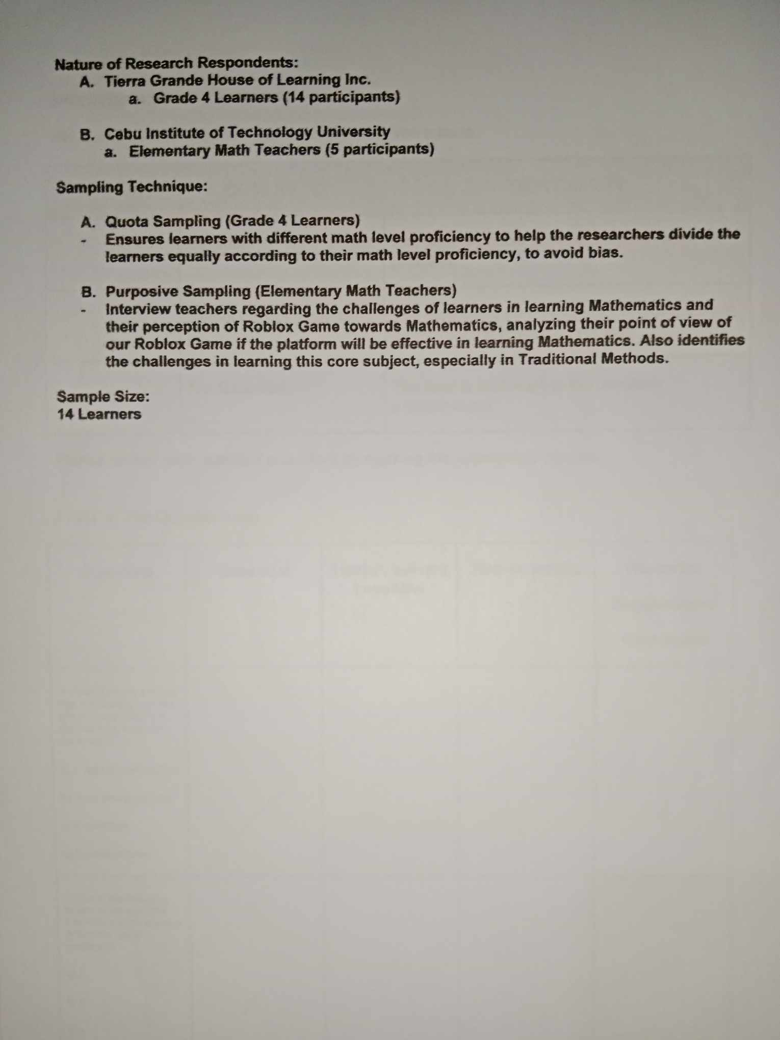

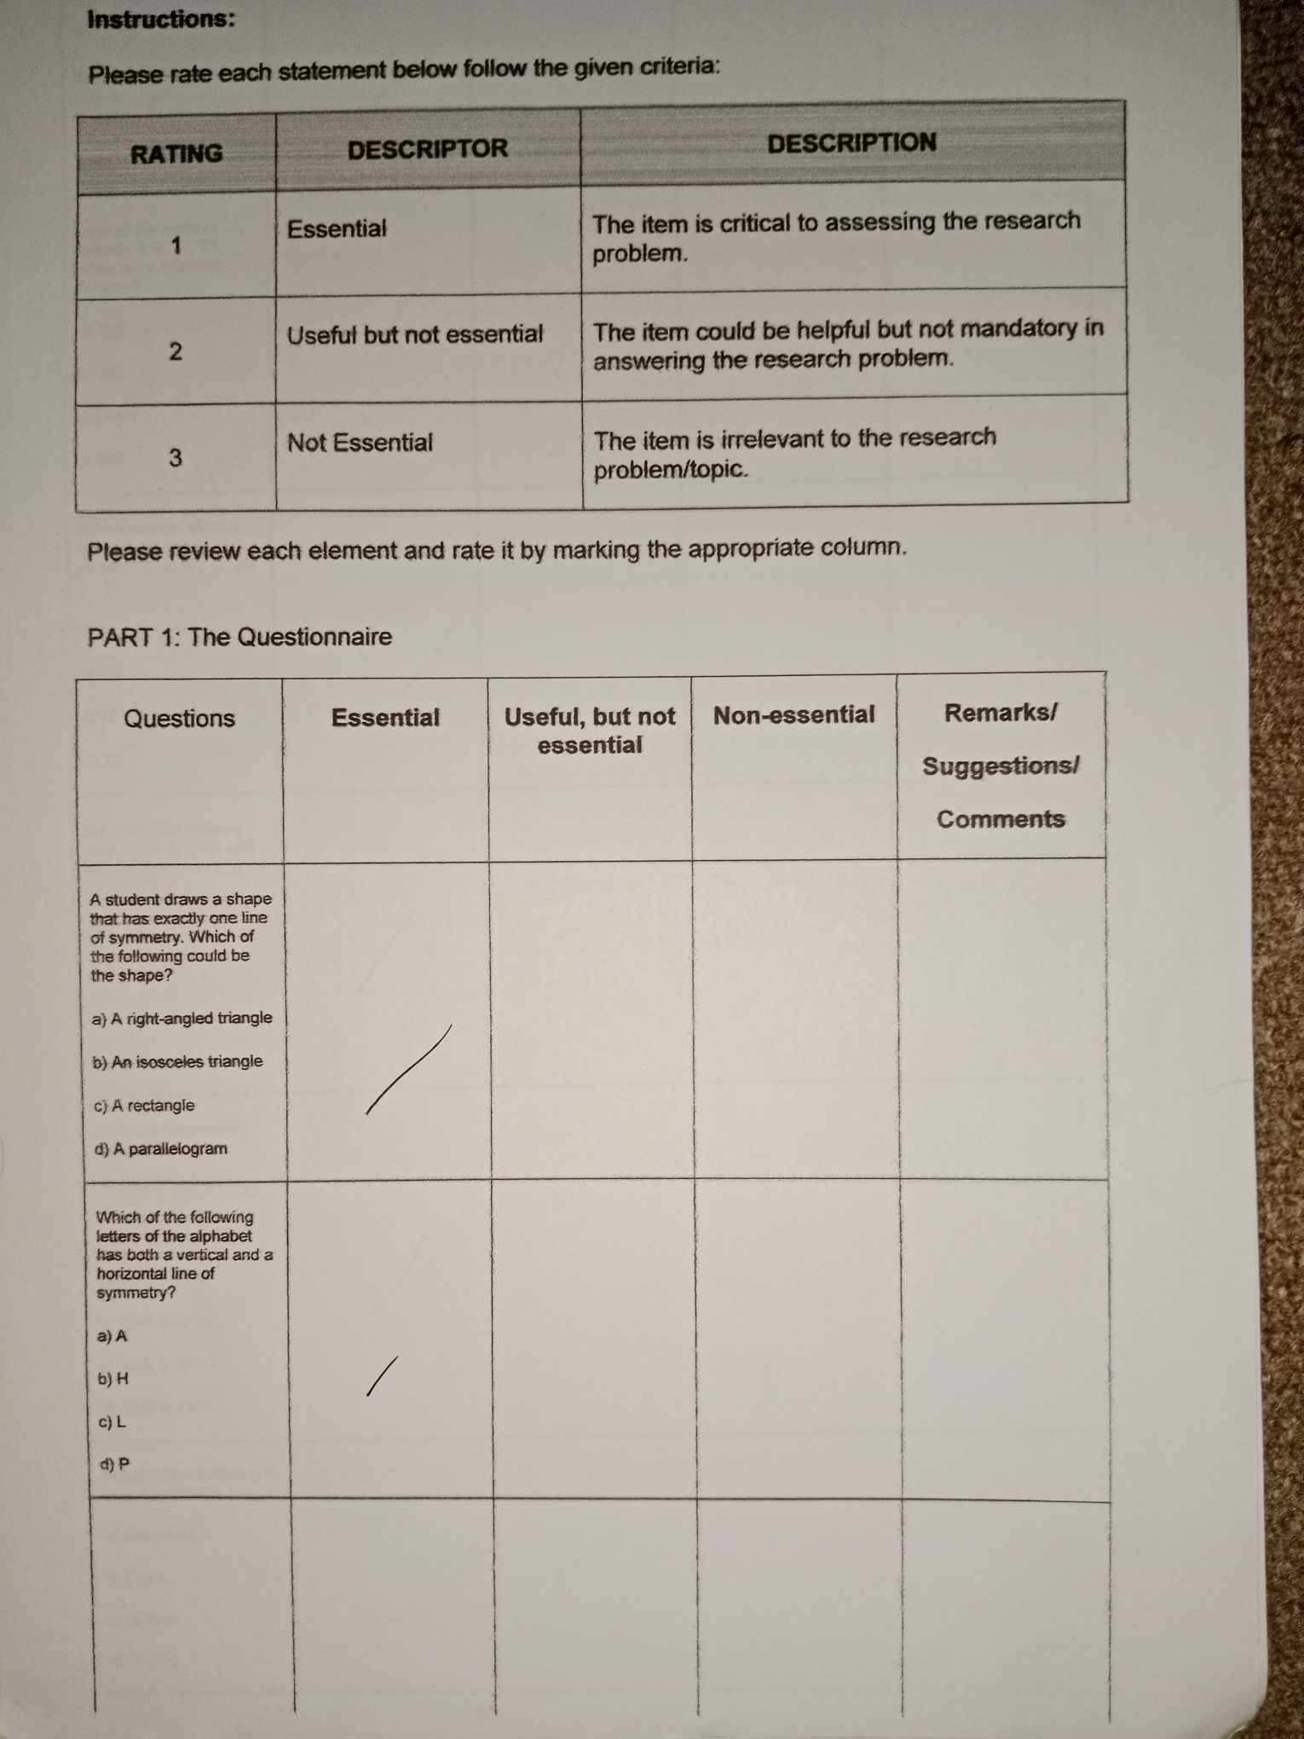

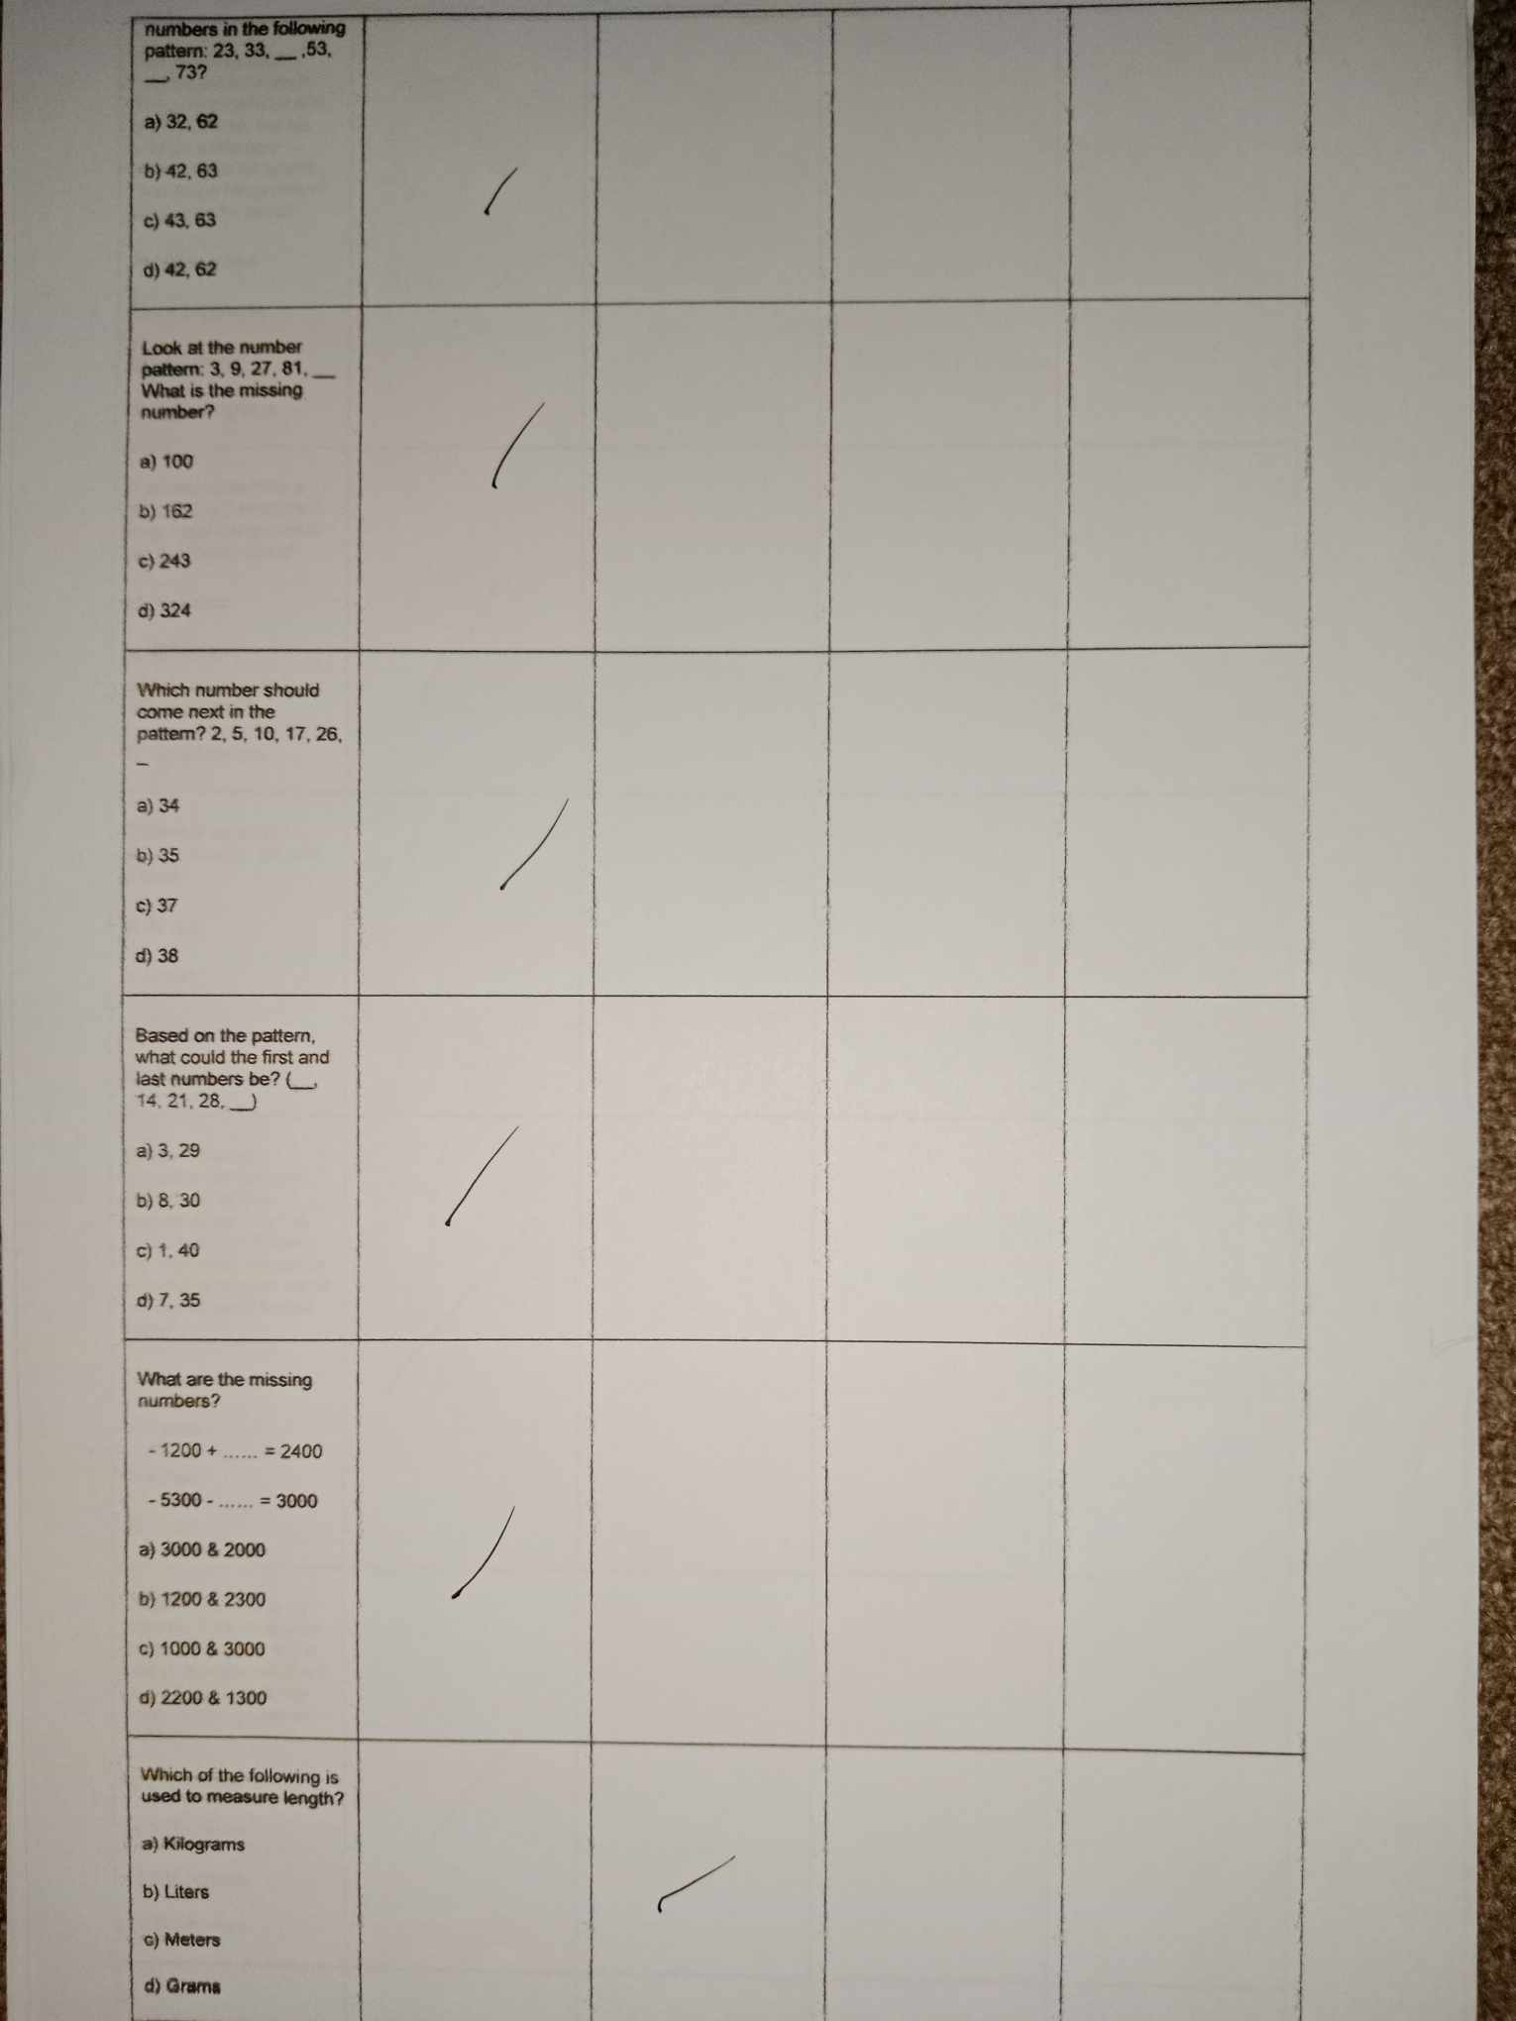

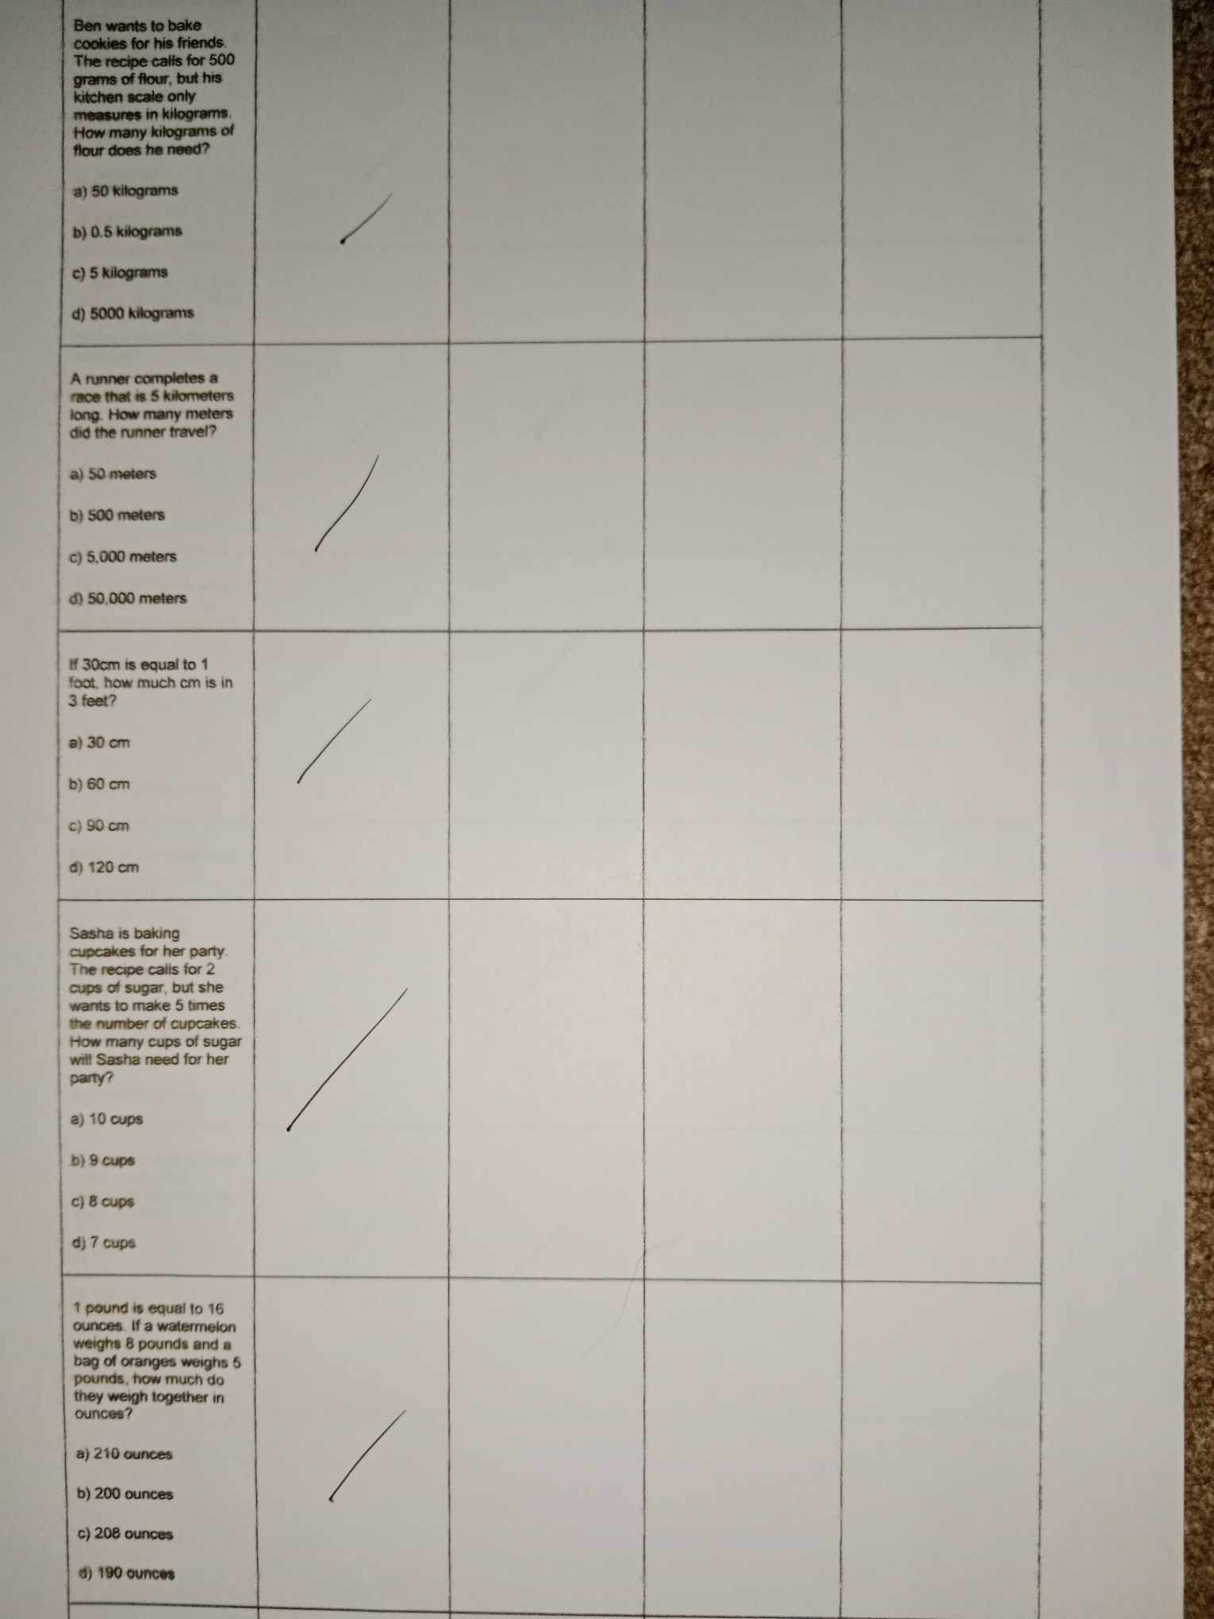

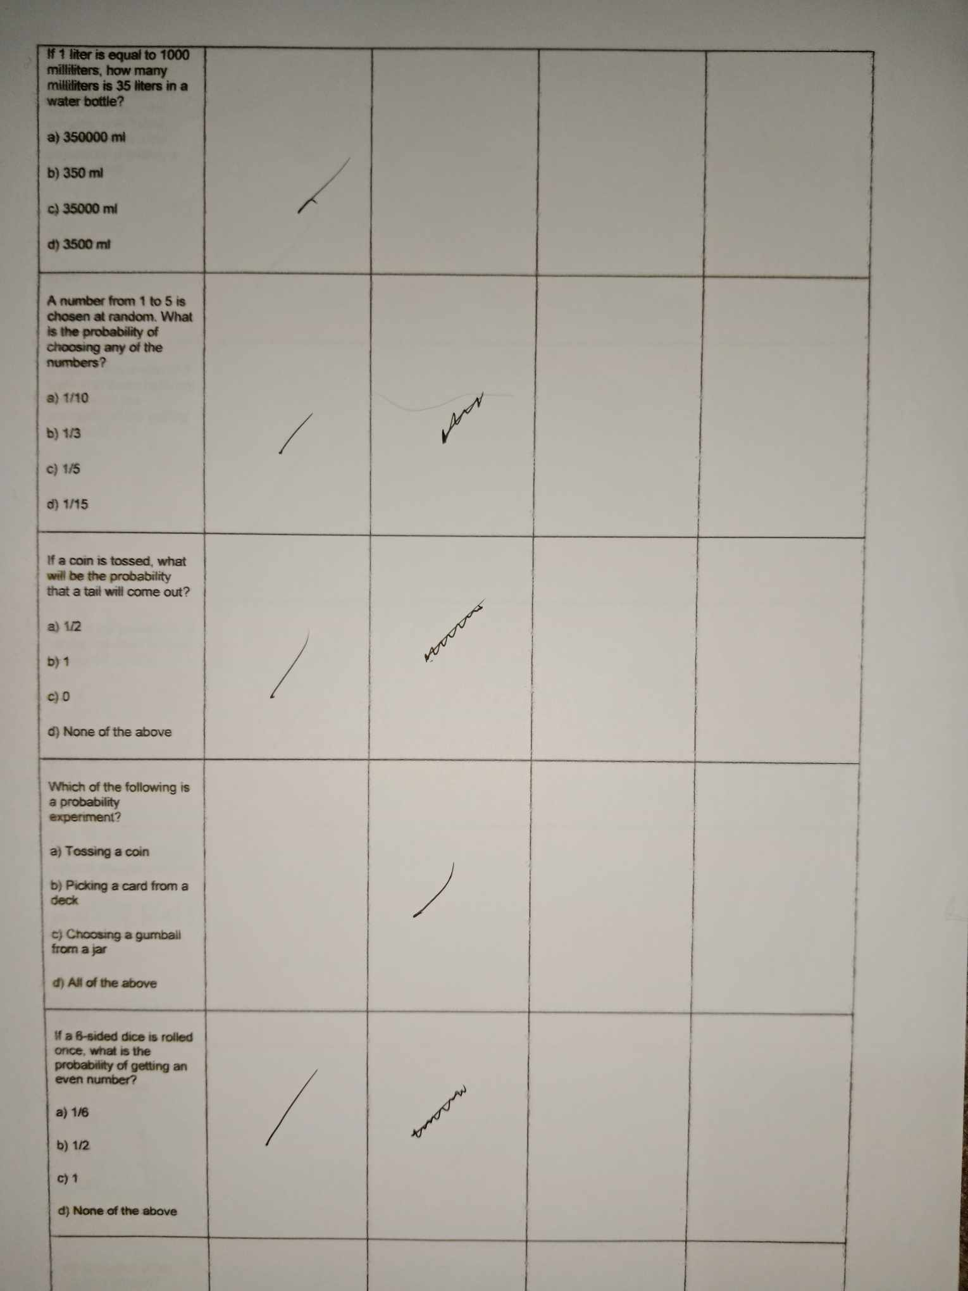

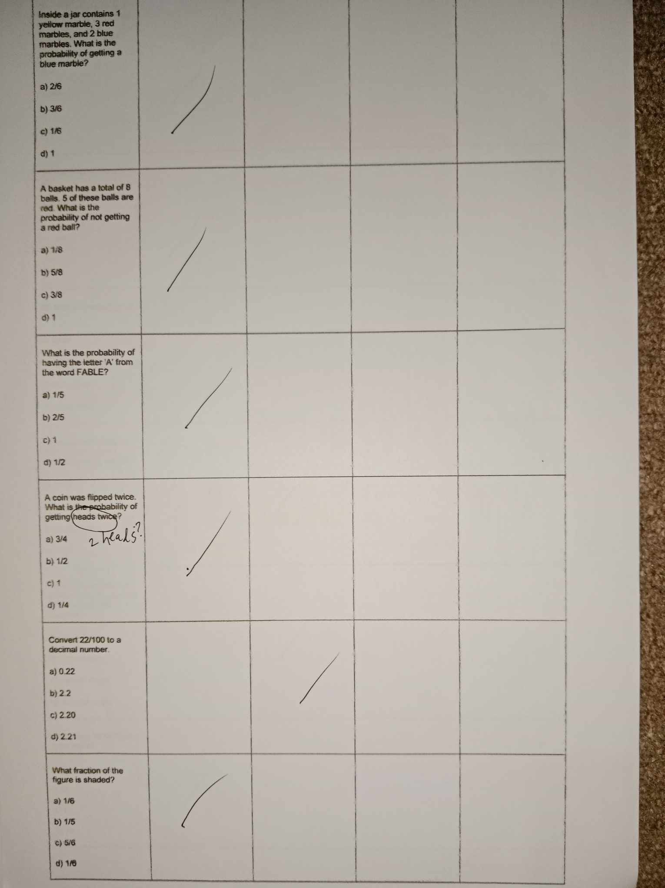

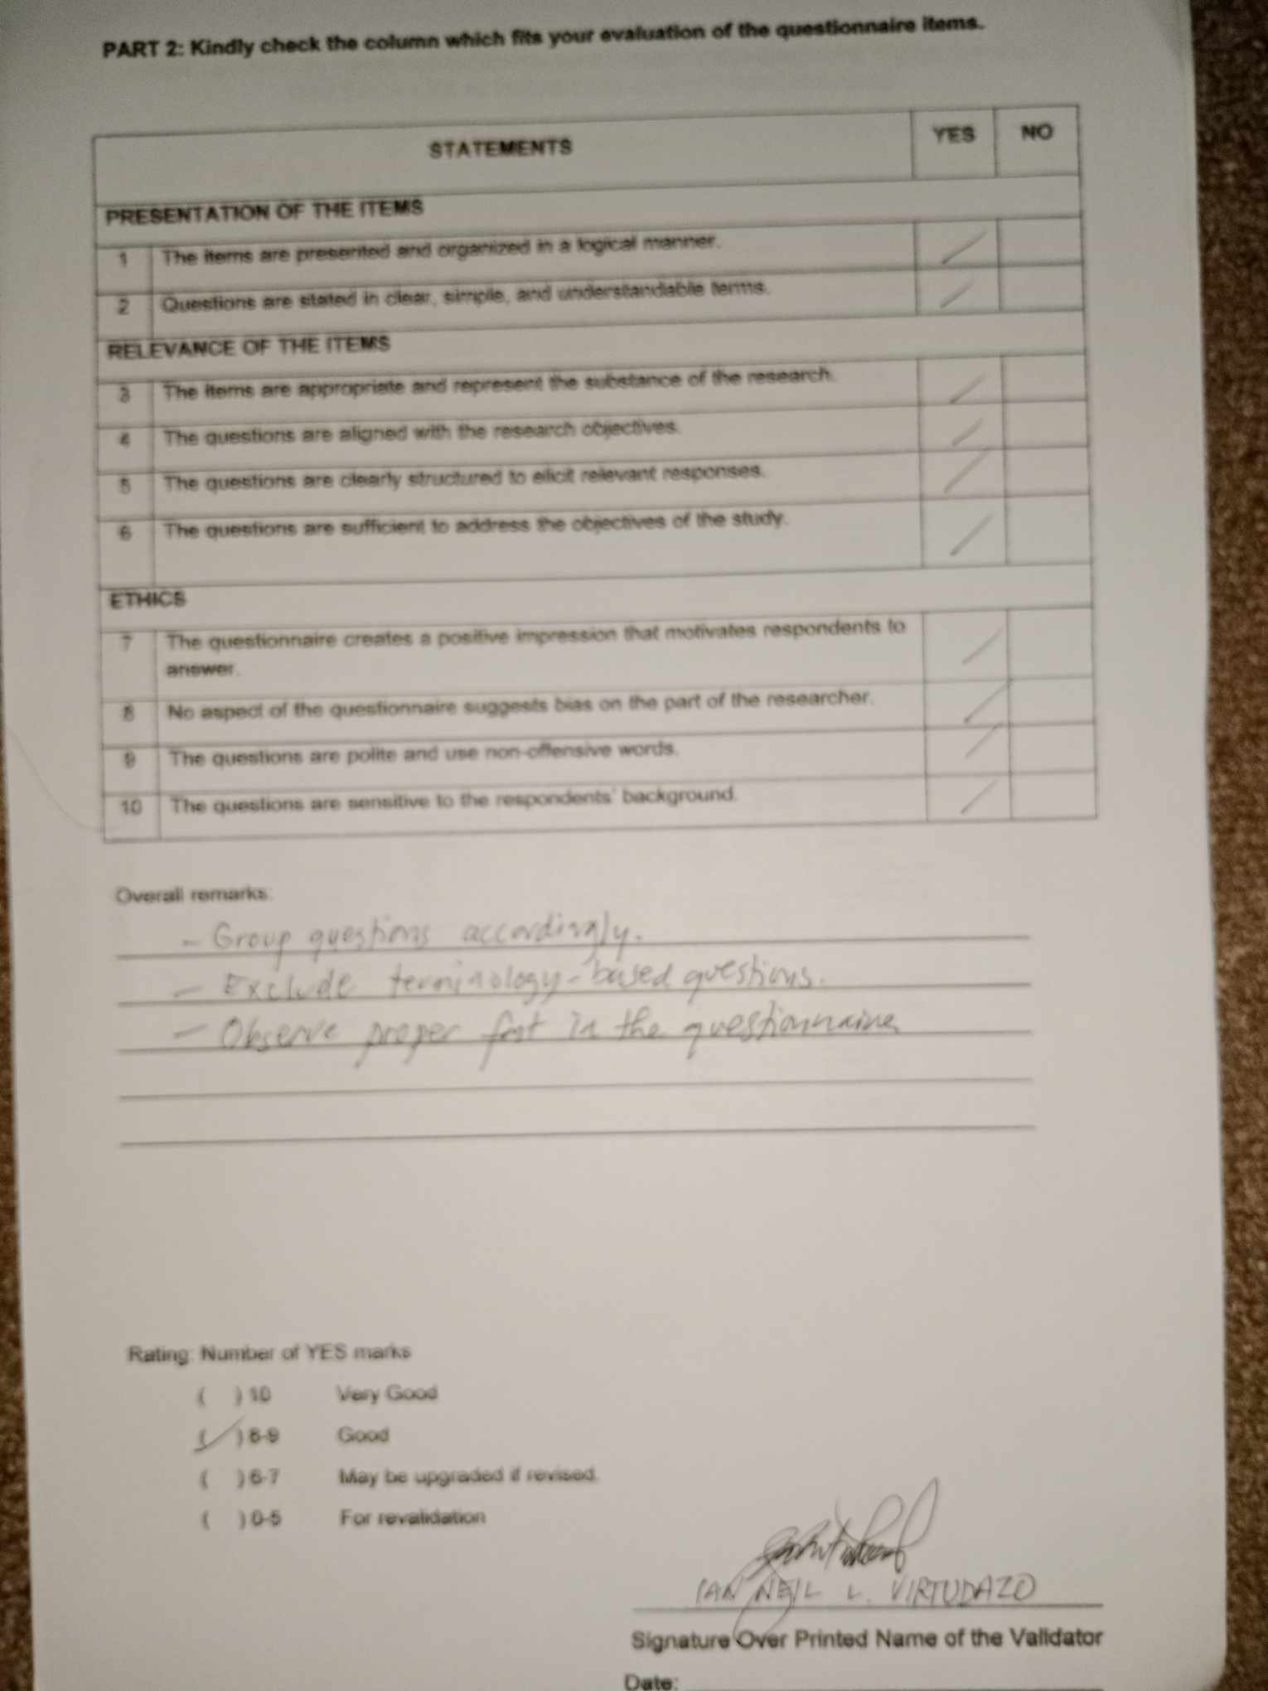









|  |  |
| --- | --- |
| Pre-Test Scores | |
| Traditional Learning | Game-Based Learning |
| Student 1 - 15 | Student 8 - 20 |
| Student 2 - 11 | Student 9 - 17 |
| Student 3 - 7 | Student 10 - 16 |
| Student 4 - 7 | Student 11 - 12 |
| Student 5 - 16 | Student 12 - 14 |
| Student 6 - 8 | Student 13 - 6 |
| Student 7 - 12 | Student 14 - 9 |
|  |  |
| Post-Test Scores | |
| Traditional Learning | Game-Based Learning |
| Student 1 - 15 | Student 8 - 22 |
| Student 2 - 10 | Student 9 - 24 |
| Student 3 - 22 | Student 10 - 16 |
| Student 4 - 13 | Student 11 - 18 |
| Student 5 - 14 | Student 12 - 16 |
| Student 6 - 10 | Student 13 - 20 |
| Student 7 - 11 | Student 14 - 8 |





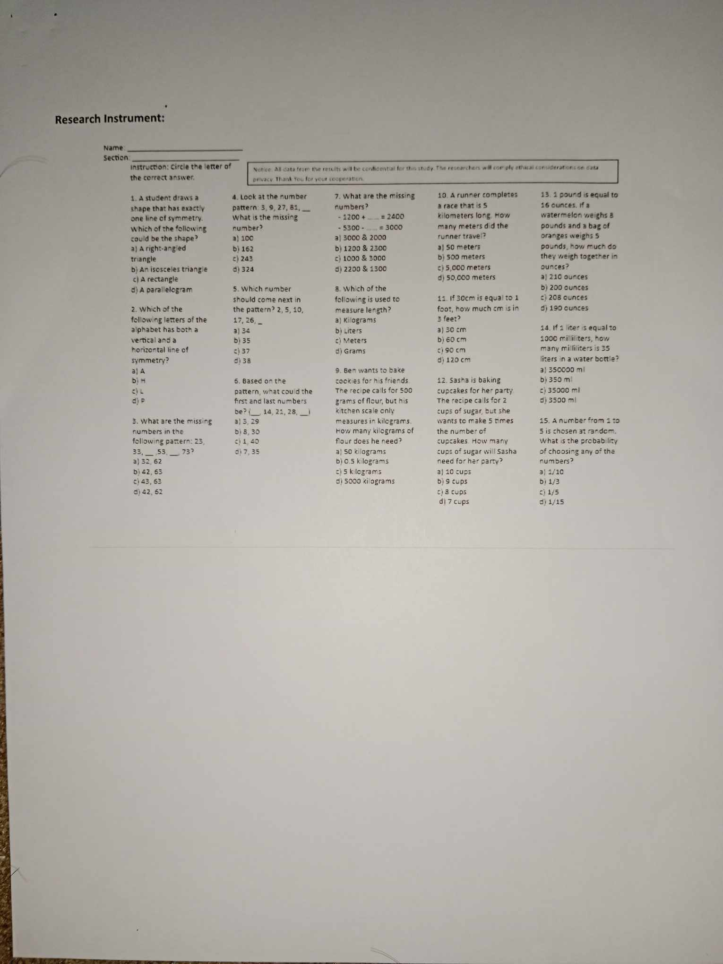

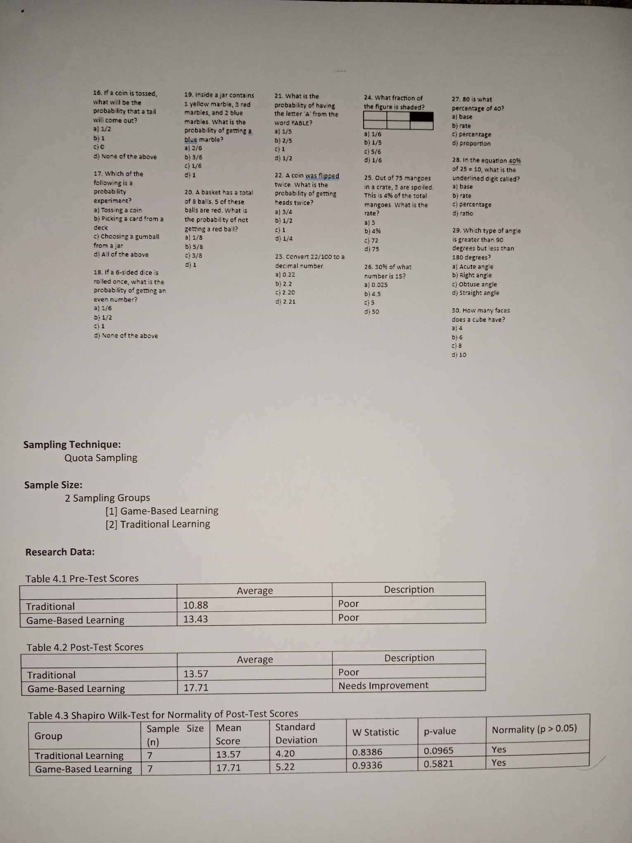



Interview Guide:

1. (Any question of how they feel today, like an introduction)
2. What are the problems you observed in learning Mathematics?
3. What are the challenges when you teach your students Mathematics? (at least the same level)
4. How effective do you find traditional methods of teaching in helping students learn Mathematics compared to game-based approach?
5. Have you used Roblox or other online educational games in learning Mathematics? If so, how often and in what ways?
6. What are your initial impressions of the Roblox Math Game as educational tool?
7. In your opinion, how does game-based learning impact student engagement compare to traditional learning methods?
8. Do you think game-based learning can be effectively integrated learning into long-term Mathematics instruction? Why or why not?
9. How do you feel after this interview? (Conclude part)



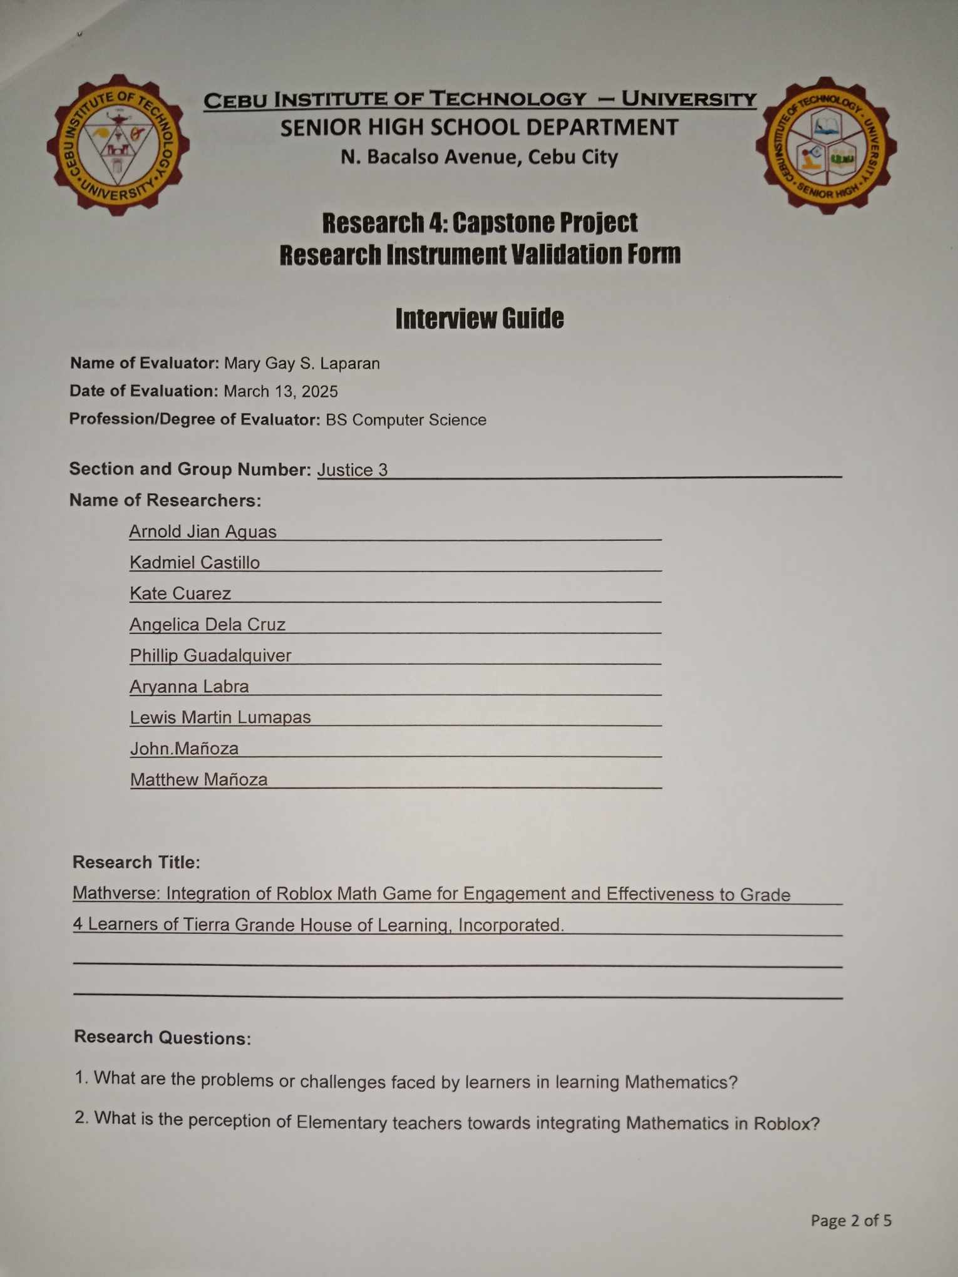

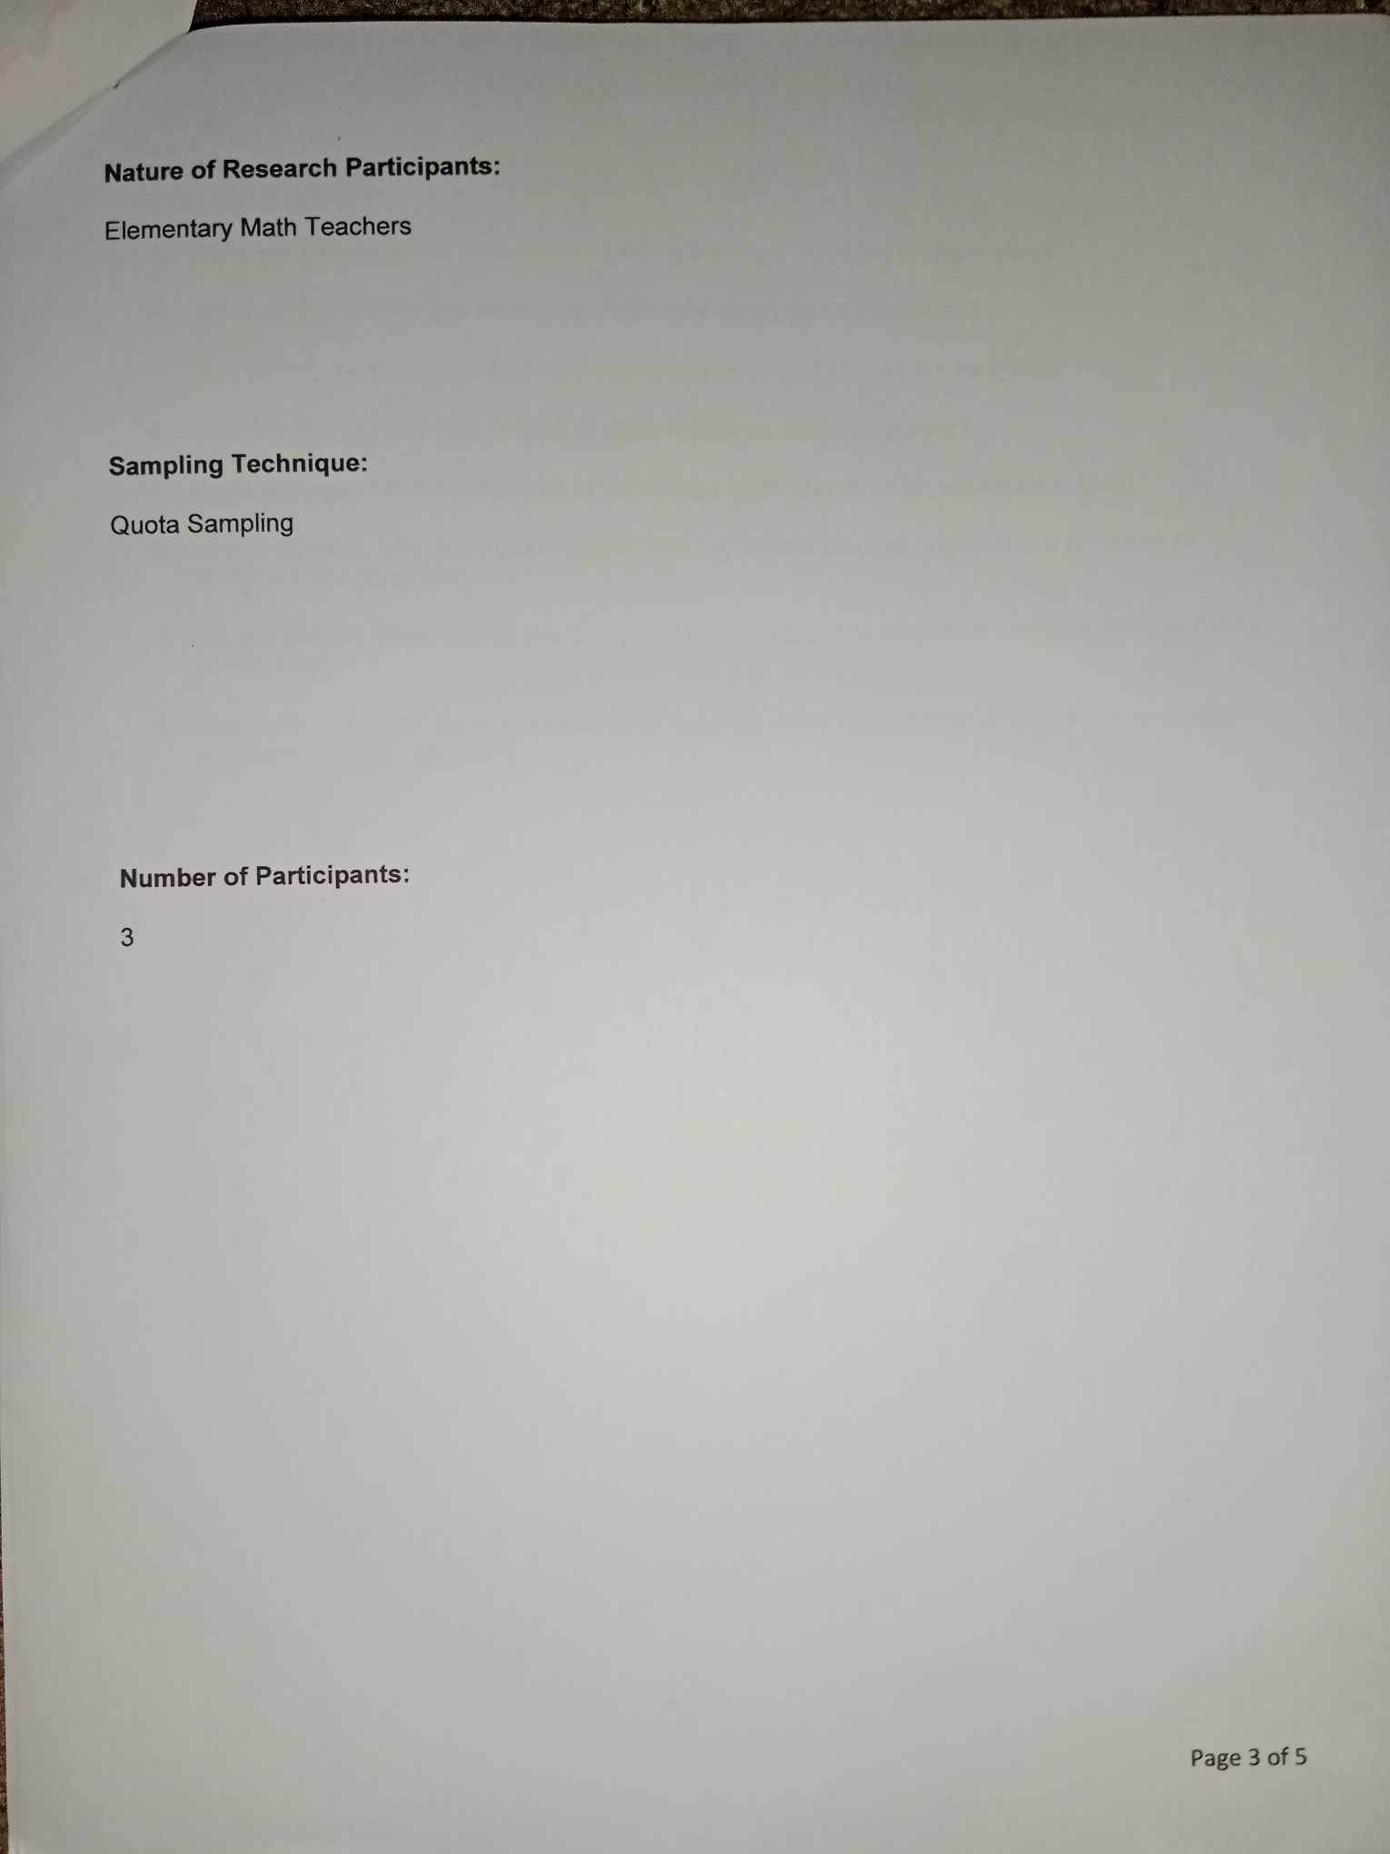

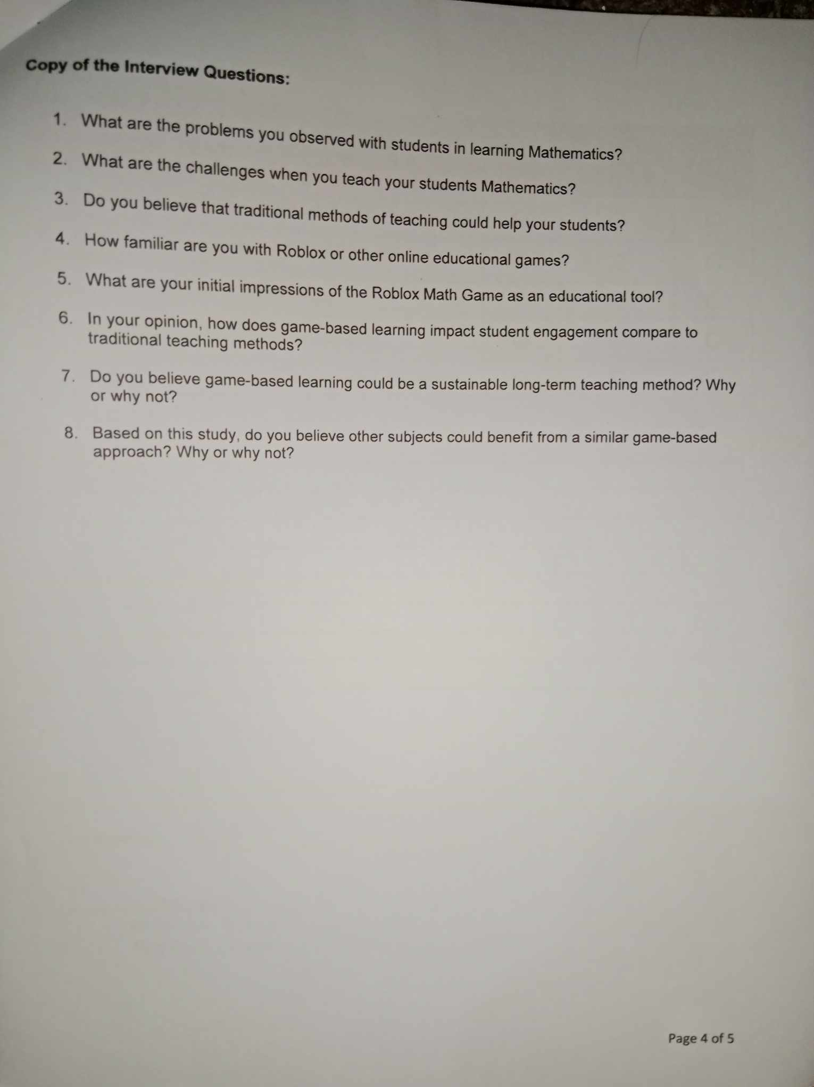

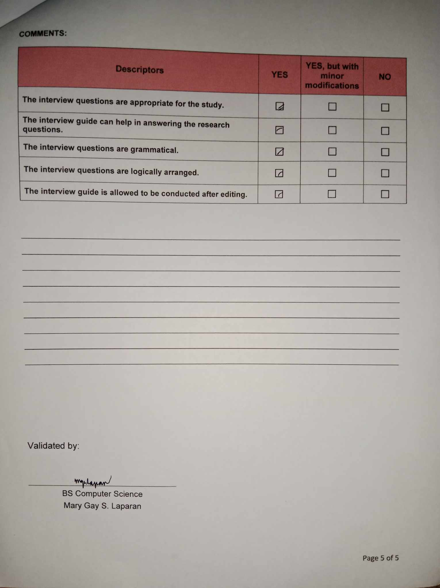



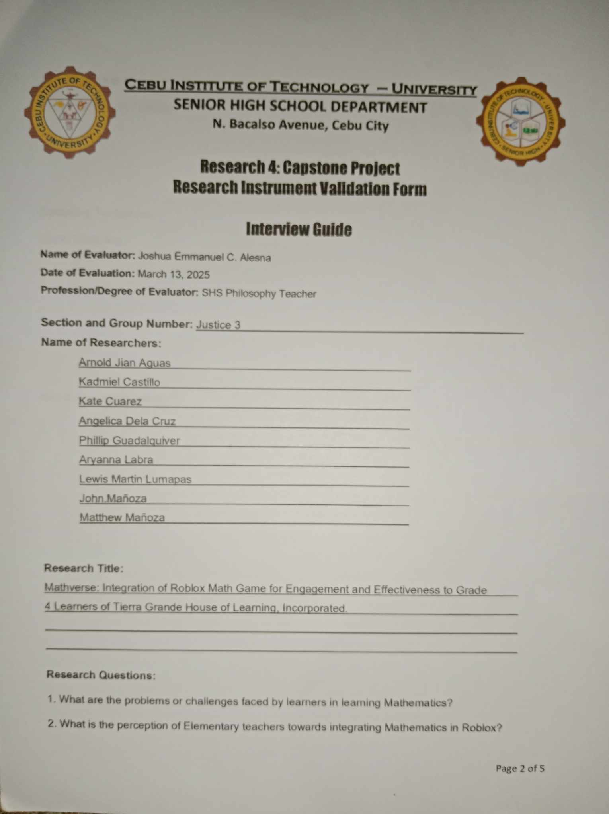



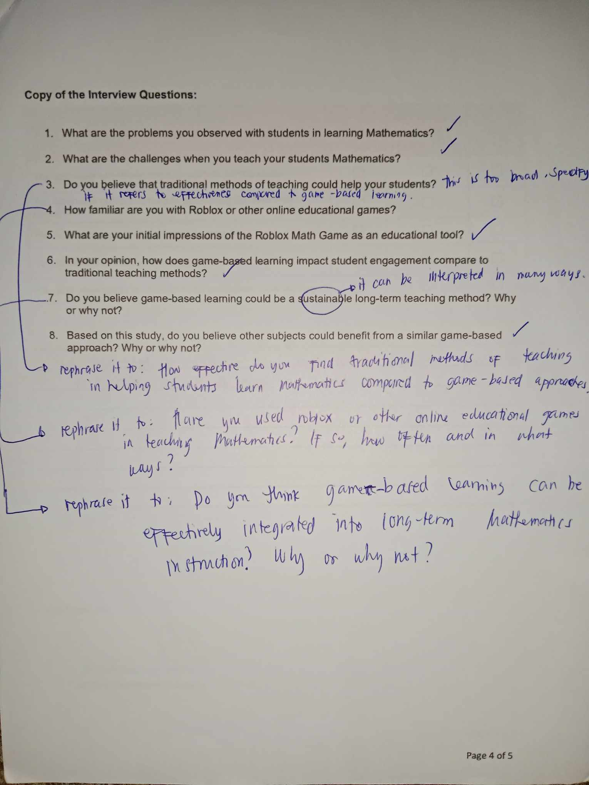

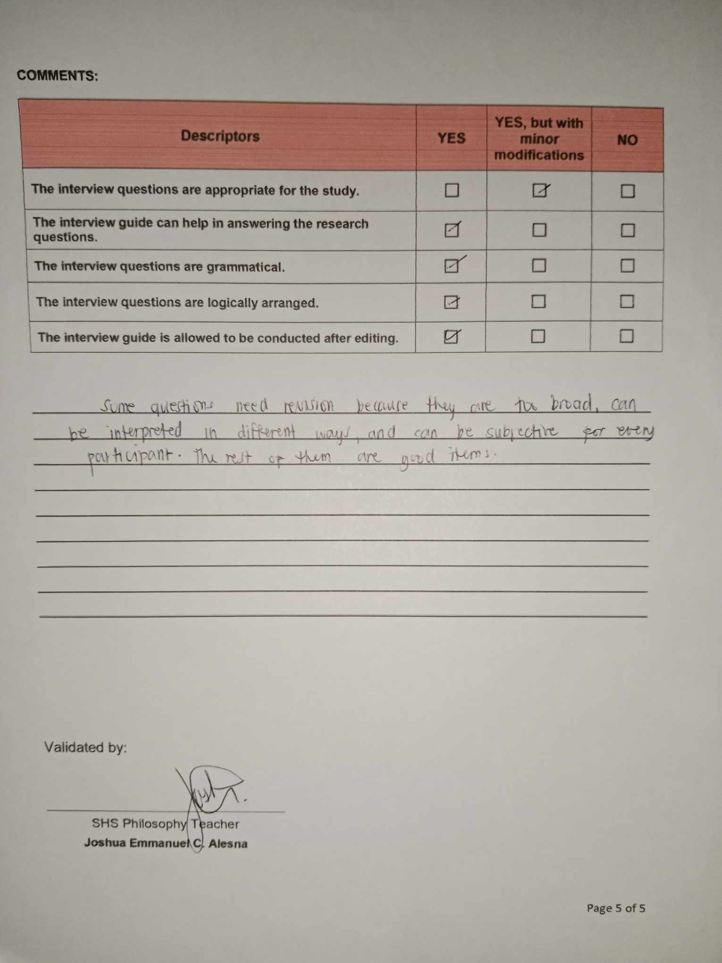



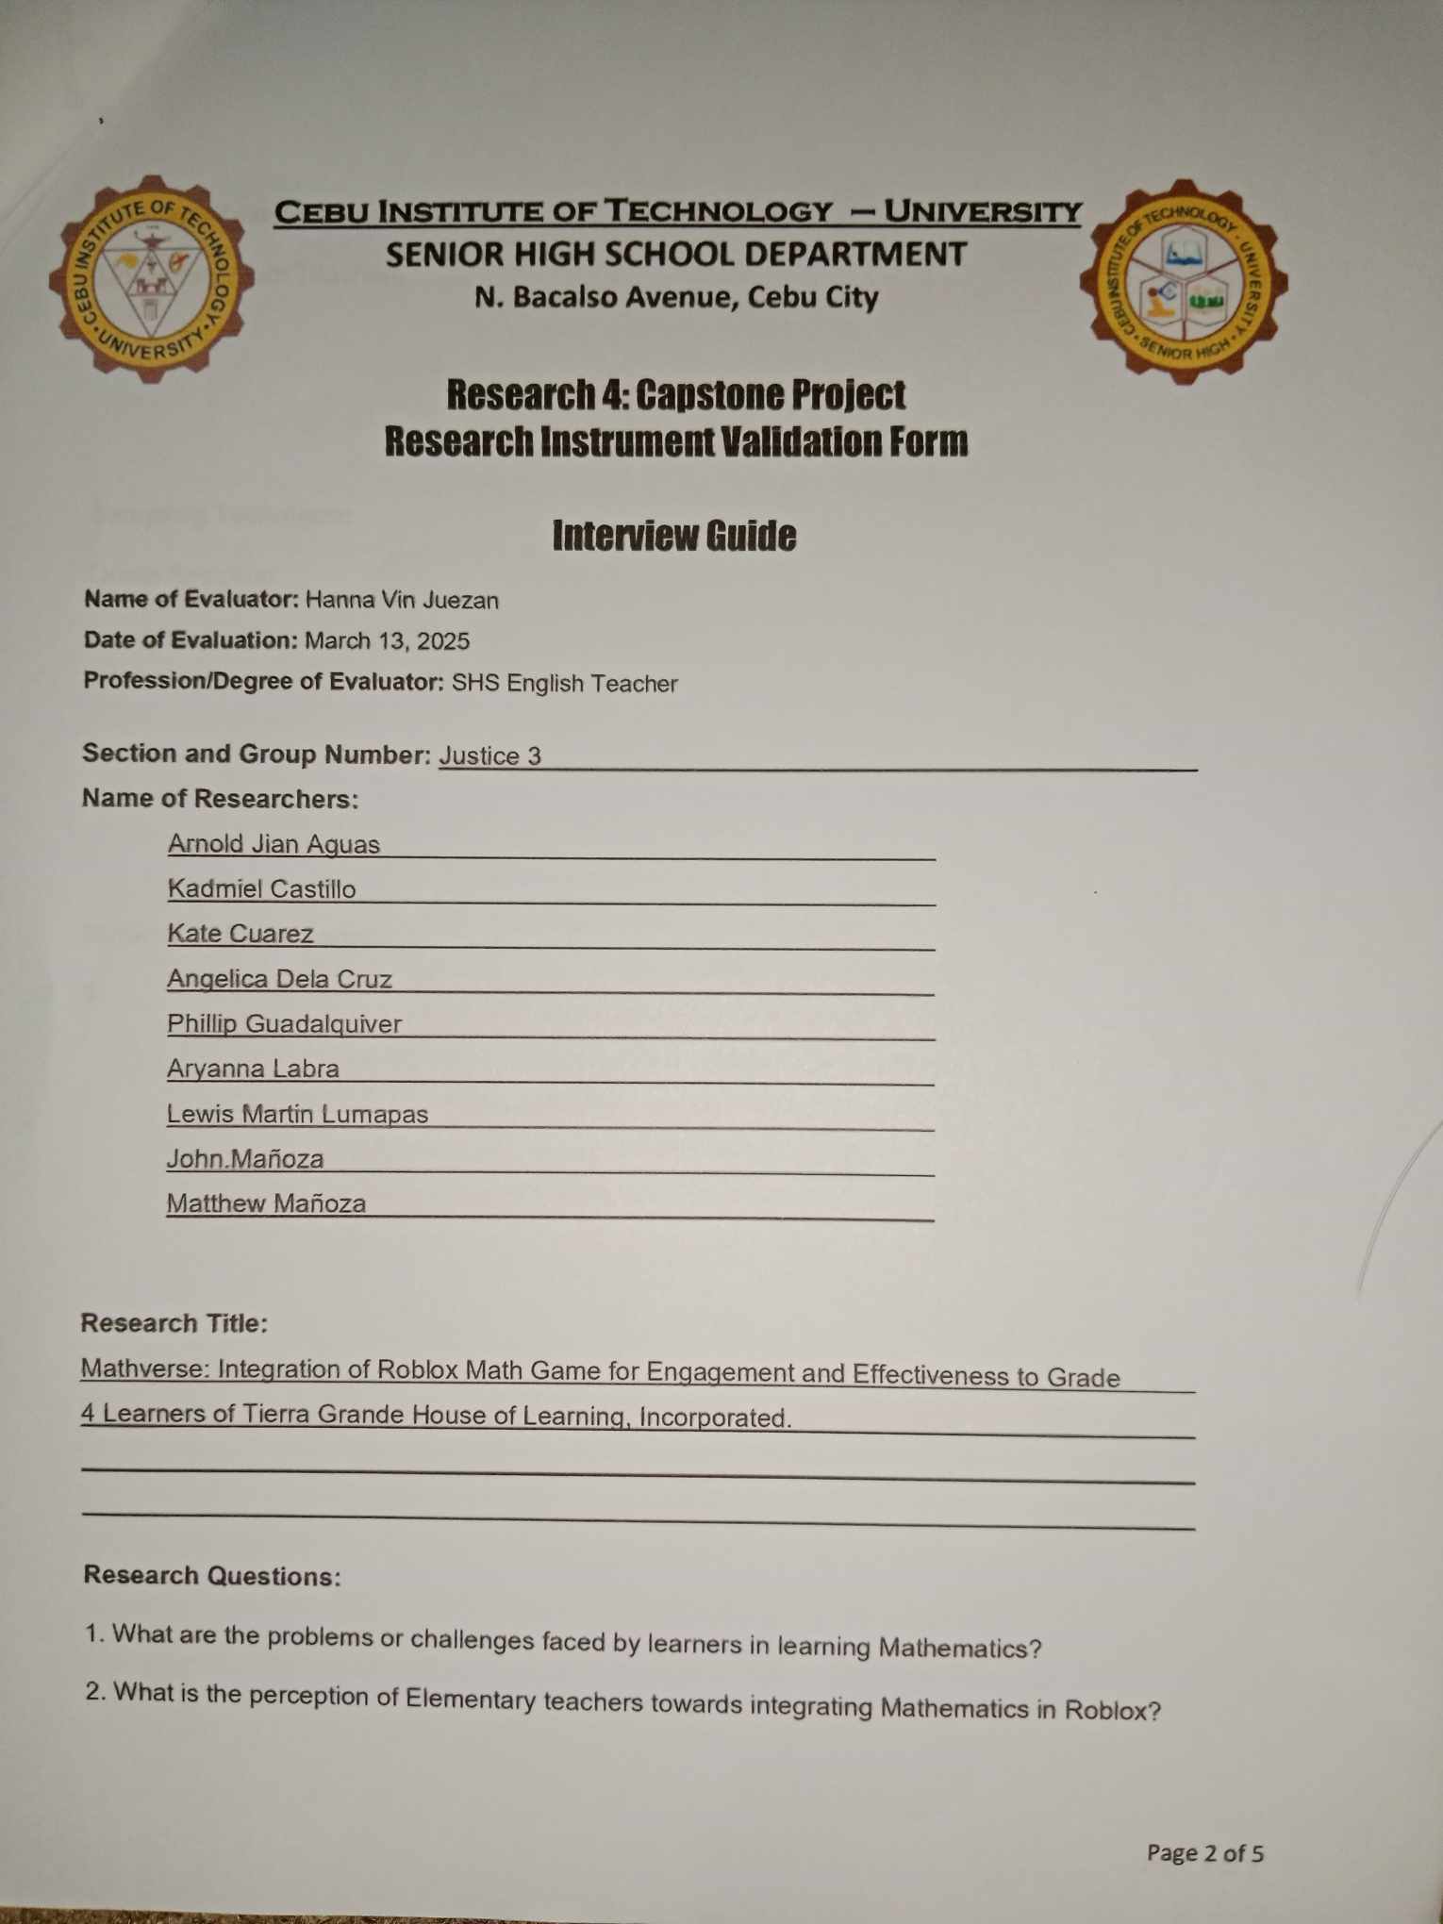





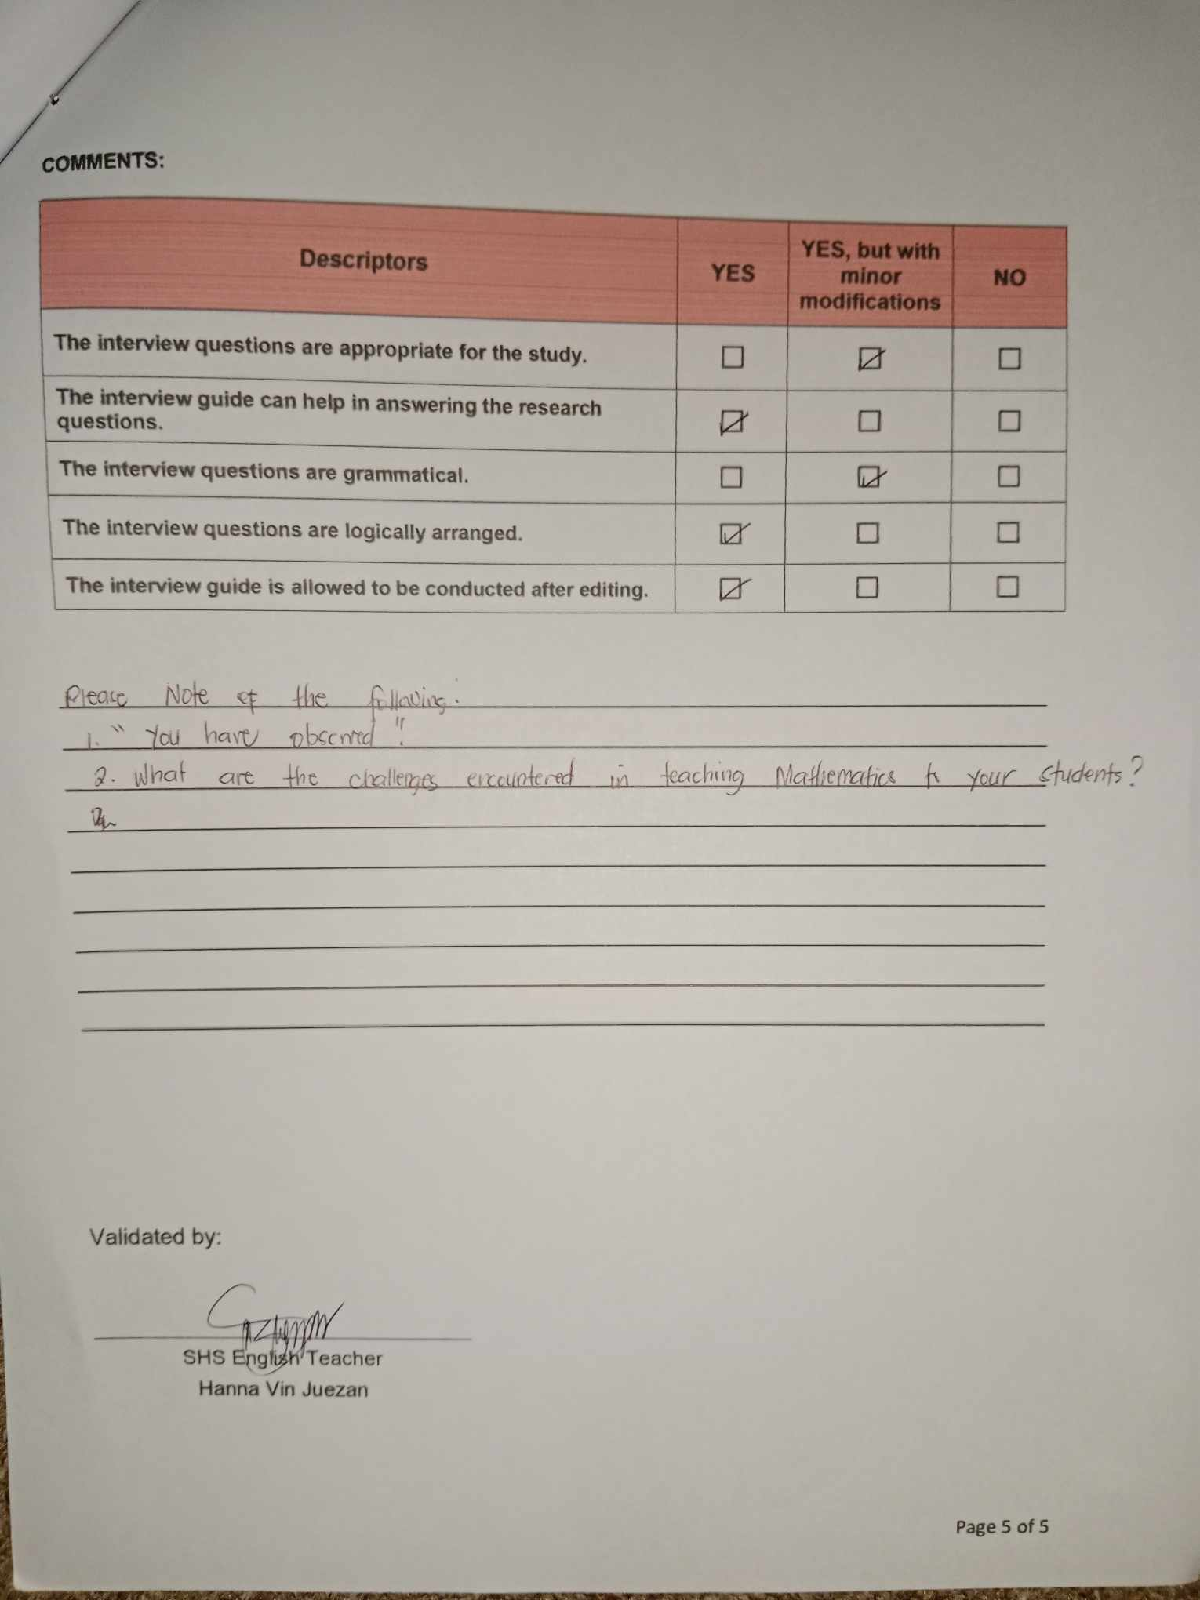



Student: How are you feeling today Maam?

Participant: I’m good, and these days are very busy, but nice to meet you, my name is Cathlyn.

Student: What are the problems you observed in learning Mathematics?

Participant: In this school year, I’m not actually a math teacher. And so far I’ve never tried teaching the Math subject, because I am a English and Science teacher in Grade 4 students this school year. And  the problems that I’ve observed in learning Mathematics is that the lessons at this time are getting more complex compared to what I learned and studied before. And even Before I find math difficult to understand, especially the difficult lessons of Mathematics.

Student: What are the challenges when you teach your students Mathematics? (at least the same level)

Participant: As I’ve mentioned before, I’ve never tried teaching mathematics. But, what I observed or heard to my fellow teachers who teaches mathematics is that their instructional materials, sometimes teachers will accidentally sometimes forget their instructional materials and instructional materials are essential because it’s the source of engagement of the students. And if they forget their instructional materials they will only have a discussion method. And because of that, some of them are quite having a hard time on having the students retain their knowledge during the discussion. Grabbing students attention also is one of the challenges of the teachers, because some of the students don’t listen and keep on talking. Also the noise that came outside and inside the school it tends to distract me whenever I have my classes.

Student: How effective do you find traditional methods of teaching in helping students learn Mathematics compared to game-based approach?

Participant: The traditional method is what students are really used to, ever since before. The Traditional method, is face to face and the teacher can monitor physically the students if they’re really listening or if they are really learning the lessons and the discussions, they also have interactive games like having quiz bowl, etc. But It’s still different when It has visuals, because kids are more on visuals and interactive fun activities, especially games. In terms of fun and engagement, the game-based learning on the other hand is having more if it. Personally what I believe, the more the engaging the learning is the faster the students will retain their knowledge about the lesson.

Student: Have you used Roblox or other online educational games in learning Mathematics? If so, how often and in what ways?

Participant: I haven’t tried Roblox yet, but my fellow teacher who is a mathematics teacher she tried Quizlet because the link or the QR code  is in the book. But they occasionally use it not often.

Student: What are your initial impressions of the Roblox Math Game as educational tool?

Participant: I haven’t tried playing Roblox yet, but my daughter plays Roblox. So my initial impression is that it’s an advantage, because kids are fond to playing online games. I think it’s very useful. What I noticed before when my daughter was not playing Roblox yet, she wasn't able to fully learn on how to read. But when my daughter played Roblox, she later on started reading the chats from the chat box, so I can really say that Roblox can really be an educational tool, because the interactive it is the more the children to feel the excitement.

Student: In your opinion, how does game-based learning impact student engagement compare to traditional learning methods?

Participant: In my opinion, it’s more engaging ,the kids will be able to understand quickly. And the duration of their learning's is not that slow. But still, for me there still should be a balance between traditional learning and game-based learning, there should be a mix between the two leanings.

Student: Do you think game-based learning can be effectively integrated learning into long-term Mathematics instruction? Why or why not?

Participant: For me, because of the generation today the technology is evolving and how much more in the future, of coarse it will be more advanced, the game-based learning will really proceed to long-term Mathematics instruction. But, as I’ve mentioned on number 7 I preferred that there should be a balance between game-based and traditional learning. I preferred to have it as mixed.

Student: How do you feel after this interview? (Conclude part)

Participant: I feel overwhelmed, because first of all. I can’t relate that much because I’m not a mathematics teacher, but it’s really nice to know that there are a lot of interactive games, especially like Roblox that us teachers can apply to our lessons. Not only in Mathematics but also in other subjects as well.



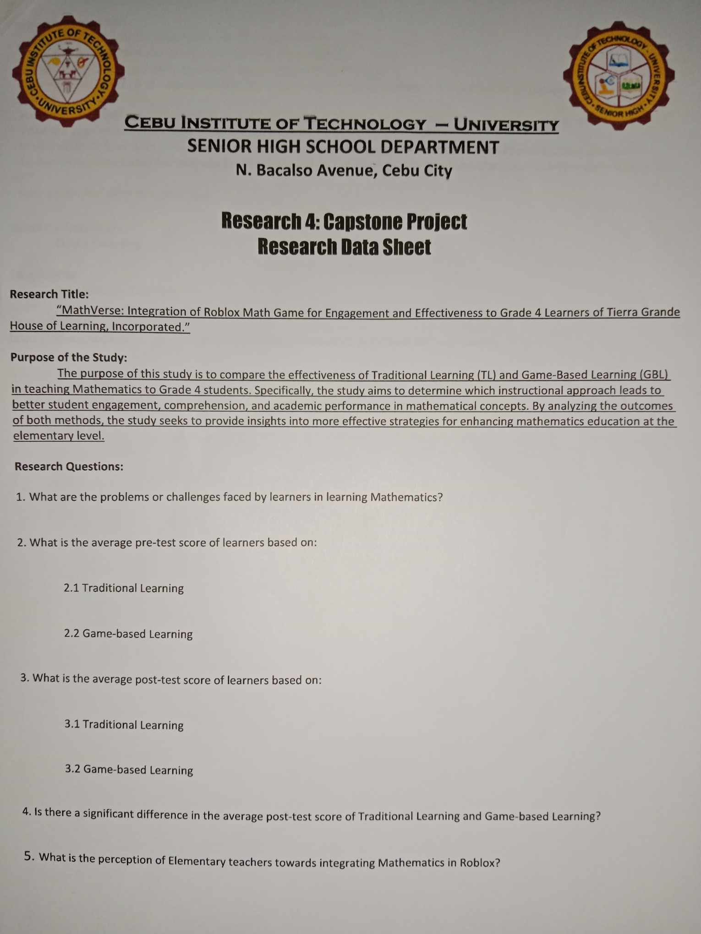

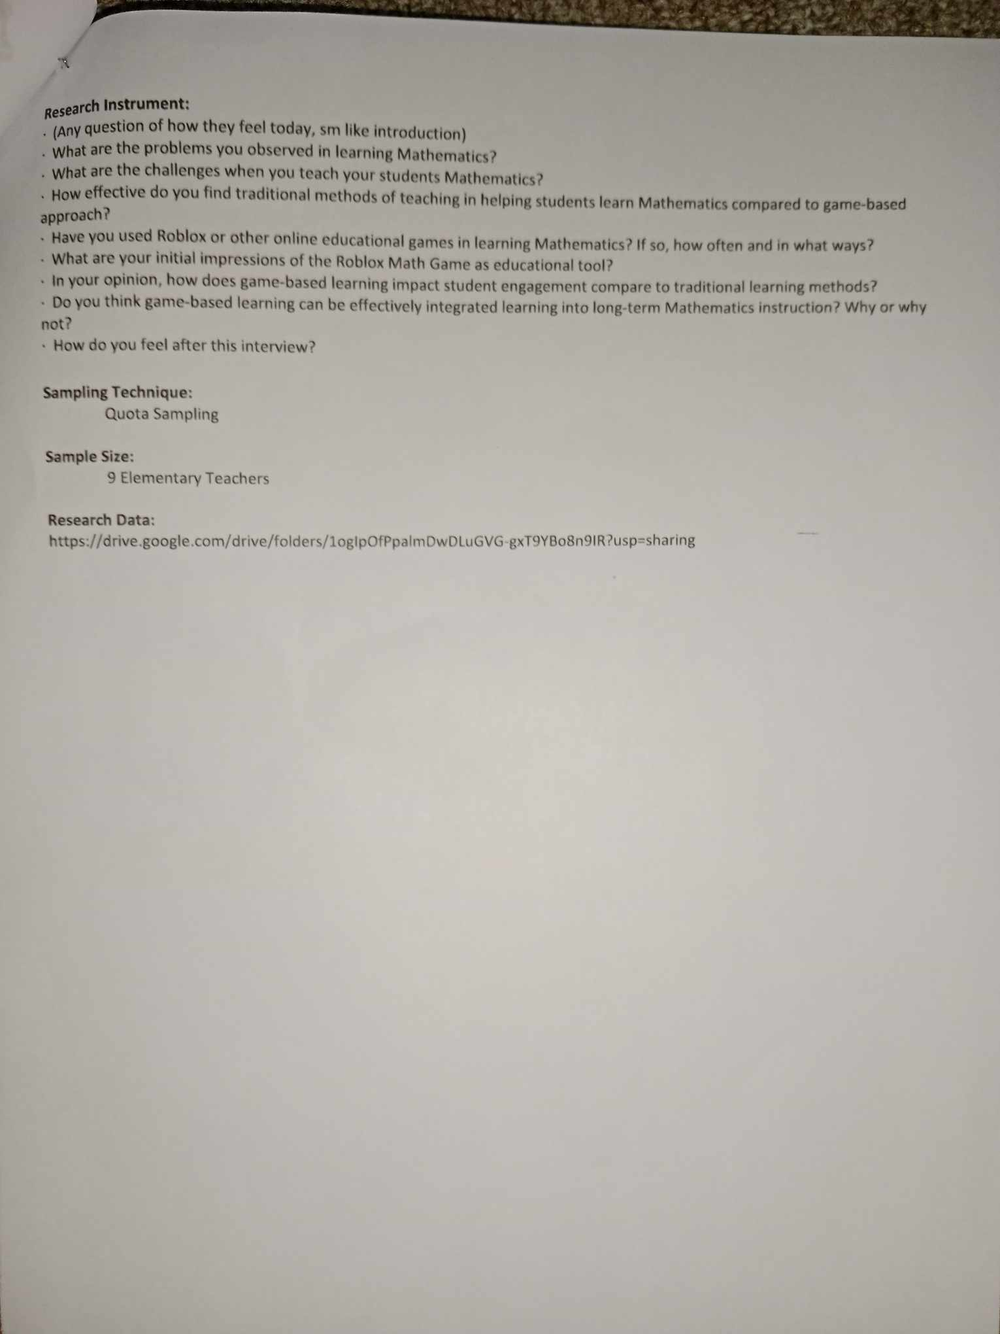

**Appendix C**



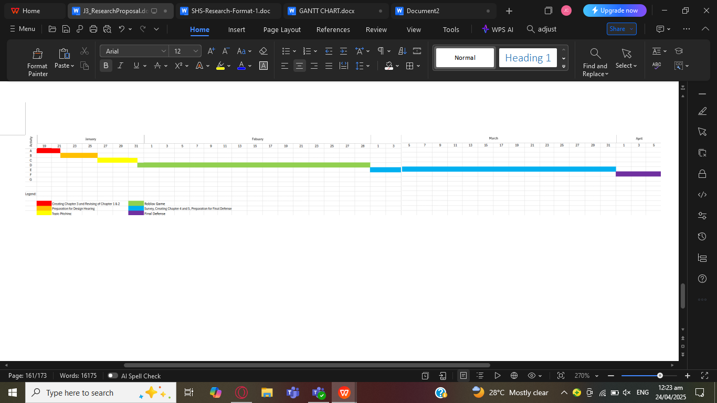

**Appendix D**

**RESEARCH BUDGET**

|  |  |
| --- | --- |
|  | **PRICE** |
| Research Consultants (Mathematics and Computer Science) | ₱600.00 |
| Research Validators (Interview and Questionnaire) | ₱900.00 |
| Statistician | ₱500.00 |
| Psychometrician | ₱300.00 |
| Data Analyst | ₱700.00 |
| Printing (Letters, Interviews, Questionnaire) | ₱300.00 |
| Research Panelist (Project Proposal and Final Defense) | ₱2400.00 |
| Token (Project Proposal and Final Defense) | ₱900.00 |
| Token (Participants) | ₱100.00 |
|  |  |
| **TOTAL:** | ₱6700.00 |

**Appendix E**

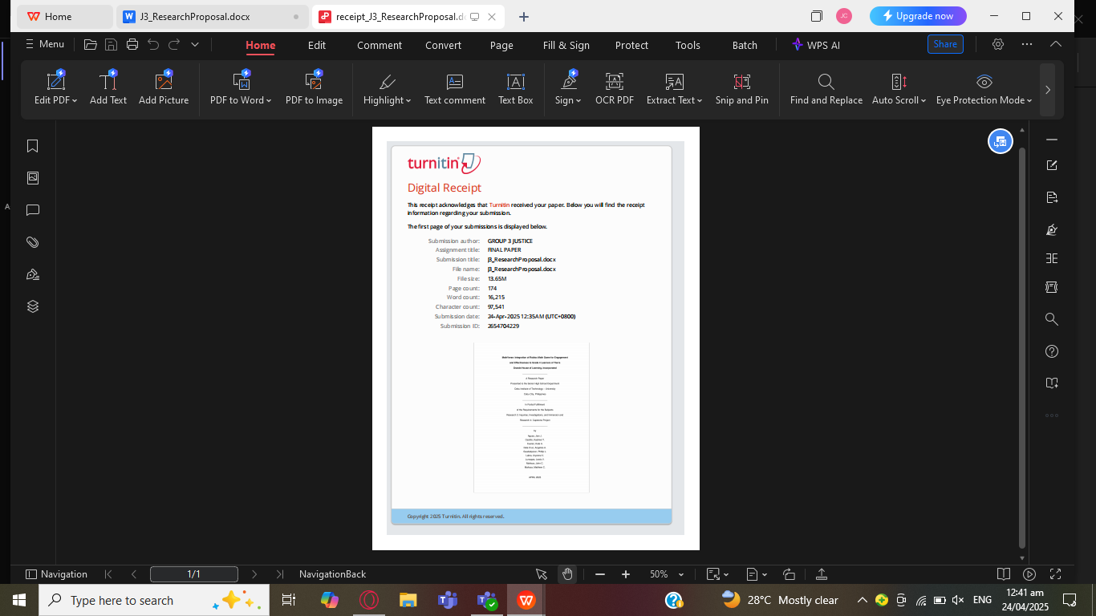

**Appendix F**



**Cebu Institute of Technology – University**

**SENIOR HIGH SCHOOL DEPARTMENT**

**N. Bacalso Avenue, Cebu City**

# **CURRICULUM VITAE**



## **Arnold Jian J. Aguas**

**PERSONAL DATA:**

**Name:** Jian Arnold J. Aguas

**Age:** 17

**Birthday:** June 14, 2007

**Address:** 229 St Tres De Abril

Labangon Cebu City

**Contact Number:** 09694879106

**E-mail:** jianarnold14@gmail.com

**Educational Background:**

**Elementary:** Marianne Childhood Education Center (2013-2019)

**Junior High School:** Cebu Institute of Technology University (2019-2023)

**Senior Highschool:** Cebu Institute of Technology University (2023-2025)



**Cebu Institute of Technology – University**

**SENIOR HIGH SCHOOL DEPARTMENT**

**N. Bacalso Avenue, Cebu City**

# **CURRICULUM VITAE**



## **Kadmiel T. Castillo**

**PERSONAL DATA:**

**Name:** Kadmiel T. Castillo

**Age:** 18

**Birthday:** September 25, 2006

**Address:** Cebu, Talisay City, Dumlog,

Deca Homes Phase 1, Blk 15 Lot 29

**Contact Number:** 09391343339

**E-mail:** kadmielcastillo@gmail.com

**Educational Background:**

**Elementary:** Talisay City Central Elementary School (2013-2019)

**Junior High School:** Cebu Institute of Technology University (2019-2023)

**Senior Highschool:** Cebu Institute of Technology University (2023-2025)



**Cebu Institute of Technology – University**

**SENIOR HIGH SCHOOL DEPARTMENT**

**N. Bacalso Avenue, Cebu City**

# **CURRICULUM VITAE**



## **Phillip L. Guadalquiver**

**PERSONAL DATA:**

**Name:** Phillip L. Guadalquiver

**Age:** 18

**Birthday:** June 21, 2006

**Address:** Blk 10 Lot 2 Decahomes Ph 1

Dumlog Talisay City Cebu

**Contact Number:** 09682423743

**E-mail:** phillipguadalquiver@gmail.com

**Educational Background:**

**Elementary:** Talisay City Central Elementary School (2013-2019)

**Junior High School:** Cebu Institute of Technology University (2019-2023)

**Senior Highschool:** Cebu Institute of Technology University (2023-2025)



**Cebu Institute of Technology – University**

**SENIOR HIGH SCHOOL DEPARTMENT**

**N. Bacalso Avenue, Cebu City**

# **CURRICULUM VITAE**



## **Lewis Martin V. Lumapas**

**PERSONAL DATA:**

**Name:** Lewis Martin V Lumapas

**Age:** 17

**Birthday:** April 28, 2007

**Address:** Talisay City Dumlog Cebu

**Contact Number:** 09205272417

**E-mail:** martinthesuper@gmail.com

**Educational Background:**

**Elementary:** Saint Thomas Aquinas School Talisay Lawaan (2013-2019)

**Junior High School:** Saint Teresa School of Talisay Inc. (2019-2023)

**Senior Highschool:** Cebu Institute of Technology University (2023-2025)



**Cebu Institute of Technology – University**

**SENIOR HIGH SCHOOL DEPARTMENT**

**N. Bacalso Avenue, Cebu City**

# **CURRICULUM VITAE**



## **John Christoff C. Mañoza**

**PERSONAL DATA:**

**Name:** John Christoff C. Mañoza

**Age:** 18

**Birthday:** October 9, 2006

**Address:** Tierra Grande Estate Lawaan 1

Talisay City Cebu

**Contact Number:** 09944055095

**E-mail:** johnchristoffmanoza@gmail.com

**Educational Background:**

**Elementary:** Tierra Grande House of Learning Inc. (2013-2019)

**Junior High School:** Mary Help of Christians School (2019-2023)

**Senior Highschool:** Cebu Institute of Technology University (2023-2025)



**Cebu Institute of Technology – University**

**SENIOR HIGH SCHOOL DEPARTMENT**

**N. Bacalso Avenue, Cebu City**

# **CURRICULUM VITAE**



## **Matthew Ivan C. Mañoza**

**PERSONAL DATA:**

**Name:** Matthew Ivan C. Mañoza

**Age:** 18

**Birthday:** October 9, 2006

**Address:** Tierra Grande Estate Lawaan 1

Talisay City Cebu

**Contact Number:** 09944055095

**E-mail:** mattmanoza@gmail.com

**Educational Background:**

**Elementary:** Tierra Grande House of Learning Inc. (2013-2019)

**Junior High School:** Mary Help of Christians School (2019-2023)

**Senior Highschool:** Cebu Institute of Technology University (2023-2025)



**Cebu Institute of Technology – University**

**SENIOR HIGH SCHOOL DEPARTMENT**

**N. Bacalso Avenue, Cebu City**

# **CURRICULUM VITAE**



## **Kate Evea A. Cuarez**

**PERSONAL DATA:**

**Name:** Kate Evea A. Cuarez

**Age:** 17

**Birthday:** October 8, 2007

**Address:** 333-10I Victor Village 2,

Punta Princesa, Cebu City

**Contact Number:** 09456859278

**E-mail:** kateevea1@gmail.com

**Educational Background:**

**Elementary:** Cebu Sacred Heart College, Bulacan (2013-2015)

St. Paul School of Sta. Maria, Bulacan (2015-2017)

Patronage of Mary Development School, Boljoon (2017-2019)

**Junior High School:** Patronage of Mary Development School, Boljoon(2019-2021)

St. Mary's Academy of Oslob (2021-2023)

**Senior Highschool:** Cebu Institute of Technology University (2023-2025)



**Cebu Institute of Technology – University**

**SENIOR HIGH SCHOOL DEPARTMENT**

**N. Bacalso Avenue, Cebu City**

# **CURRICULUM VITAE**

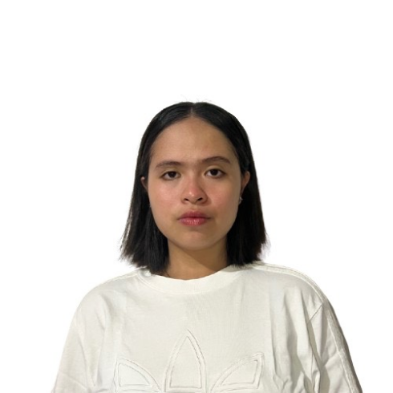

## **Angelica Samantha A. Dela Cruz**

**PERSONAL DATA:**

**Name:** Angelica Samantha A. Dela Cruz

**Age:** 19

**Birthday:** May 13, 2005

**Address:** 125A.f Jaca St. Tugas Pardo C.C

**Contact Number:** 09694336179

**E-mail:** angelcruzsam82@gmail.com

**Educational Background:**

**Elementary:** Sae Young Christian School (2013-2019)

**Junior High School:** St. Scholastica Academy Tabunok (2019-2023)

**Senior Highschool:** Cebu Institute of Technology University (2023-2025)



**Cebu Institute of Technology – University**

**SENIOR HIGH SCHOOL DEPARTMENT**

**N. Bacalso Avenue, Cebu City**

# **CURRICULUM VITAE**



## **Aryanna Rafaella V. Labra**

**PERSONAL DATA:**

**Name:** Aryanna Rafaella V. Labra

**Age:** 19

**Birthday:** March 28, 2006

**Address:** Lot 16 Block 1 St. Lourdes

Subdivision Mohon, Talisay

**Contact Number:** 09282673170

**E-mail:** labraaryanna@gmail.com

**Educational Background:**

**Elementary:** Golden Success College (2013-2019)

**Junior High School:** Cebu Normal University (2019-2023)

**Senior Highschool:** Cebu Institute of Technology University (2023-2025)

**Appendix G**

